Access to SAP API Platform

Version : 1.0

prepared by

Malleswara Rao

SR Architect

**Revision History**

| **Version** | **Date** | **Author** | **Description** |
| --- | --- | --- | --- |
| 0.1 | 26th April 2019 | Malleswara Rao | Draft version |
| 0.2 | 6th May 2019 | Malleswara Rao | Added API portal design capabilities |
| 0.3 | 9th May 2019 | Malleswara Rao | Added remaining API portal capabilities |
| 0.4 | 12th May 2019 | Malleswara Rao | Added API creation capabilities |
| 0.5 | 16th May 2019 | Malleswara Rao | Added API policy capabilities |
| 0.6 | 23rd May 2019 | Malleswara Rao | Added API policy template capabilities |
| 0.7 | 4 th June 2019 | Malleswara Rao | Added API Product capabilities |
| 0.8 | 10th June 2019 | Malleswara Rao | Added API Security Policy capabilities |
| 0.9 | 11th June 2019 | Malleswara Rao | Added API Testing capabilities |
| 1.0 | 12th June 2019 | Malleswara Rao | Added API Debugging capabilities |

**Table of Contents**

1. SAP API Management Access 4

**1.1** **Solvay Account** 4

2. API Management 5

**2.1** **API Management Tools** 5

**2.1.1** **API Portal** 5

**2.1.2** **Developer Portal** 6

3. API Portal Functionalities 7

**3.1** **Create API/Proxy using the Designer (swagger)** 7

**3.1.1** **From Designer** 7

**3.1.2** **Importing an existing swagger (YAML or JSON) file** 11

**3.2** **Create API Proxy using API Portal** 13

**3.2.1** **From an API Provider** 14

**3.2.2** **From an API Proxy.** 26

**3.2.3** **Using an endpoint URL.** 29

**3.3** **Further Proxy Configurations.** 33

**3.3.1** **Adding Resources.** 33

**3.3.2** **Adding Proxy Endpoint** 37

**3.3.3** **Adding Target Endpoint** 39

**3.4** **Policy** 40

**3.4.1** **Create Policy** 41

3.4.1.1 Verify API Key Policy 41

3.4.1.2 Spike Arrest 49

3.4.1.3 OAuth 2.0 52

**3.5** **Policy Template.** 59

**3.5.1** **Create a Policy Template.** 60

**3.5.2** **Apply a Policy Template.** 62

**3.5.3** **Update a Policy Template.** 65

**3.5.4** **Import a Policy Template.** 68

**3.5.5** **Export a Policy Template.** 69

**3.5.6** **Delete a Policy Template.** 71

**3.6** **Test API’s** 72

**3.7** **Debug API’s** 74

**3.8** **Publish your API Proxy** 78

**3.8.1** **Create a Product** 78

**3.9** **Consume API’s** 81

# SAP API Management Access

* 1. **Solvay Account**

The below description provides the access for Solvay employee (API Developer, Application Developer) to Solvay account

**1. API Developer Access**

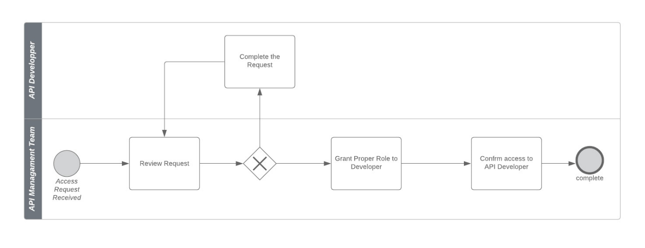

The above figure describes the access flow of a API Developer .It contains two main roles involved in it

**API Developer:** This team requests for the access.

**API Management Team**: The request is reviewed and if the request is complete then the access is granted if not additional information is requested and completes the request.

**2. Application Developer Access**

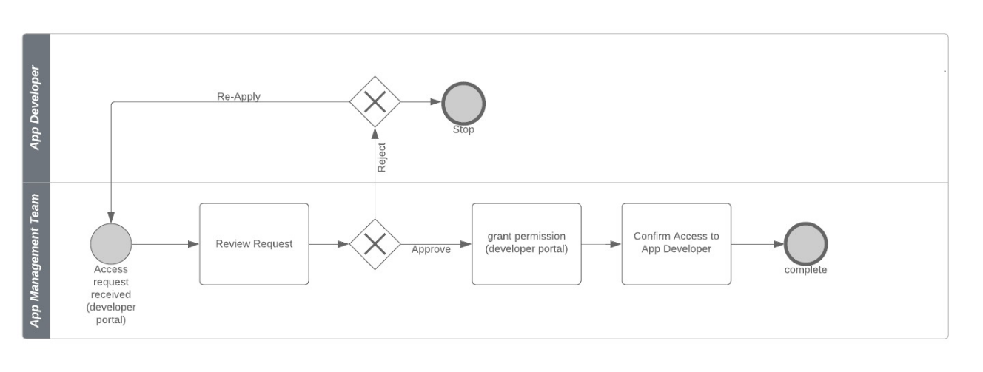

The above figure describes the access flow of a Application Developer to Developer portal. It involves two roles in it:

**Application Developer**: Requests the access.

**Application Management Team**: Request is received by this team. They review the request, if the request is complete they grant the permission and confirm the access. If the request is not proper then the request is cancelled and the developer has to re-apply for the access.

# API Management

* 1. **API Management Tools**
     1. **API Portal**
* Click on API portal link from the service main page

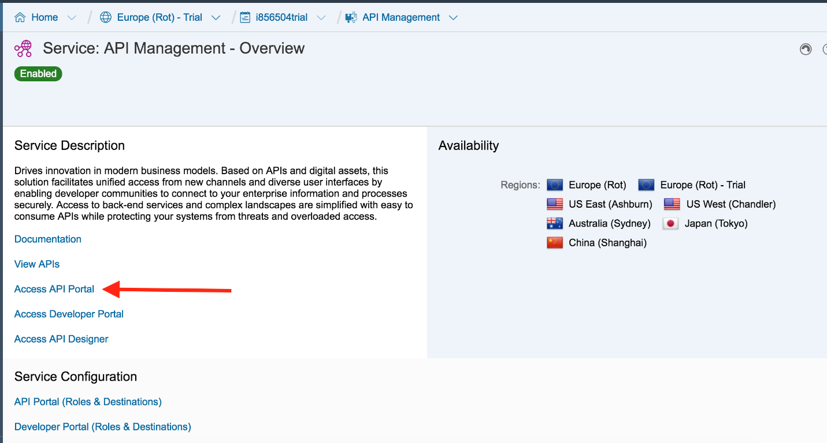

*Figure 10: Access API Portal*

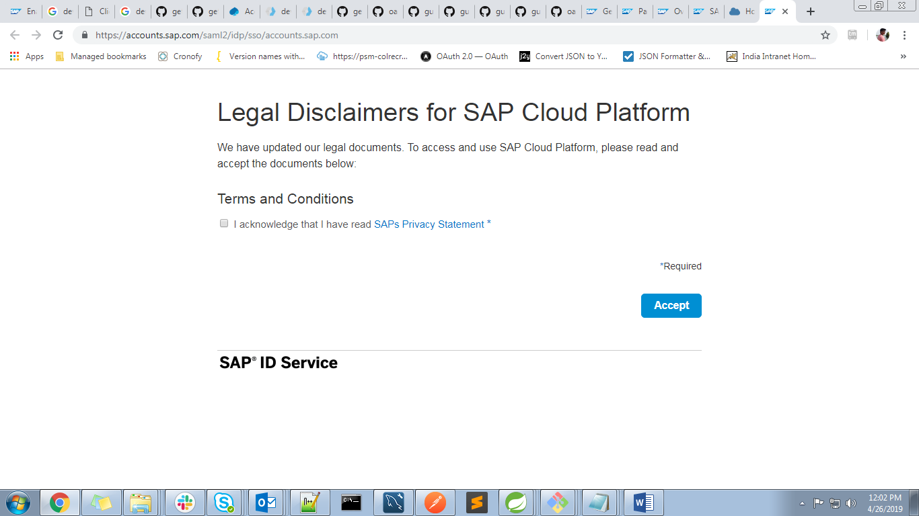

* Setup will take few minutes:

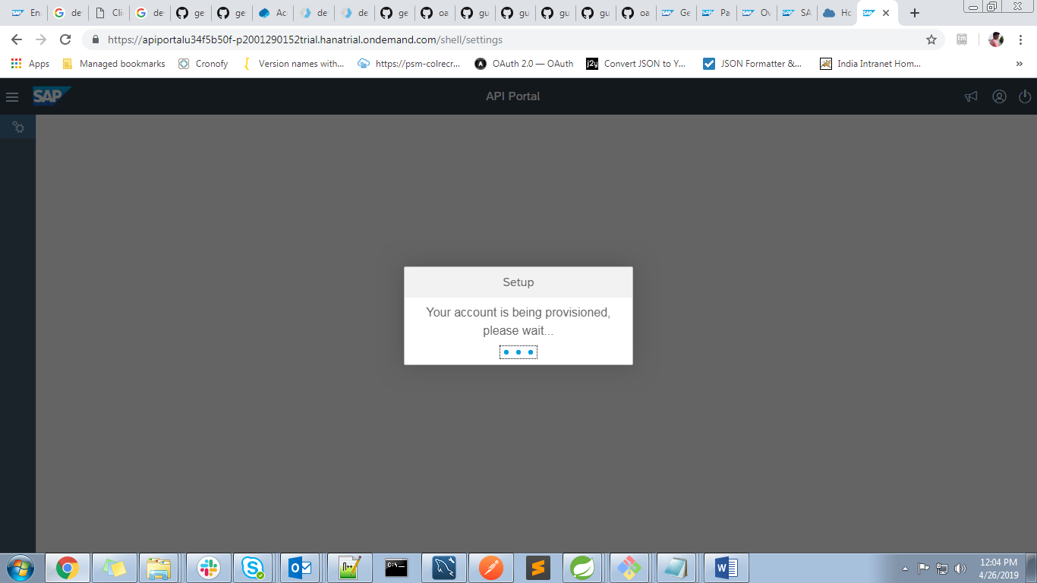

* API Portal is used to create different artifacts like API Provider, API Proxy etc.

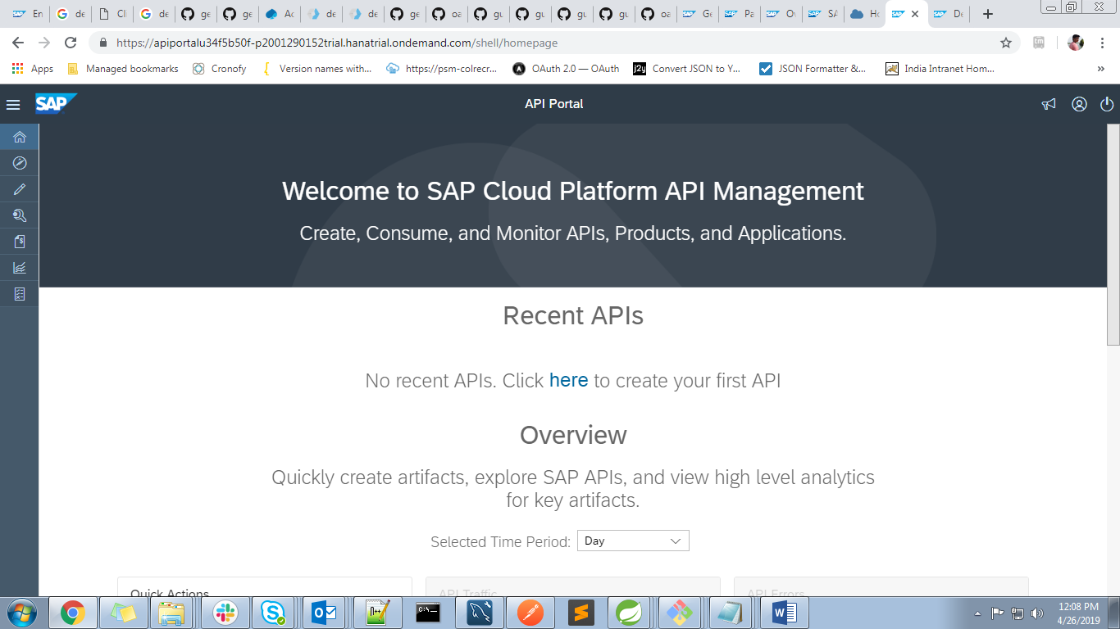

*Figure 11: API Portal*

* + 1. **Developer Portal**
* Navigate back to Service: API Management and Click Developer Portal

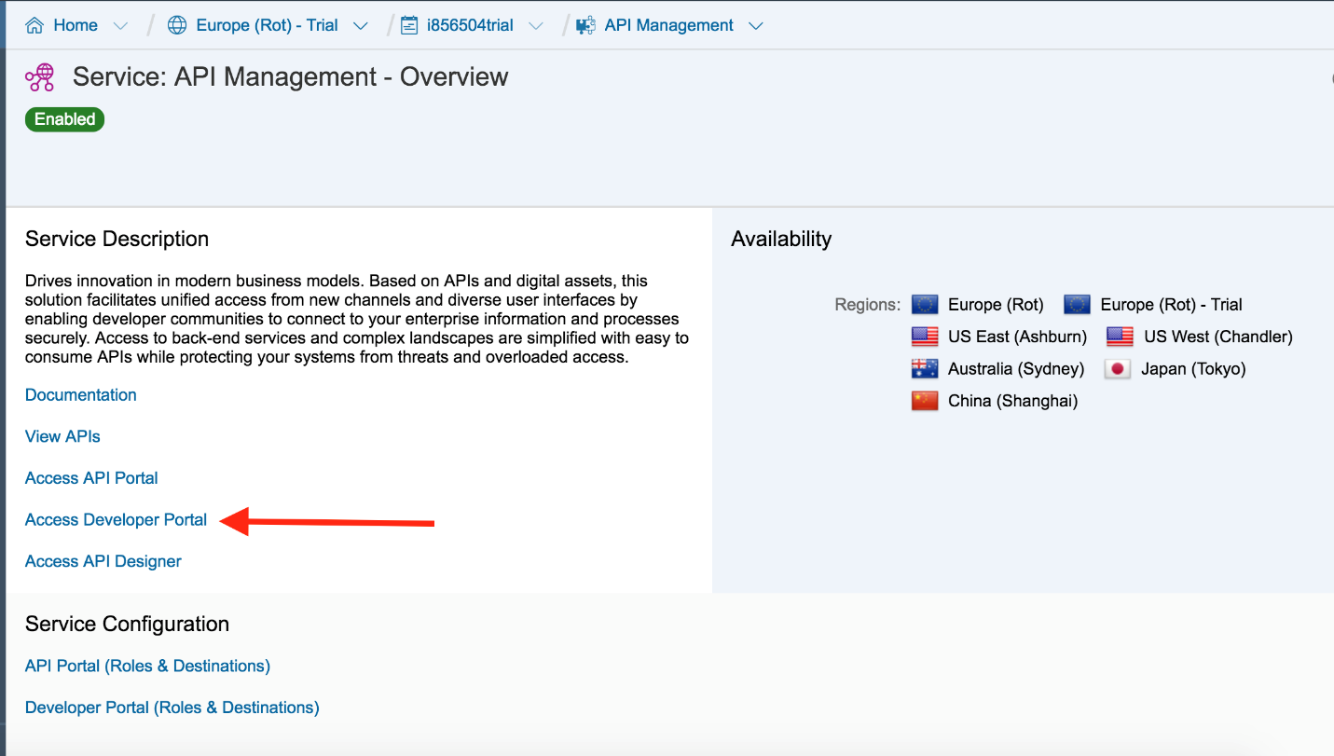

*Figure 12: Access Developer Portal*

* Within Developer Portal we can consume and monitor already configured API’s in portal

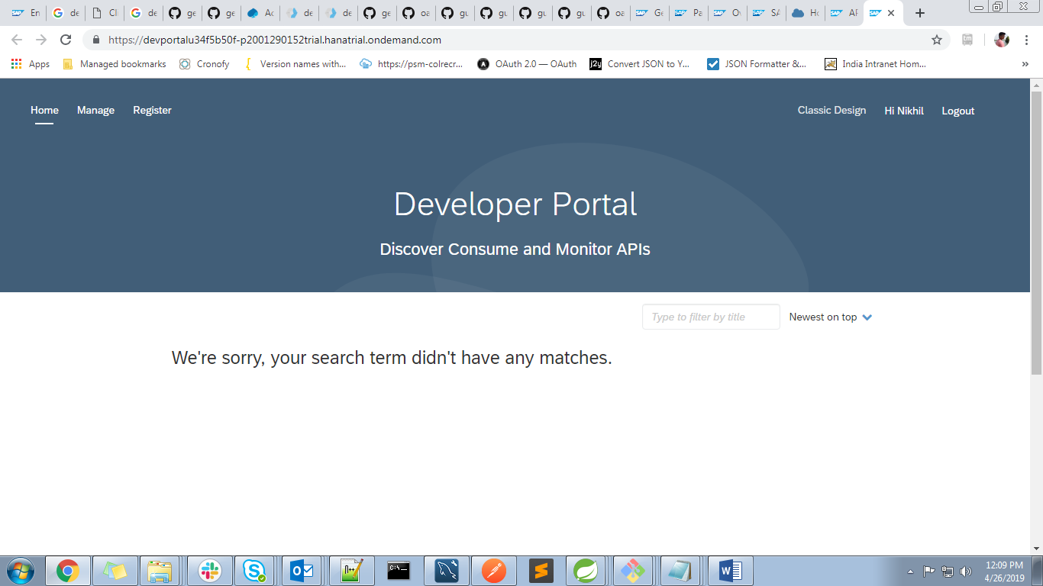

*Figure 13: Developer Portal*

Now we have enabled API and Developer portals and are ready to play with SAP API Management by System, API Provider, API Proxy and Product. Here’s the [tutorial](https://developers.sap.com/group.cp-apim-code-1.html) with getting started with SAP API Management. Happy learning ☺

# API Portal Functionalities

* 1. **Create API/Proxy using the Designer (swagger)**
     1. **From Designer**
* From the navigation bar, choose  (Develop).



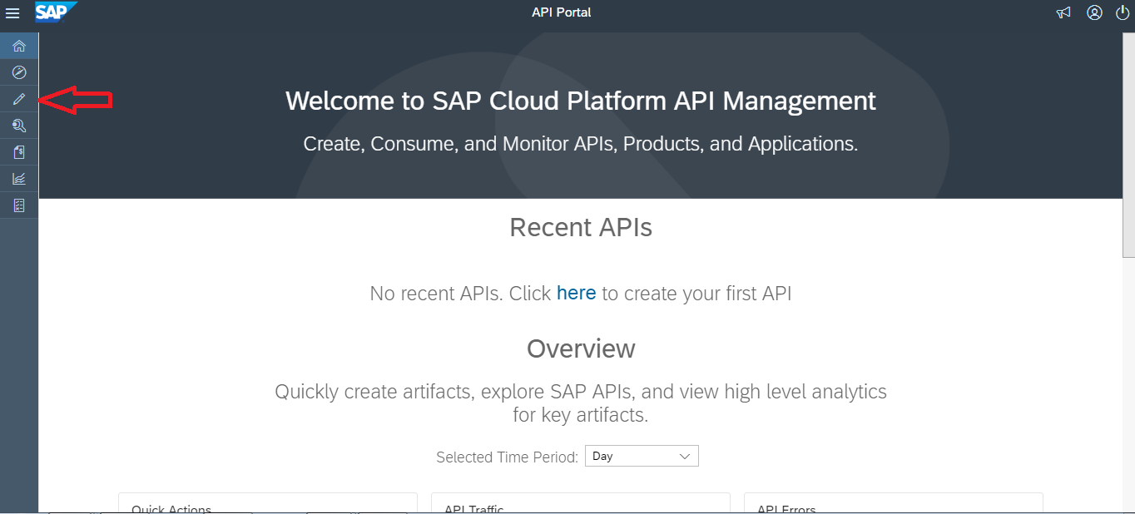

*Figure 14: API Portal*

* Click on the new button called “Create in API Designer”.

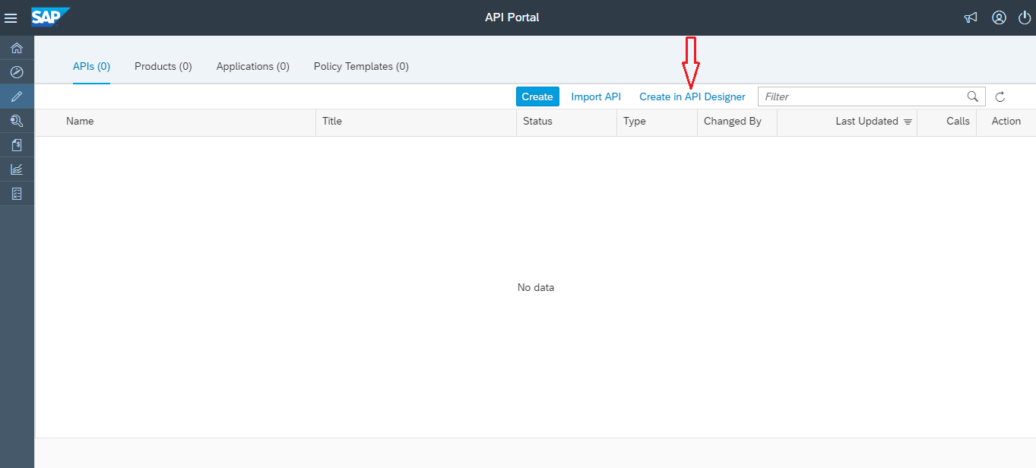

*Figure 15: Creating API in Designer*

* The API Designer opens, with a predefined skeleton of an API description.

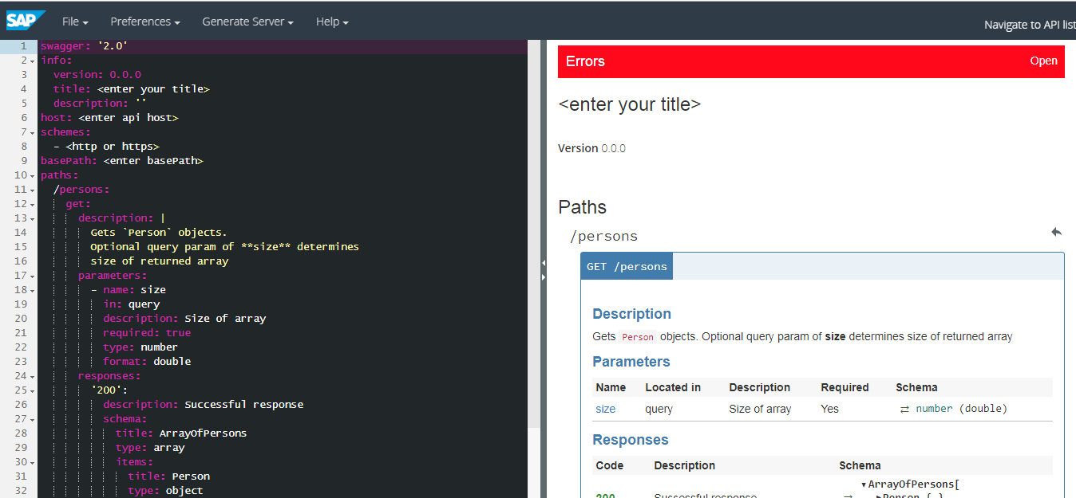

*Figure 16: API Designer window*

* In the above skeleton, YAML file is present and this file can either be modified or can be replaced with an existing file (already created YAML/JSON files from tools like Swagger etc.)
* After resolving all the errors on the right-hand side, the user can save the file.

Note: API management does not accept the swagger 3.0 version YAML formats.

In order to create the API Proxy from the API Designer, user must “Save” the file from file menu.

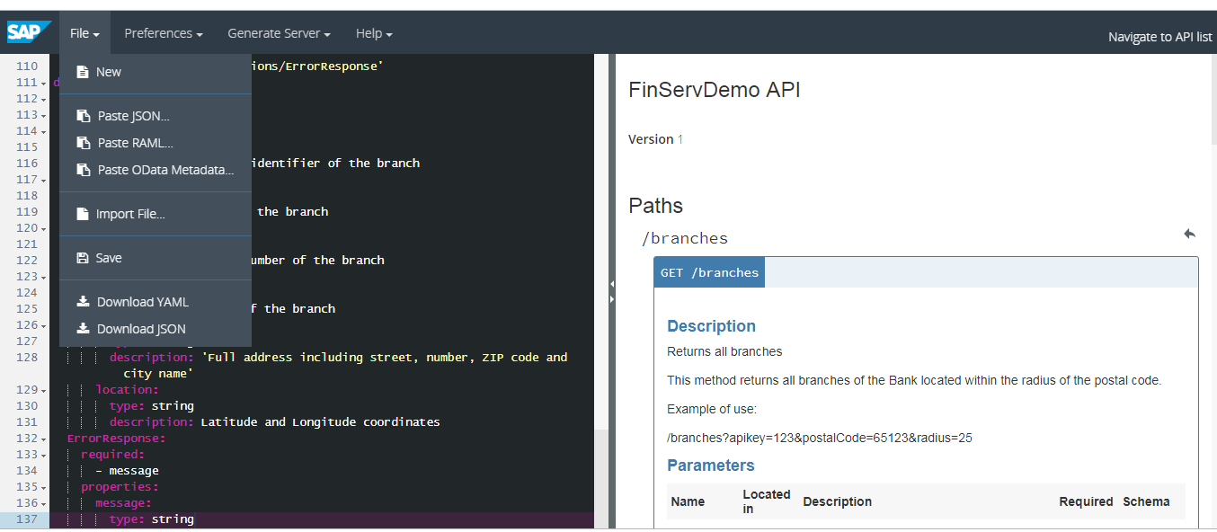

*Figure 17: Saving API*

* While saving the design, user can specify the name of the API Proxy that gets created in API management tool.

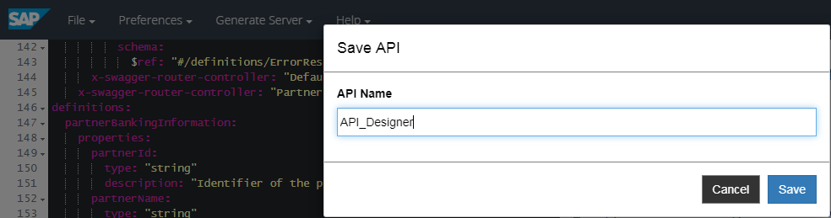

*Figure 18: Naming API*

* Navigate back to the API Proxy list.

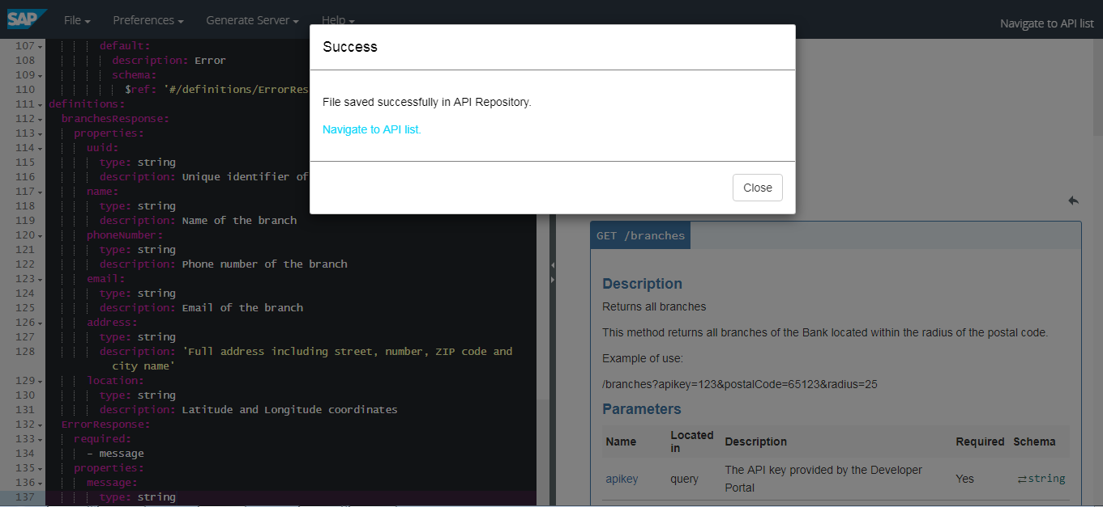

*Figure 19: Navigate to API list*

* In the API Management Portal, you can see that the “sample” Proxy has been created

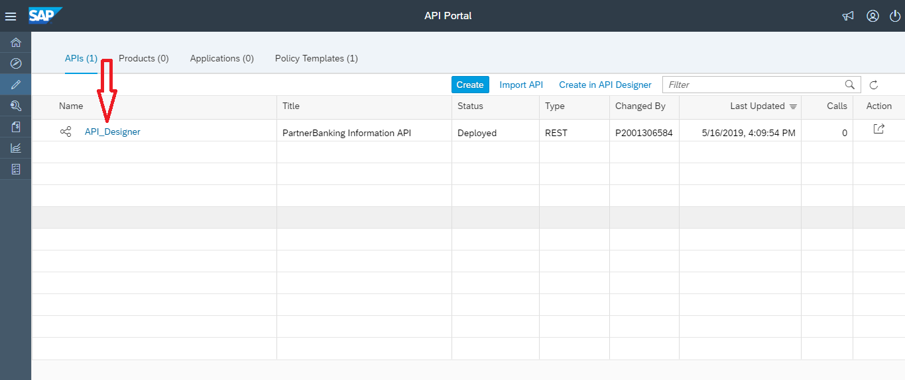

*Figure 20: API list*

* We can deploy the API using the deploy option as mentioned.

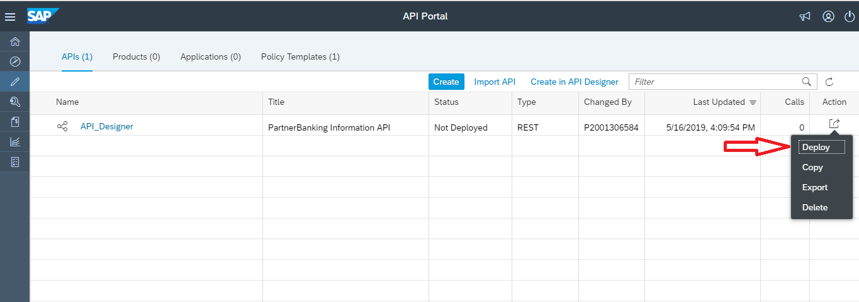

*Figure 21: Deploying API*

* Deployment of the created API is successful.

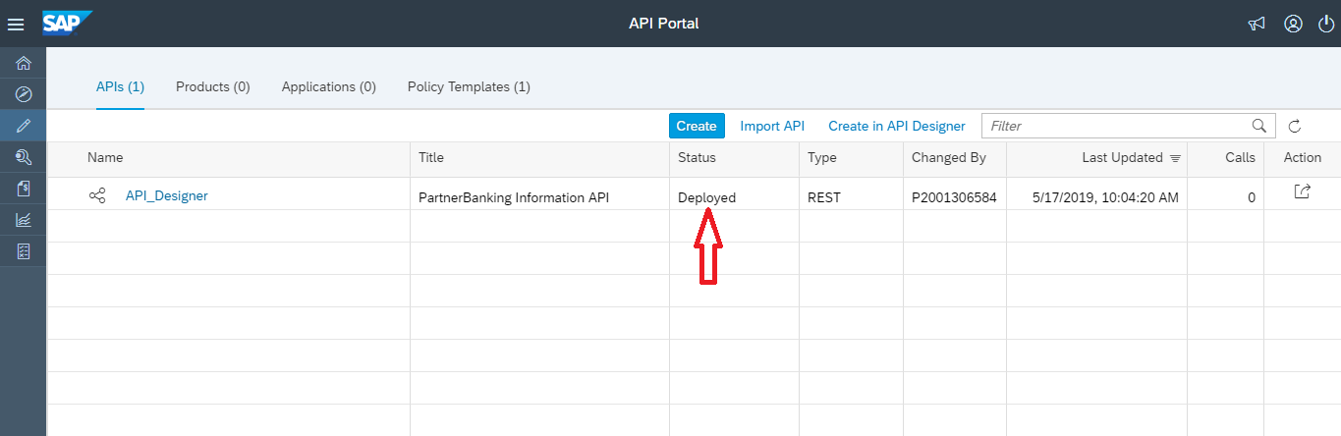

*Figure 22: Deployed API*

* Click on the name of the API Proxy to review its details.

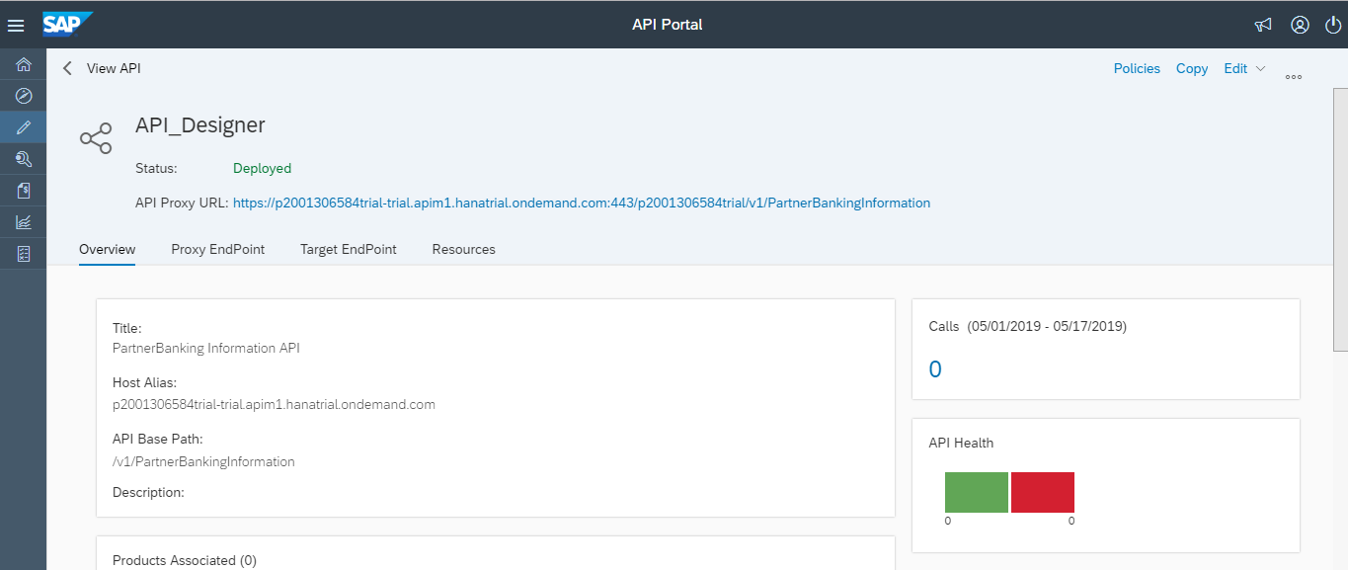

*Figure 23: API Details*

* We can export the created API using the export option. After exporting you will get a zip file of the API.

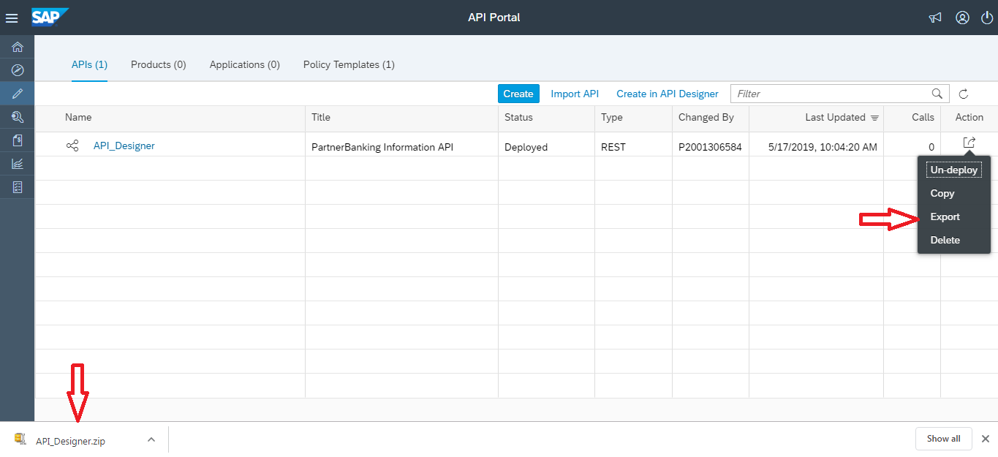

*Figure 24: Exporting API*

* + 1. **Importing an existing swagger (YAML or JSON) file**
* Choose the import option to import an existing Yml or JSON file into the API list.

Note: Files which are exported from the API list in the form of zip folders can only be imported into the API list again.

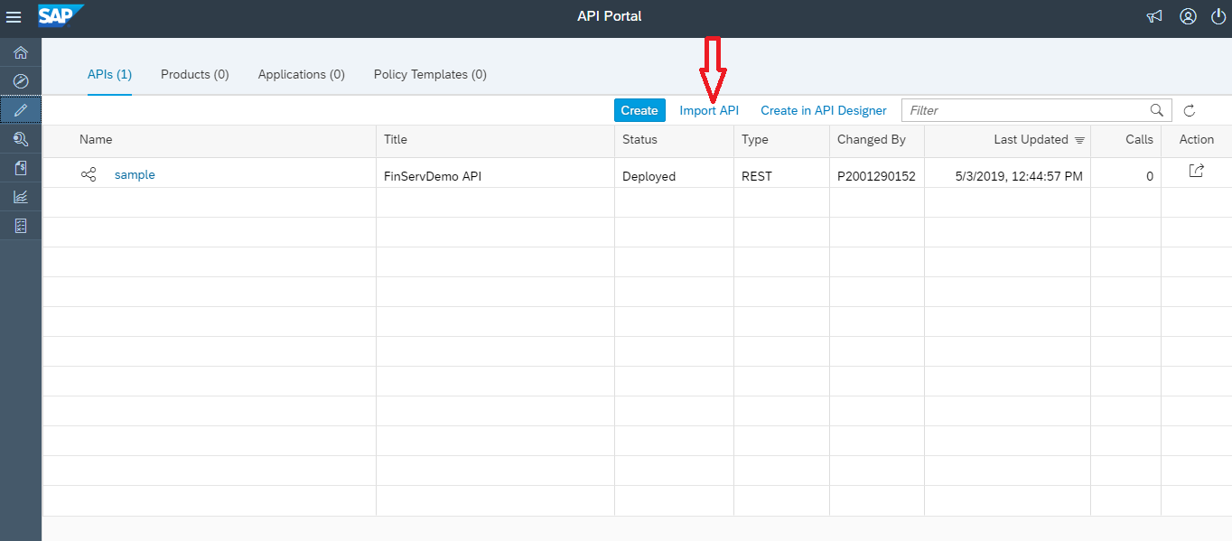

*Figure 25: Importing API*

* Browse the location of the file in your machine which has to be imported.

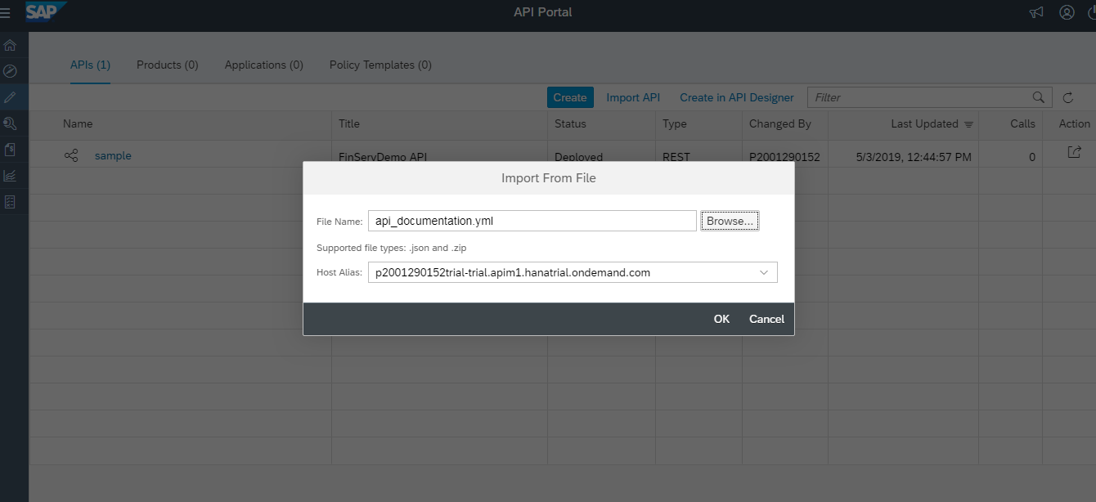

*Figure 26: Browsing API*

* User ca see that the file got imported into the API list and the deployment of that particular file got started.

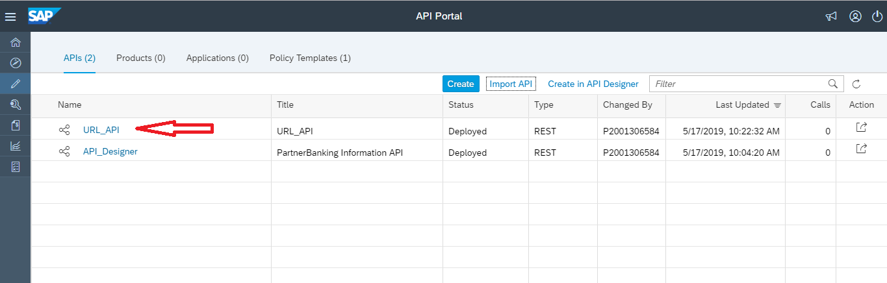

*Figure 27: Imported API*

* User can Un-deploy the API using the option as specified.

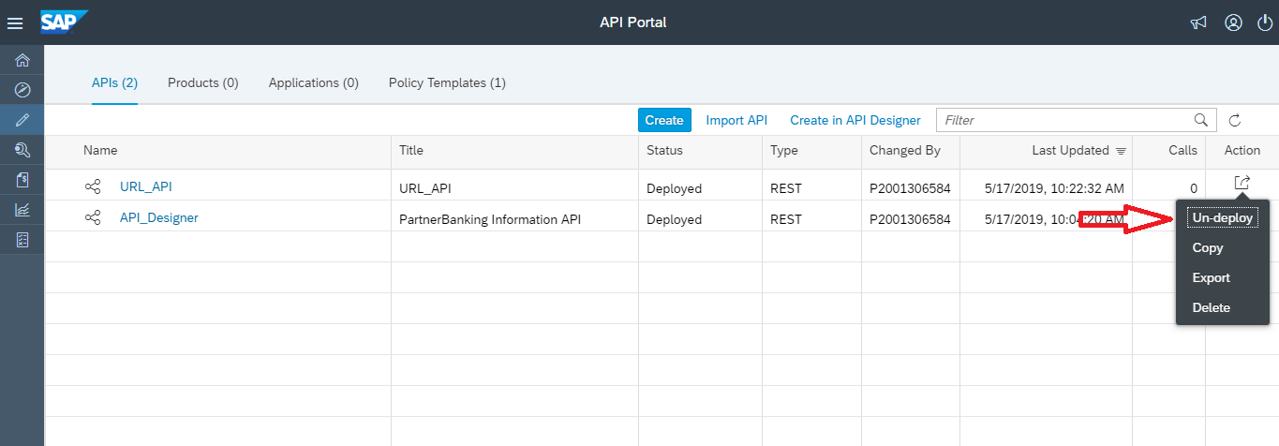

*Figure 28: Un-Deployment of API*

* Now we are able to create an API both using Designer and by importing an existing Yml or JSON file. Further we can learn more about API portal in detailed.
  1. **Create API Proxy using API Portal**

This topic describes the steps to create an API from the API Portal.

To create a new API from this page, click **Create**.

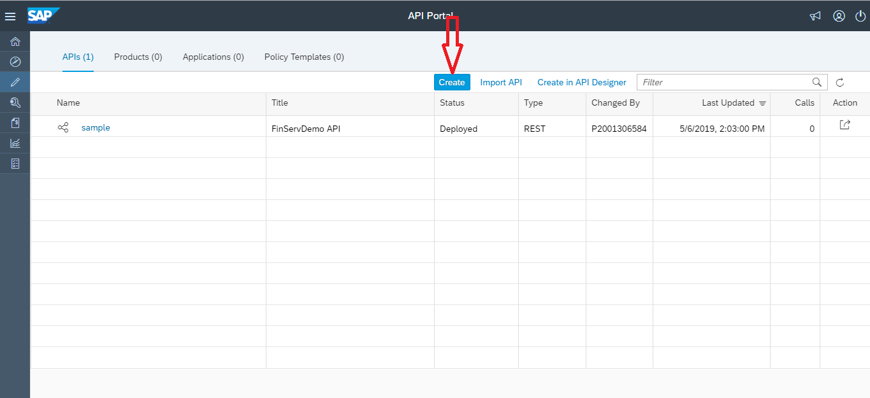

*Figure 29: API creation in API portal*

* + 1. **From an API Provider**
* Select the API Provider radio button from the pop-up window to create an API using Provider.

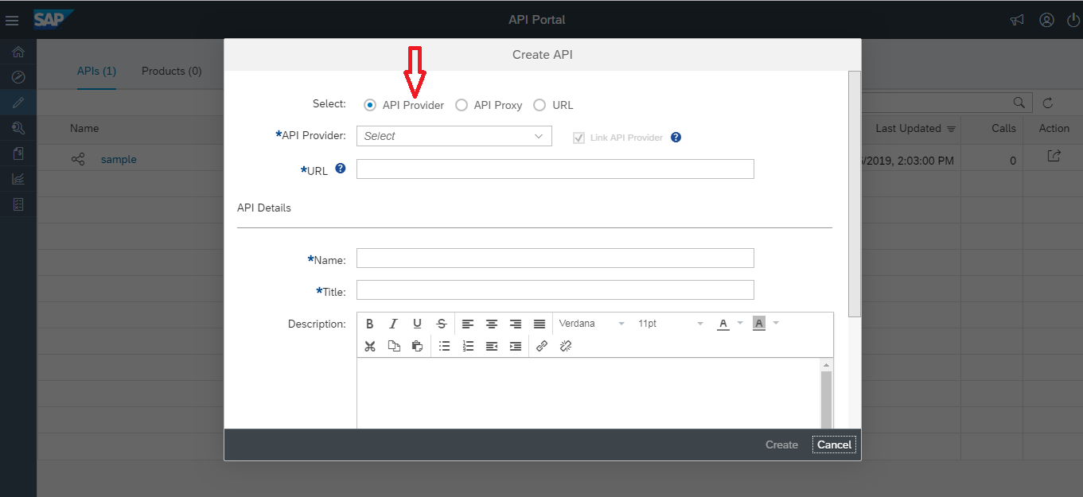

*Figure 30: API Provider*

* The dropdown list contains the providers that you are connected to. If the provider you need is not listed here, add it on the Configure tab.

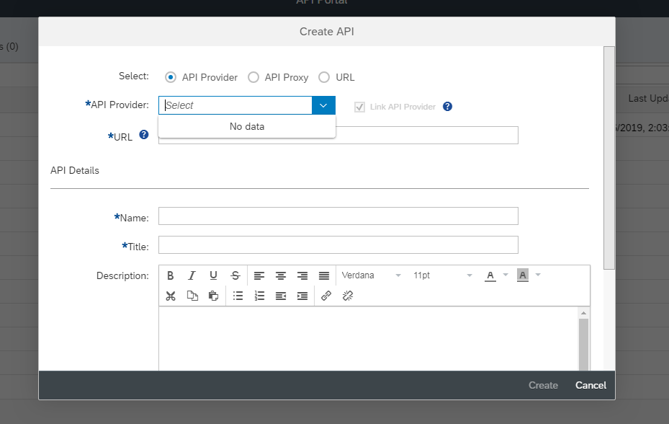

*Figure 31 : Provider Selection*

* In the navigation bar on the top-left, choose the icon  (Configure).



* The list of API providers configured on SAP Cloud Platform for the API Portal appears.
* Choose Create.

`

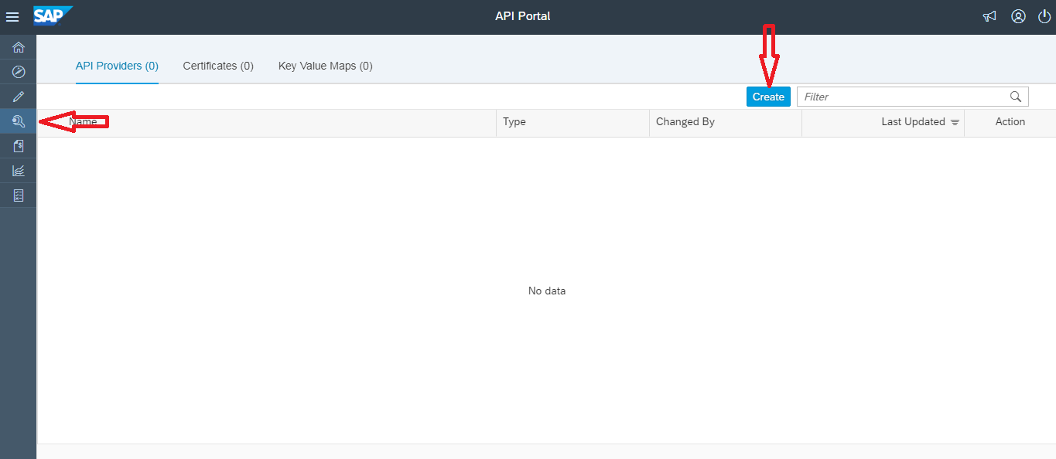

*Figure 32: Provider Creation*

* In the blue overview area, enter the Name & Description for the API Provider.

Note: You cannot use the names mentioned in following list as API provider names:

* DEST_CI APIMGMT_PORTAL
* Content Catalog
* ON_PREM
* Apimgmt_rt
* Apimgmt_rt*
* TC
* TC_*

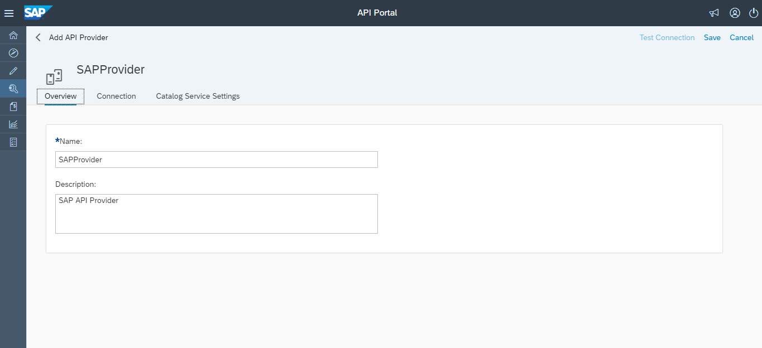

*Figure 33 : API Provider Creation*

* Click On the Connection tab, provide the following information.
* ***Internet*** connection type:

|  |  |
| --- | --- |
| **Fields** | **Description** |
| Host | Host Address is that portion of IP Address which is used to identify hosts on the network. Host addressing is a process of identifying host addresses of host devices such as Laptop, Desktop, mobiles phones or anything which posses an IP Address.  Example: "example.com". |
| Port | In programming, a port (noun) is a "logical connection place" and specifically, using the Internet's protocol, [TCP/IP](https://searchnetworking.techtarget.com/definition/TCP-IP), the way a client program specifies a particular server program on a computer in a network.  Example: 443 as the port number for SSL and 8080 for all other ports. |
| Use SSL | SSL is a transparent protocol which requires little interaction from the end user when establishing a secure session. In the case of a browser for instance, users are alerted to the presence of SSL when the browser displays a padlock, or, in the case of [Extended Validation SSL](https://www.globalsign.com/en-in/ssl-information-center/what-is-an-extended-validation-certificate/), when the address bar displays both a padlock and a green bar. This is the key to the success of SSL – it is an incredibly simple experience for end users.  Select the checkbox to secure the connection using SSL (HTTPS protocol)  *Note:*  *Setting this option is not sufficient to set up the SSL connection. If you want to use SSL to secure connections to the configured destination, then upload the server certificate in the SAP Cloud Platform Cockpit.* |
| Trust store certificate | By default, API Management trusts all TLS certificates. To validate a certificate, create a trust store to configure API Management to validate the certificate. Specify the trust store certificate details in the API Provider. |
| Key store certificate | Specify the key store certificate details. |

* ***On******Premise*** connection type:

|  |  |
| --- | --- |
| **Fields** | **Description** |
| Host | Enter a value for the host in the format "example.com". |
| Port | Enter 443 as the port number for SSL and 8080 for all other ports. |
| Use SSL | Select the checkbox to secure the connection using SSL (HTTPS protocol)  Note:  Setting this option is not sufficient to set up the SSL connection. If you want to use SSL to secure connections to the configured destination, then upload the server certificate in the SAP Cloud Platform Cockpit. |
| Location ID | If you have configured multiple cloud connectors to your SAP Cloud Platform account, then  Provide the location ID of the cloud connector that you want to add.  *Note:*  *The Location ID value for a cloud connector is set while configuring the cloud connector.* |
| Authentication | Authentication is the process of recognizing a user’s identity. It is the mechanism of associating an incoming request with a set of identifying credentials. The credentials provided are compared to those on a file in a database of the authorized user’s information on a local operating system or within an authentication server.  Choose an authentication method:  None: No authentication.  Principal Propagation: Enables authentication  Of a message in the receiver system with the same user that issued the message in the corresponding sender system. For more information, see Enable Principal Propagation |
| Additional Property | Select sap-client from the dropdown and enter the three-digit client id.  Note  The metadata would be fetched from the specified client id. |

* ***Open Connectors*** connection type:

**Prerequisites**

The following prerequisite is applicable to Open Connector type provider only.

You have enabled open connector service in the cockpit and noted down the organization secret and user secret. Note

To enable open connector service, perform the following:

* Navigate to SAP Cloud Platform Cockpit   Services  Open Connectors
* Enable the service
* After the service is enabled, choose in the Take Action Go to Service section.
* You are navigated to Open Connectors home page. In the home page, choose the user icon at the bottom left of the screen and note down the Organization Secret and User Secret.
* User must have created at least one instance against ORG/USER secret to create an API Proxy in API portal.

|  |  |
| --- | --- |
| **Fields** | **Description** |
| Host | Enter a value for the host in the format "example.com". |
| Port | Enter 443 as the port number for SSL and 8080 for all other ports. |
| Region | Select a region from the drop down list. |
| Organization Secret | Enter the organization secret. For more information on how to obtain the value, see prerequisites section. |
| User Secret | Enter the user secret. For more information on how to obtain the value, see prerequisites section. |

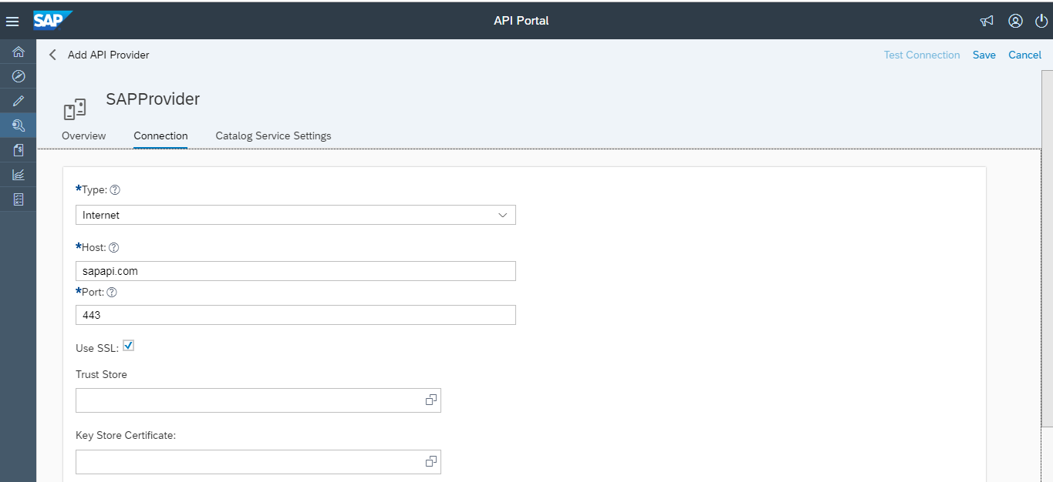

*Figure 34 : API Provider creation*

* On the **Catalog Service Settings** tab, provide the following information.

|  |  |
| --- | --- |
| **Fields** | **Description** |
| Path Prefix | Specify the path prefix. |
| Service Collection URL | Specify the relative path from where the catalog service should be fetched. For example, /CATALOGSERVICE/ServiceCollection.  Note This option is only relevant for SAP Gateway-enabled SAP NetWeaver systems. A catalog service retrieves a list of all available OData services on SAP Gateway. It is based on a catalog service pattern proposed by Microsoft and consists of an implementation approach of the catalog service pattern in the context of SAP Gateway. Only use the field if you want to fetch services from SAP Gateway. For more information on the catalog service, see [here](http://help.sap.com/saphelp_gateway20sp10/helpdata/en/26/50ea3c3ceb44b0a437fa44c420ad49/content.htm) |
| Catalog URL | Automatically populates the complete URL in the format https:<host>:<port>/<path prefix>/Catalog Service. |
| Authentication | Select the authentication method to be used for connection requests to the server. By default, the authentication type is set to None. If you choose Basic, then provide a user name and password as authentication credentials in the respective fields.For the credentials [regster here.](https://accounts.sap.com/saml2/idp/sso/accounts.sap.com) |

Note:

Catalog service settings are not applicable for Open Connectors type connection.

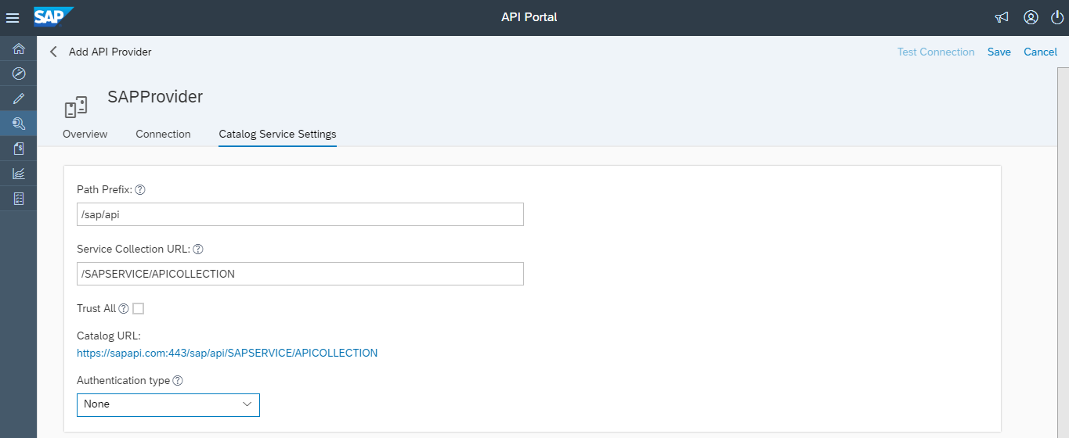

*Figure 35: API Provider creation*

* Save the changes.

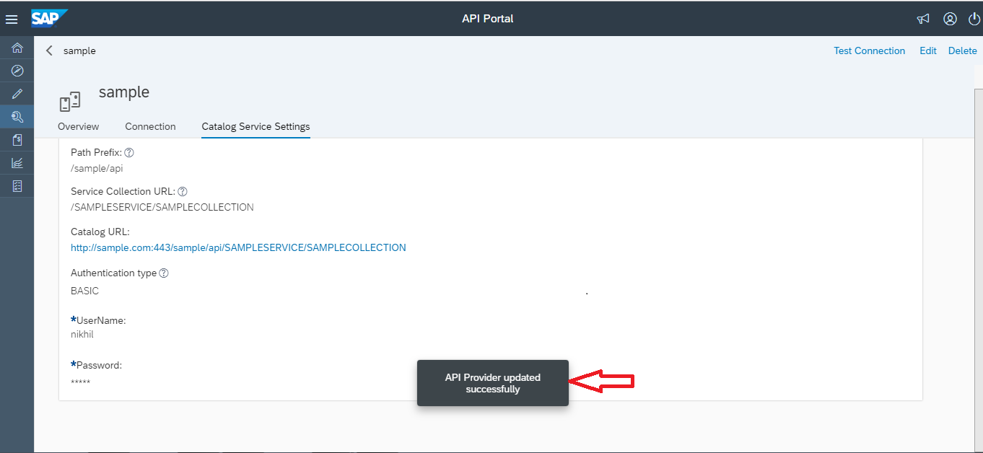

*Figure 36: Created API Provider*

* To Test your settings, click the **Catalog** Service Settings tab on the API Provider. Click on the Catalog URL link to see the catalog.

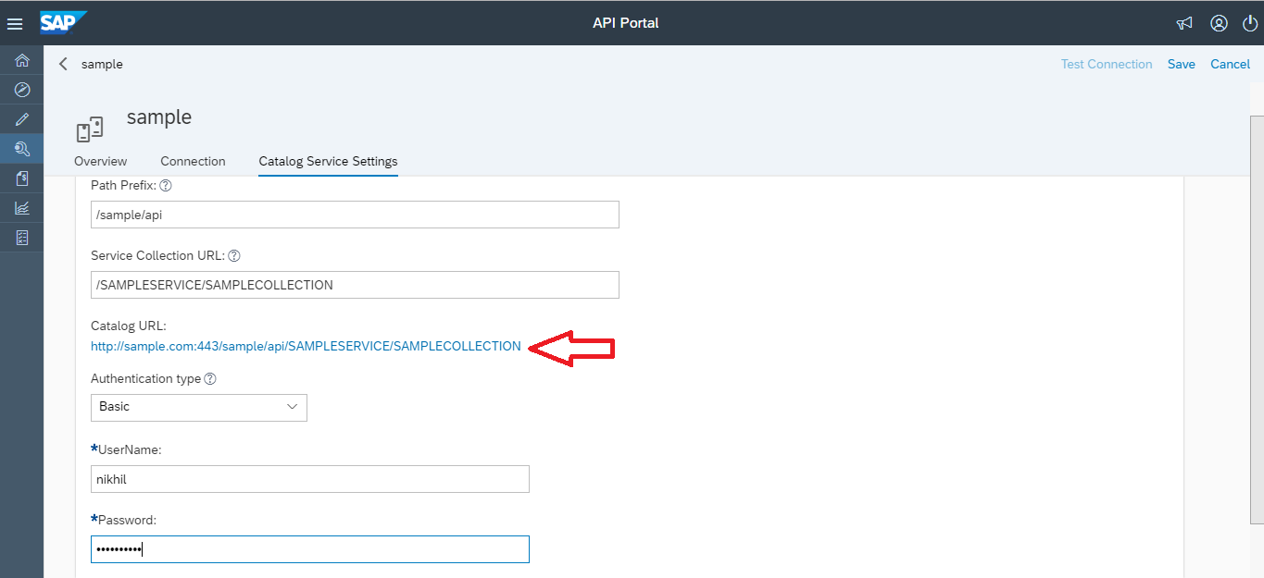

*Figure 37 : Testing API Provider*

* After hitting the above URL the below window appears.

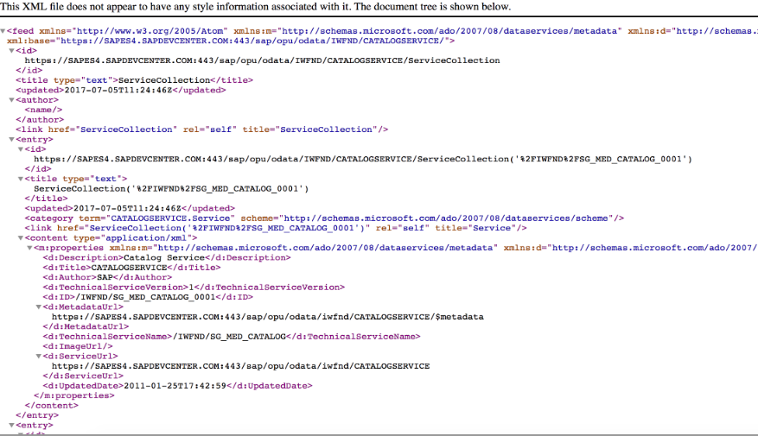

*Figure 38: Testing API Provider*

* You can view the created API Provider, by navigating to **Develop**> **API Provider**.

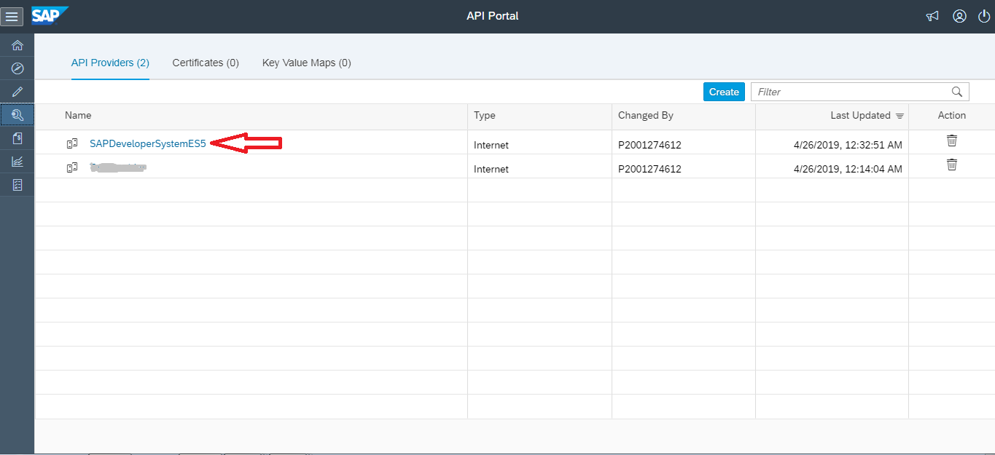

*Figure 39: List of API Providers*

* Select the required open connector type provider from the API Provider dropdown list.

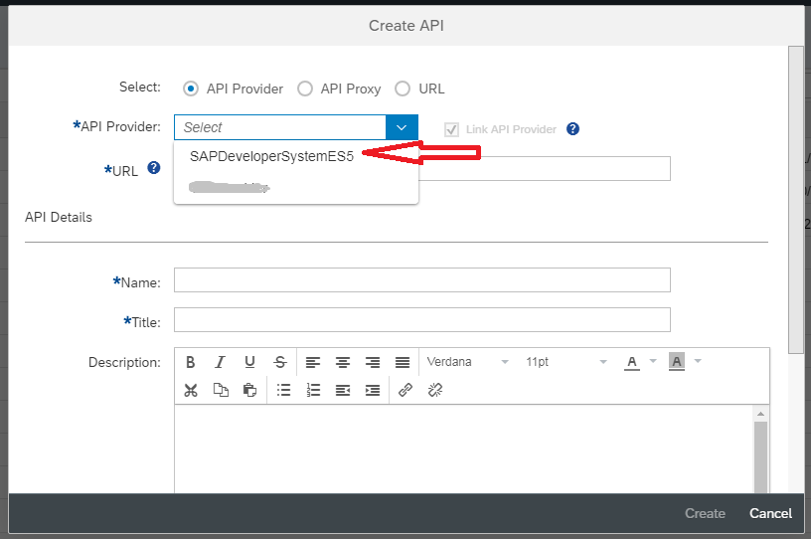

*Figure 40: Provider Selection*

* Click on **Discover**.

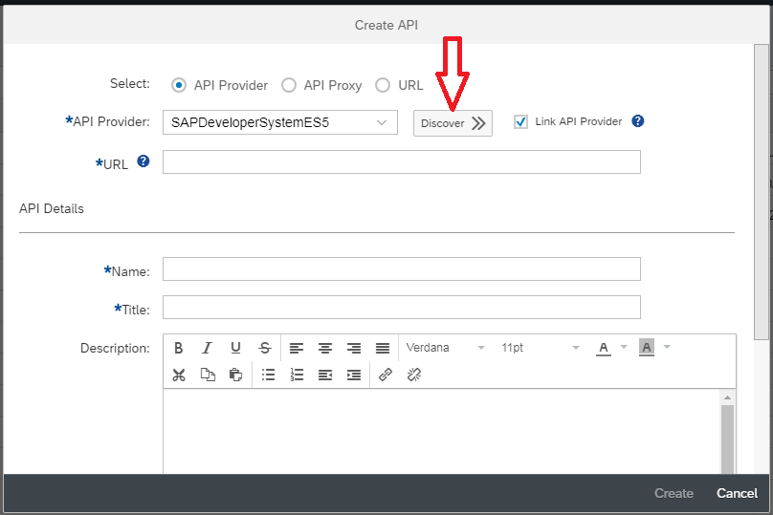

*Figure 41: Discovering the Provider*

* Select the GWSAMPLE_BASIC services by using the search bar to search for *sample*.
* Click on **OK**.

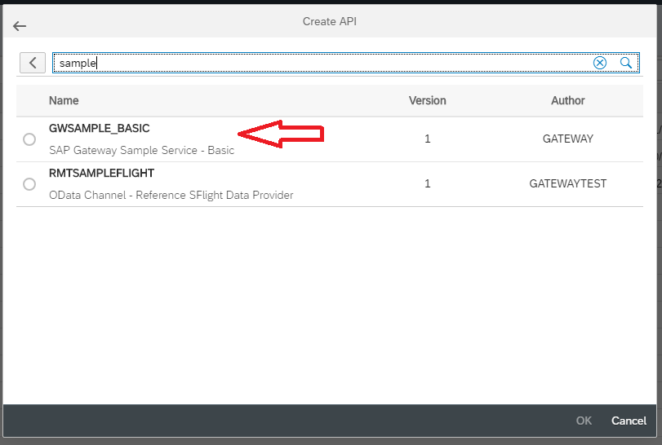

*Figure 42: Selection of Provider*

* The remaining fields from the API Proxy creation screen are populated. Click Create.

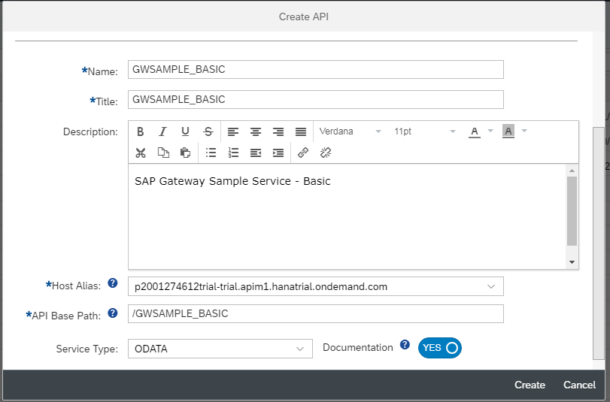

*Figure 43: Creating API*

* Click on **Save and Deploy**.

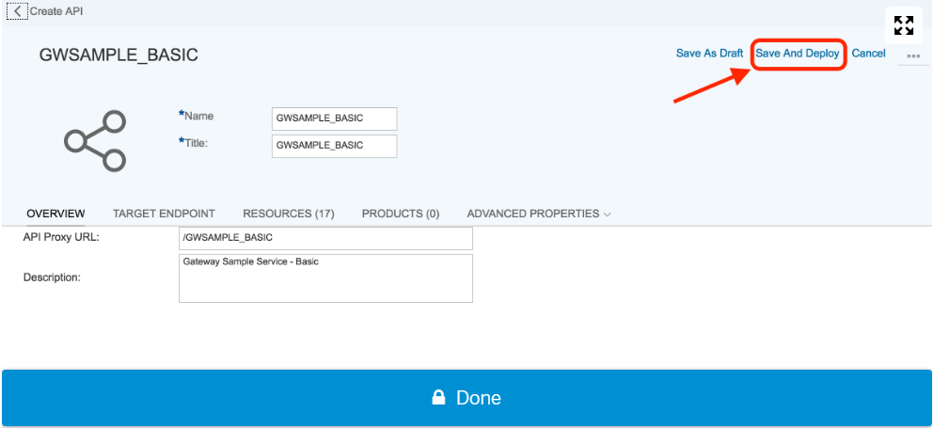

*Figure 44: Saving API*

* A new API Proxy has been created.
* Click on action button from right side and select **Deploy.**

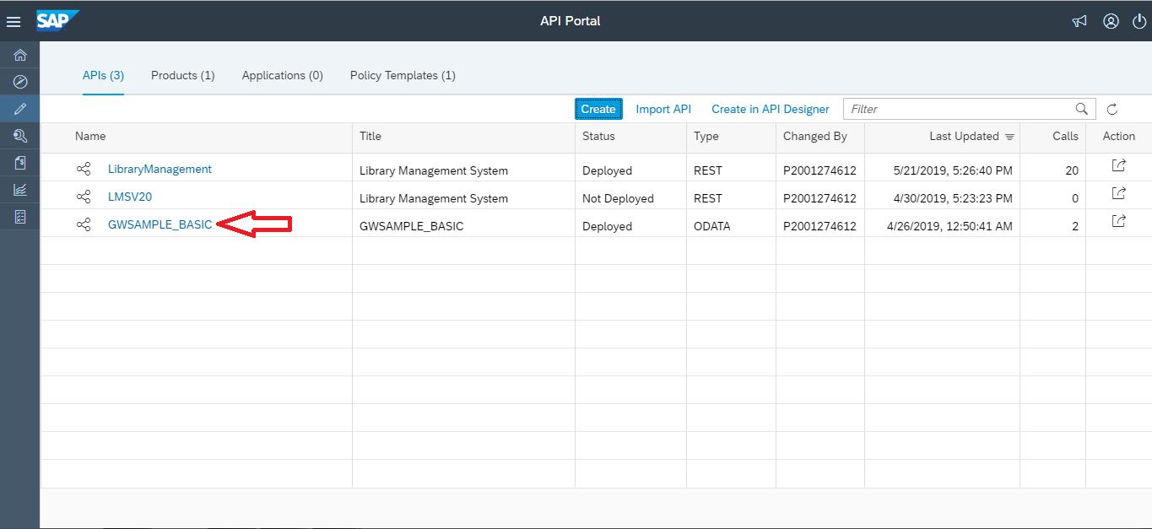

*Figure 45: API List*

* On clicking the API we can view the details of the API.

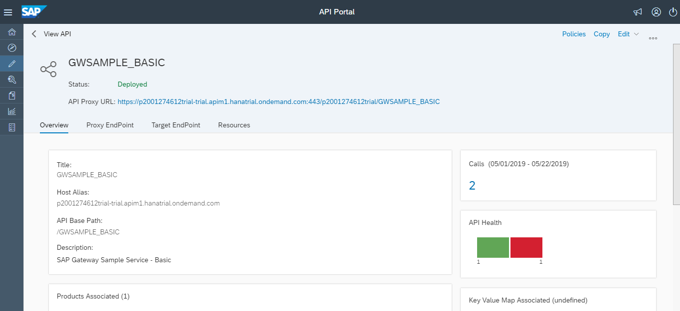

*Figure 46: API Details*

* + 1. **From an API Proxy.**
* Select the API Proxy radio button.
* To view all available API proxies, choose Discover.

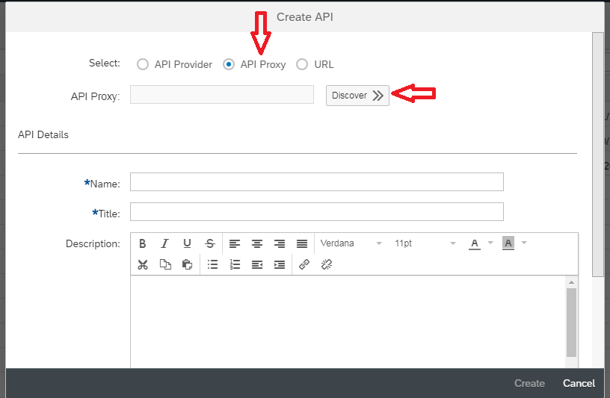

*Figure 47: Selecting API Proxy*

* Select the required API proxy from the dropdown list.

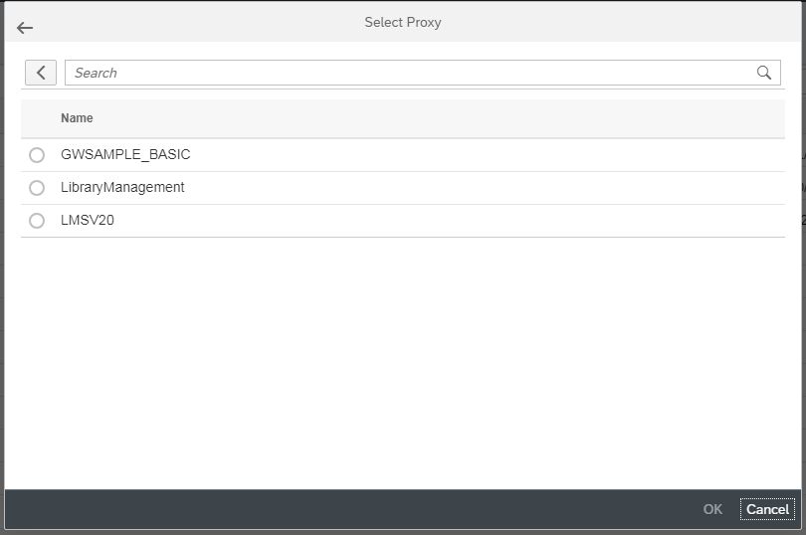

*Figure 48: Discovering API Proxy*

* Enter a name and description for the API.
* Select a virtual host alias from the Host Alias dropdown.
* In the API Base Path field, provide a path prefix for the API.
* Click on Create after filling required details.

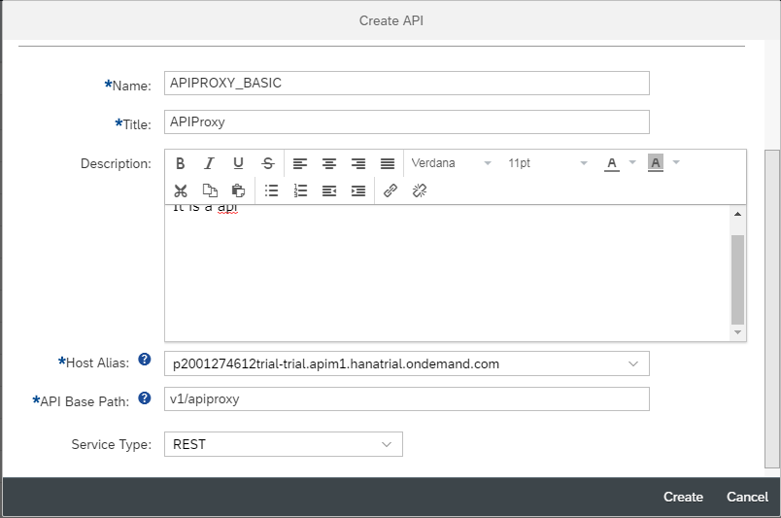

*Figure 49: Adding details*

* You can save the API after creating the API.

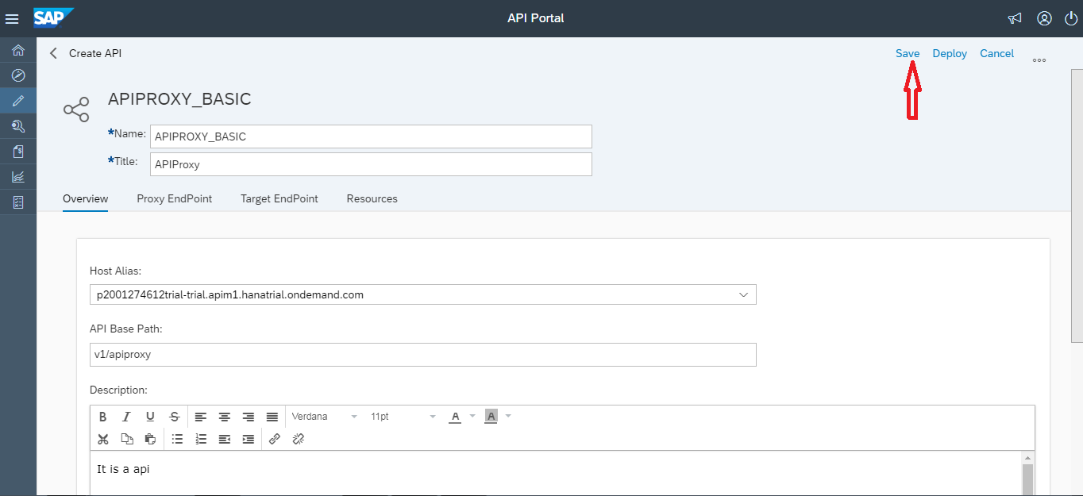

*Figure 50: Saving API*

* After saving the API you can see it is in Not deployed state. Click on action button from right side and select **Deploy.**

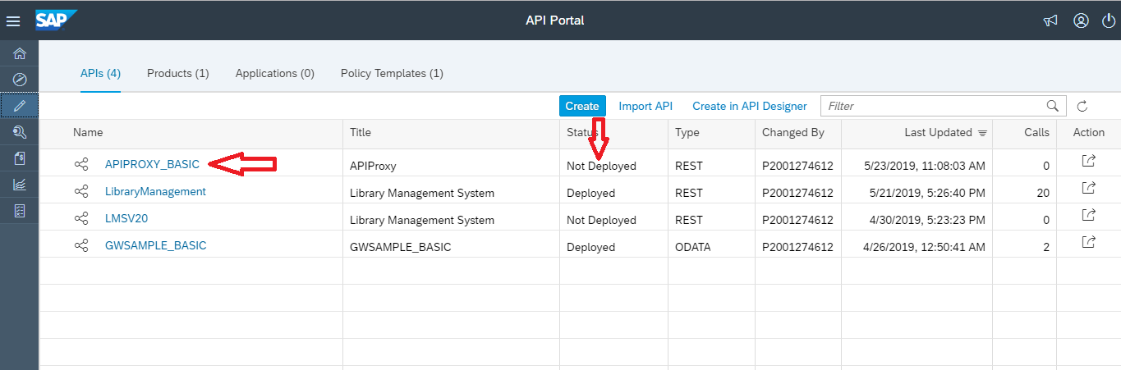

*Figure 51: Deploying API*

* This way we can deploy the API.

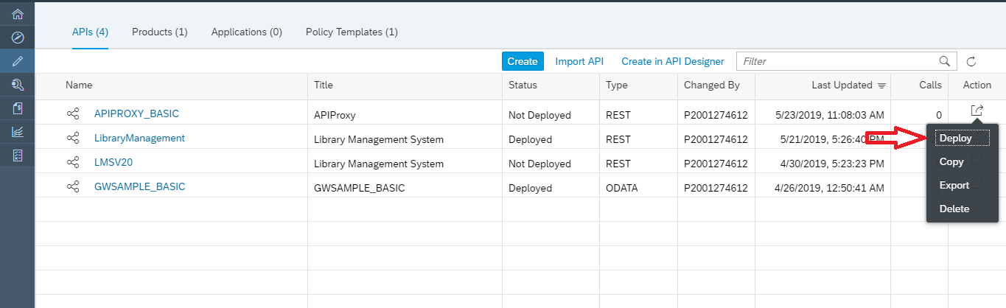

*Figure 52: Deploying API*

* This way the API gets created and deployed using API Proxy.

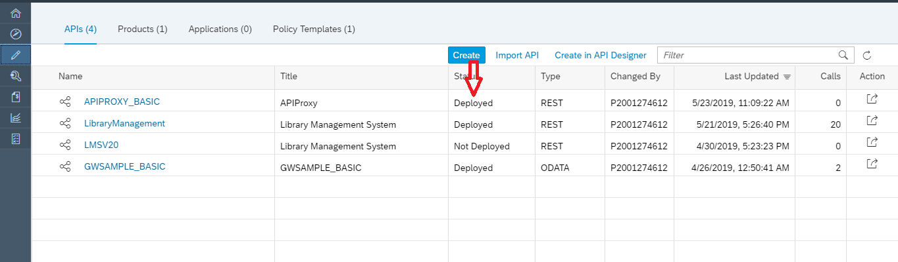

*Figure 53: Deploying API*

* + 1. **Using an endpoint URL.**
* If you have the URL of the **REST** service, proceed as follows:
* Select the URL radio button.

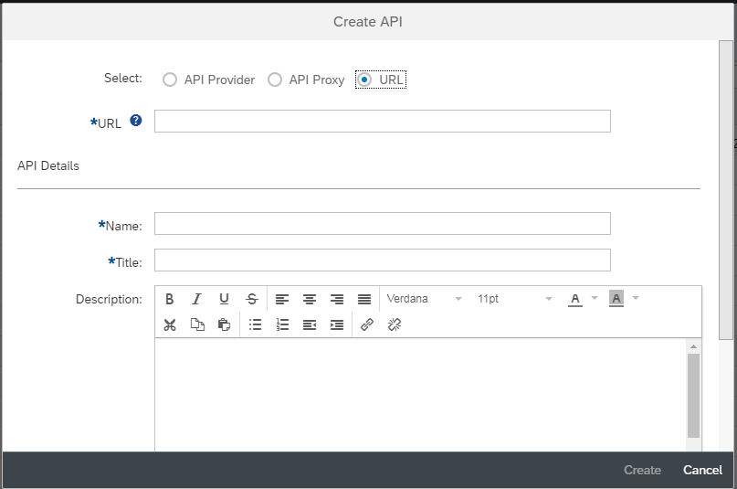

*Figure 54: URL Proxy Method*

* Copy the catalog URL of the required provider and paste it in the URL field of API Creation portal.



*Figure 55: Catalog URL Selection*

* Enter the REST-based service URL in the URL field. For example, http://<host>:<port>/Sample.
* Enter a name and description for the API.
* Select a virtual host alias from the Host Alias dropdown.
* In the API Base Path field, provide a path prefix for the API. For example, v1/ Sample

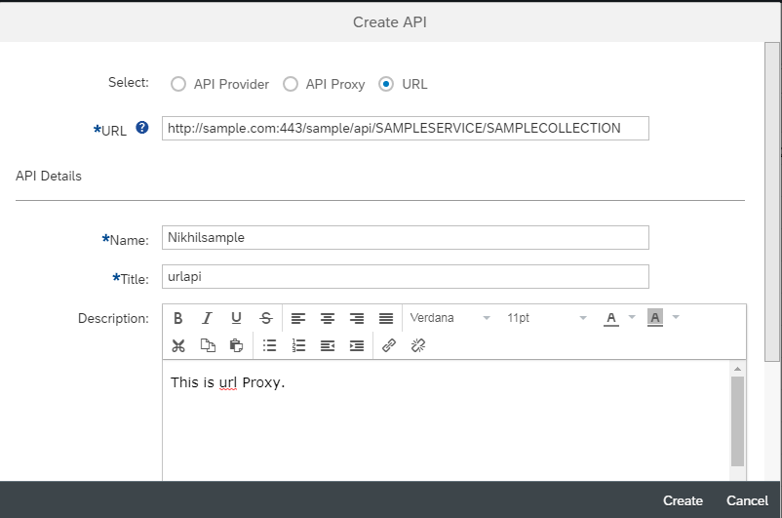

*Figure 56: Creating API*

* In the Service Type field, enter REST.
* Choose Create.

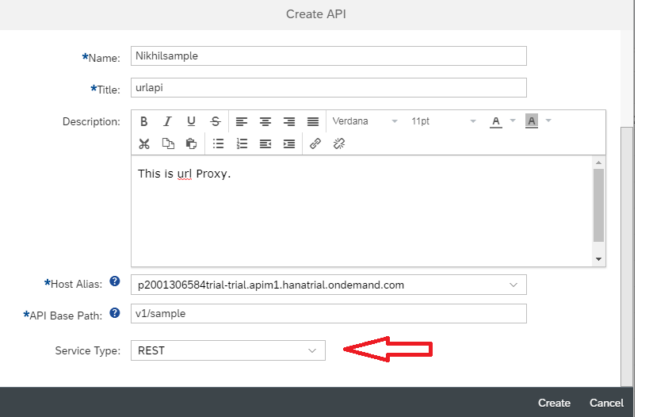

*Figure 57: Creating API using REST*

* If you have the URL of the **REST** service, proceed as follows:
* Select the URL radio button.
* Enter the REST-based service URL in the URL field. For example, http://<host>:<port>/SFlight.
* Enter a name and description for the API.
* Select a virtual host alias from the Host Alias dropdown.
* In the API Base Path field, provide a path prefix for the API. For example, v1/Sample.
* In the Service Type field, enter REST.
* If you have the URL of the **OData** service, proceed as follows:
* Select the URL radio button.
* Enter the OData service URL in the URL field. For example, http://<host>:<port>/ Sample.
* Enter a name and description for the API.
* Select a virtual host alias from the Host Alias dropdown.
* In the API Base Path field, provide a path prefix for the API. For example, v1/Sample.
* In the Service Type field, enter OData.
* If you have the URL of the **SOAP** service, proceed as follows:
* Choose the URL radio button.
* Enter the SOAP service URL in the URL field. For example, http://<host>:<port>/Sample.
* Enter a name and description for the API.
* Select a virtual host alias from the Host Alias dropdown.
* In the API Base Path field, provide a path prefix for the API. For example, v1/Sample.
* In the Service Type field, choose SOAP.
* API gets created as shown in Figure 51.

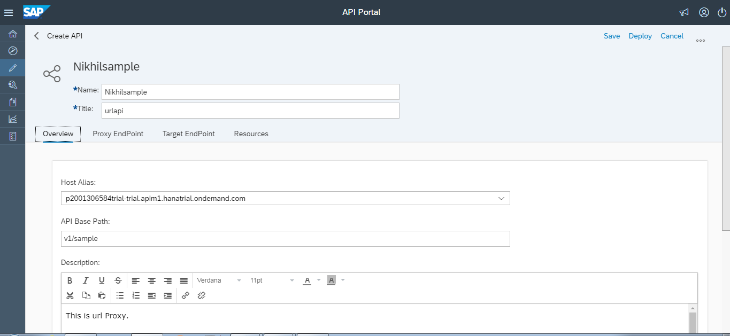

*Figure 58: Creating API Portal*

* 1. **Further Proxy Configurations.**

In an API proxy configuration, there are two types of endpoints and resources:

**Proxy Endpoint**: Defines the way client apps consume your APIs. You configure the Proxy Endpoint to define the URL of your API proxy. The proxy endpoint also determines whether apps access the API proxy over HTTP or HTTPS. You usually attach policies to the Proxy Endpoint to enforce security, quota checks, and other types of access control and rate-limiting.

**Target Endpoint**: Defines the way the API proxy interacts with your backend services. You configure the Target Endpoint to forward requests to the proper backend service, including defining any security settings, HTTP or HTTPS protocol, and other connection information. You can attach policies to the Target Endpoint to ensure that response messages are properly formatted for the app that made the initial request.

**Resources**: The fundamental concept in any RESTful API is the resource. A resource is an object with a type, associated data, relationships to other resources, and a set of methods that operate on it.

You can visualize API proxies as shown by the graphic below:

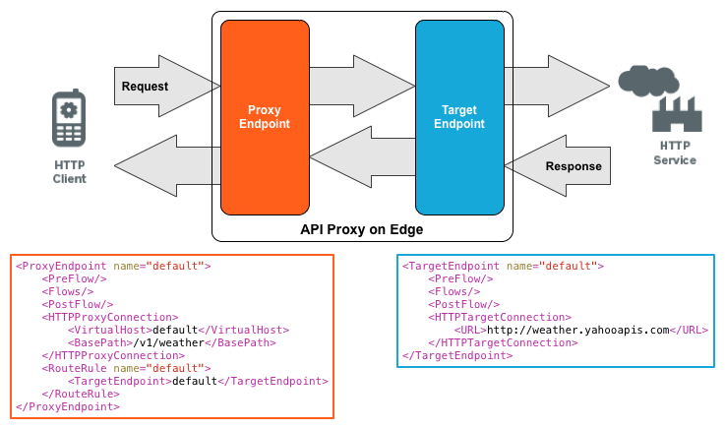

*Figure 59: API configurations*

* + 1. **Adding Resources.**

Note:

* For an OData service, all the associated artifacts appear on the different tab pages mentioned below. The **Resources** tab lists all the resources associated with the API. The API documentation with SAP documentation annotations, if selected, is also fetched from the metadata.
* For a SOAP- and REST-based service, the Resources tab appears. Add the resources manually.
* For a REST service, add a resource as follows:
* Choose + (Add).

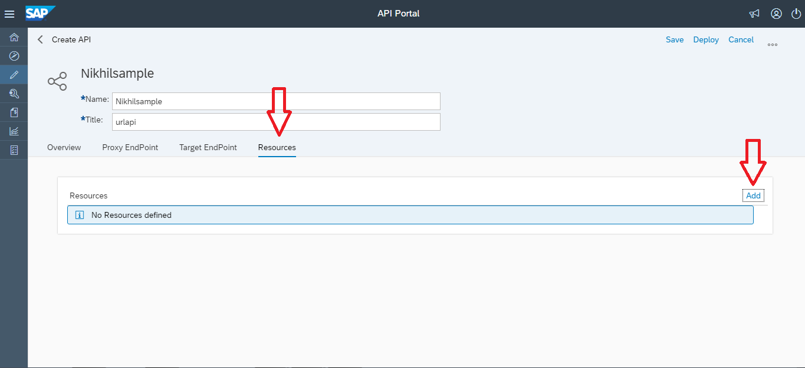

*Figure 60: Adding Resources in API Portal*

* In the popup, enter a title and path prefix for the resource.
* Select the methods that need to be supported for this resource.

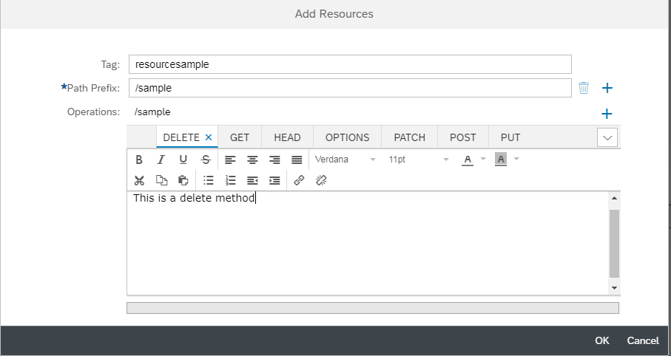

*Figure 61: Add Resources in API*

* Add descriptions in the editor and choose Add.
* The added resource appears on the Resources tab.
* Choose Add to add more resources to the same API.

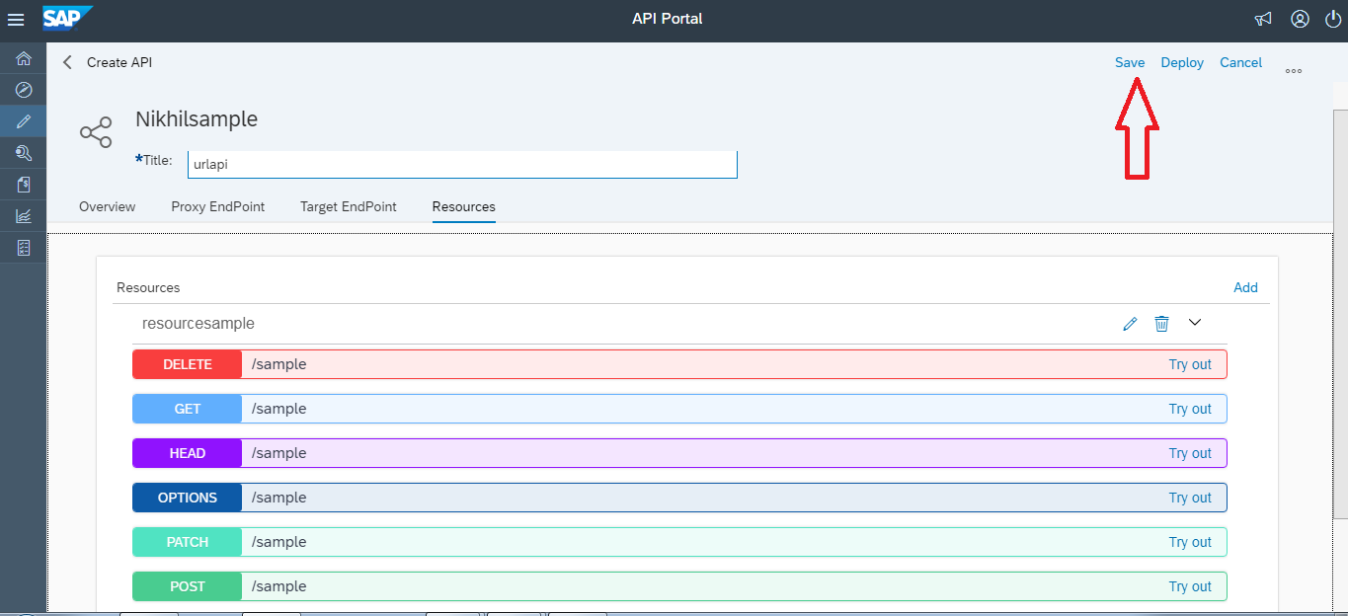

*Figure 62: Creating API Portal*

* The API using URL Proxy is created successfully.

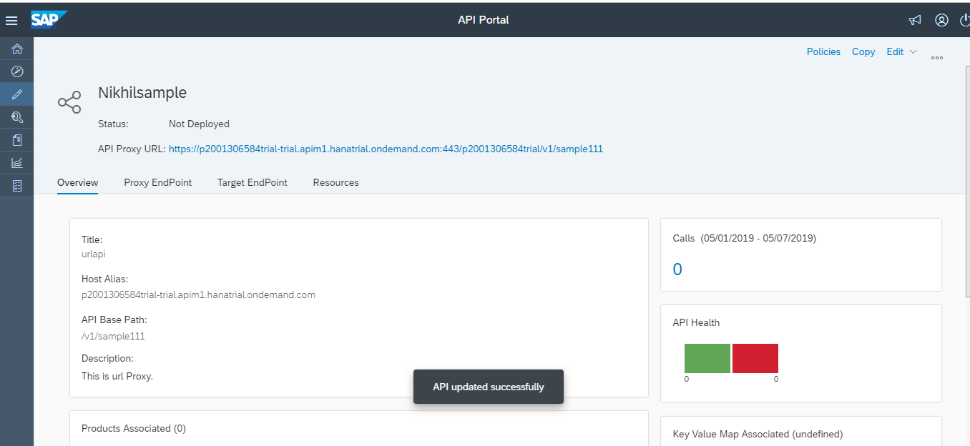

*Figure 63: API using URL Proxy*

* Once you have filled in all the required details of the API, you can select one of the following two actions for the API:

| **Action** | **Resulting API State** | **Future Action on API** |
| --- | --- | --- |
| **Save** | Not Deployed  API is available only in the API portal, and is not available for product assignments. | Deploy  API is deployed and is ready for product assignments. |
| **Deploy** | Deployed  Only deployed APIs can be selected for product publishing. | Undeploy  If any API is undeployed after being published, it is removed from the developer portal. When the API is deployed again, the product is updated. You can bring down an API without having to delete it from the product assignment. You cannot undeploy an API if it is the only one associated with the product. |

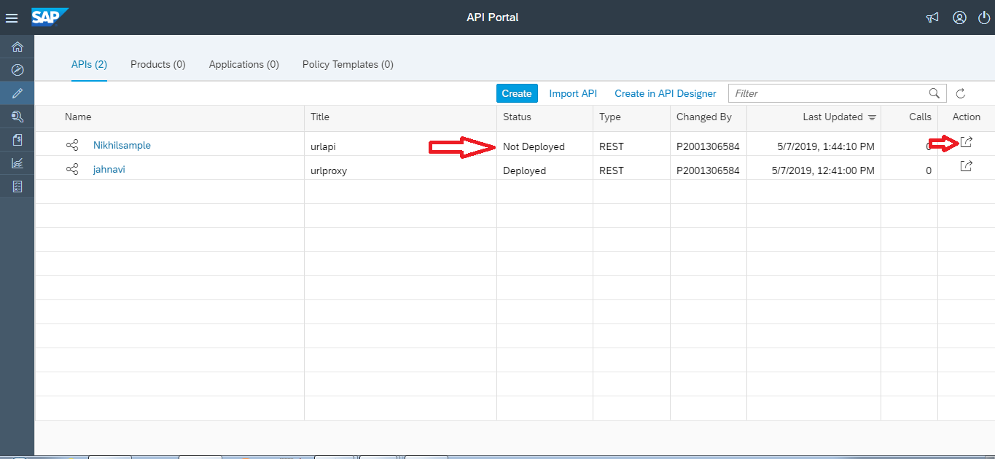

*Figure 64: Deployment of API*

* Here we can do the deployment of the API.

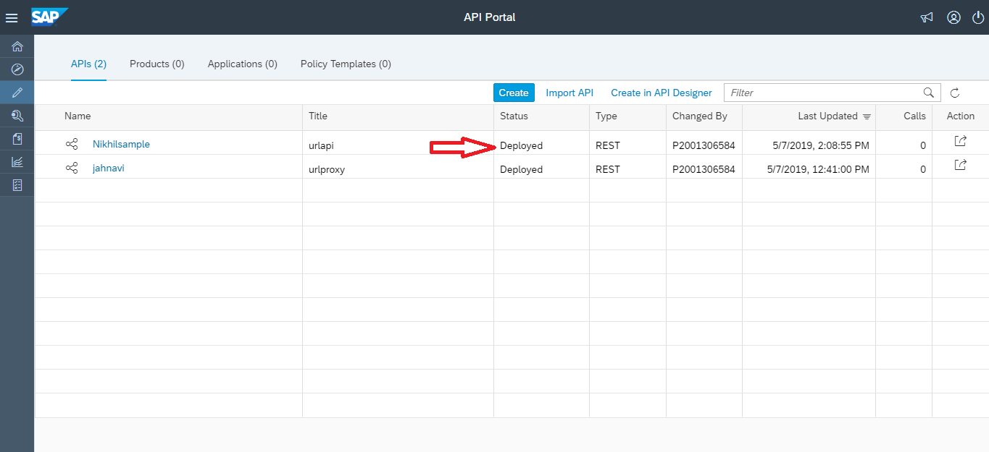

*Figure 65: Deployment of API*

* For a SOAP service, add a resource as follows:
* Choose + (Add).
* Enter a title and specify the SOAP operation name in the path prefix.
* Use the editor to enter the relevant API documentation in the description field, and choose Add.
* The added resource appears on the Resources tab. By default, only the POST operation is selected.
* Choose Add to add more resources to the same API.
* For an OData service, select the methods that the application developer can perform:
* **Get**: Read an entity.
* **Post**: Create an entity.
* **Put**: Update an entity.
* **Delete**: Delete an entity.
  + 1. **Adding Proxy Endpoint**

The Proxy endpoint defines the settings for the inbound connections for an API proxy. When you configure a Proxy endpoint, you define how the client applications should invoke the API proxy. The main purpose of this configuration object is to manage interactions with consumers of the API. An API Proxy must contain a proxy endpoint.

* To add multiple Proxy Endpoints in order to increase the security we need to navigate to the API details windows. There you can find an option called Proxy Endpoint, click on that and at the top right of the window you can find a edit option. On selecting Edit you can see an Add option present near the Proxy Endpoint Properties.

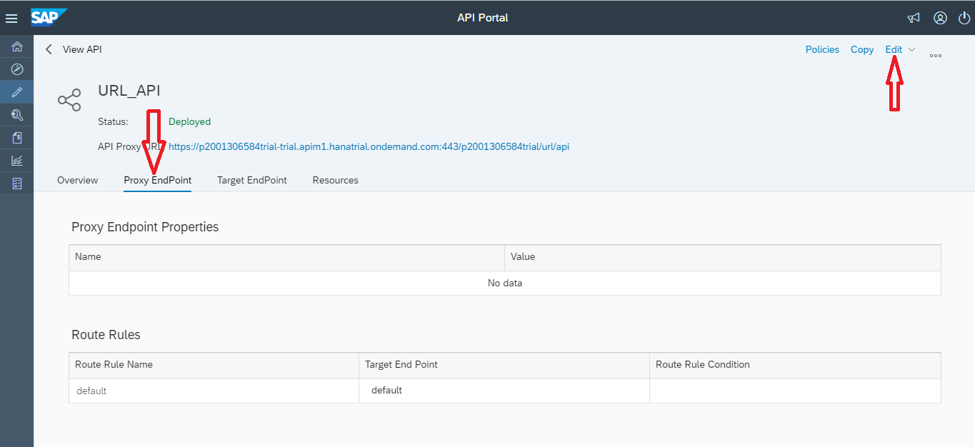

*Figure 66: Adding Proxy Endpoint*

* Select the Add option, two fields appear after selecting this. Fill up the required name and value for the Proxy.

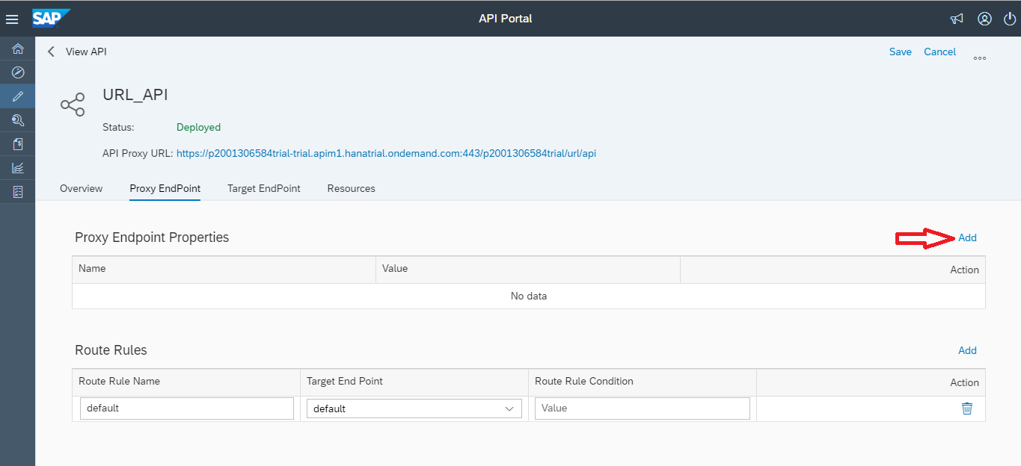

*Figure 67 : Adding Proxyendpoint*

* After adding you can update the API by saving it. Route rules can also be added, this is shown in the below step.

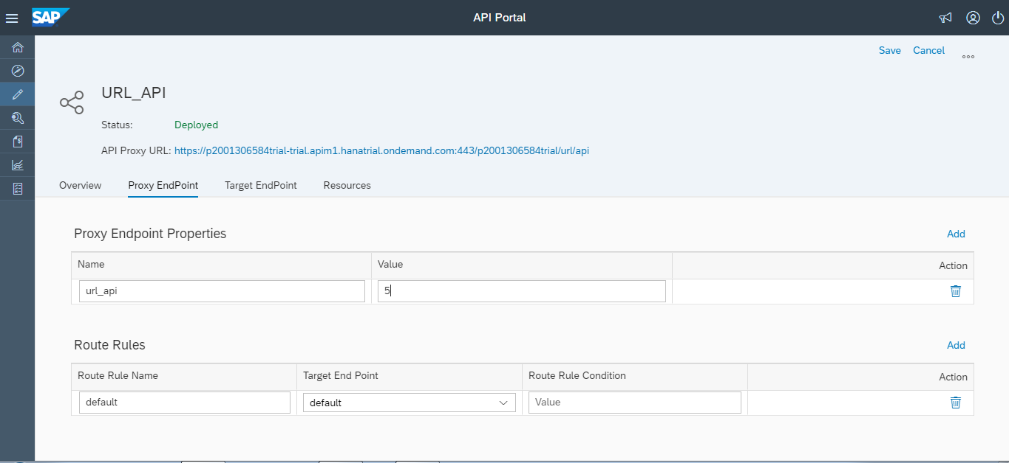

*Figure 68: Added Proxyendpoint*

**Route Rule**:

A route determines the path of a request from the Proxy Endpoint to the Target Endpoint. Included in the route is the URL used to access the API Proxy Endpoint and the URL of the backend service defined by the Target Endpoint.

* If you want to define multiple route rules, navigate to Proxy Endpoint tab. In the Route Rules section, choose Add.
* It is default in the beginning you can add multiple rules, fill up the name of the route rule and the target endpoint to which it should get routed.
* After adding the required fields you can update the API by saving it.

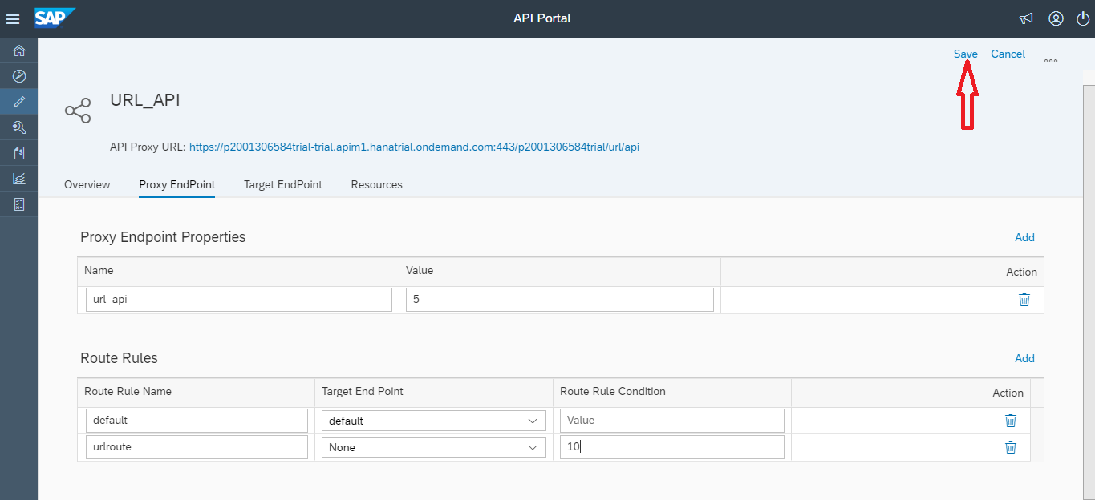

*Figure 69: Saving API*

Note:

You can also have an empty route, which means you do not define a Target Endpoint. You can define such routes when you do not want to forward the request message to any Target Endpoint. For example, flows that generate OAuth token.

* The API gets updated with the proxy endpoint and route rule.

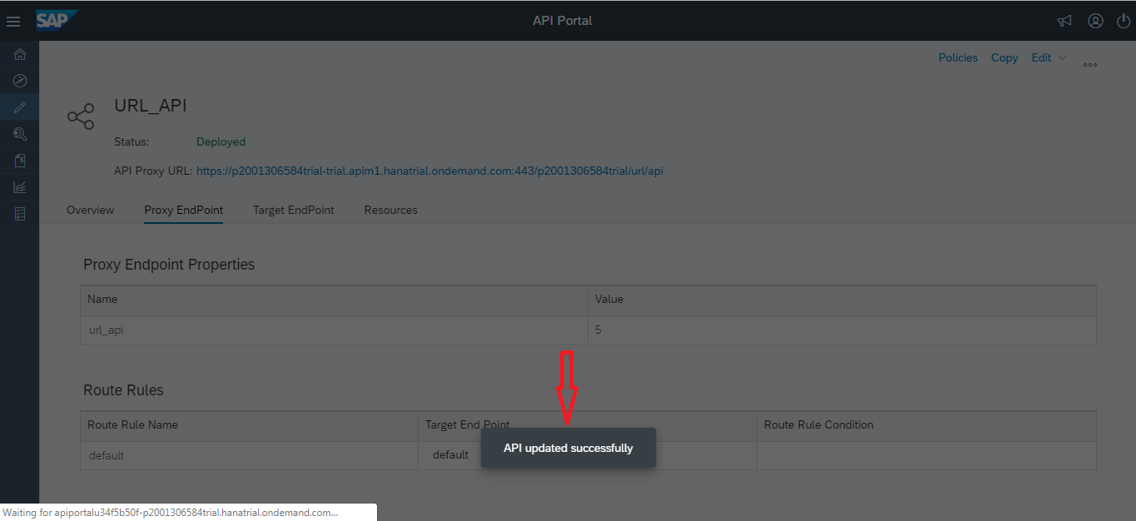

*Figure 70: Updating API*

* + 1. **Adding Target Endpoint**

The Target endpoint defines the outbound connections for an API Proxy. The main purpose of this object is to manage interactions to the actual backend service endpoint on behalf of consumer applications. An API Proxy can contain zero or many target endpoints.

* If you want to define multiple target endpoints, navigate to Target Endpoint tab and select Edit option. In the Target Endpoint Properties section, choose **Add**.

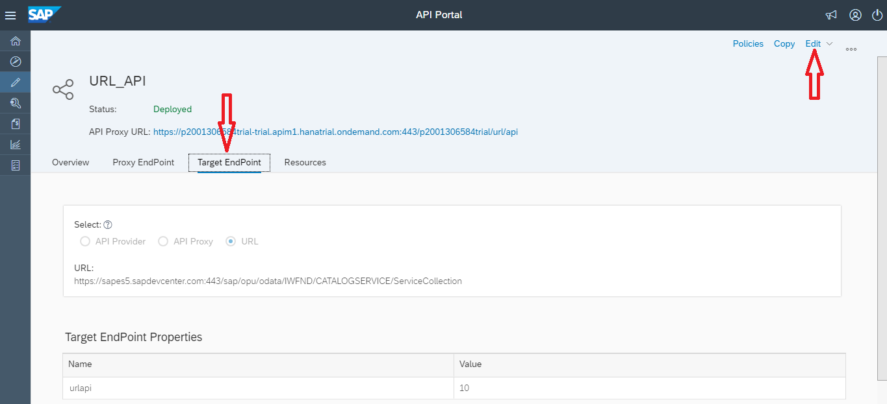

*Figure 71: Adding Target Endpoint*

* After adding the required fields you can update the API by saving it.

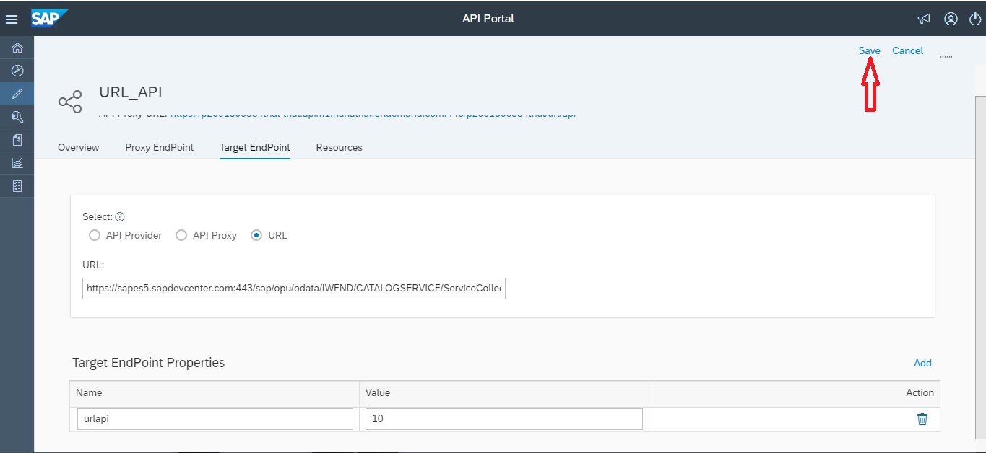

*Figure 72: Saving the API*

* 1. **Policy**

Policies are applied to an API Proxy to customize its behavior. These are preprocessing steps which are run on the SAP API Management layer and not on backend services.

Policies can be broadly classified into following four categories:

* Traffic Management Policies
* Mediation Policies
* Security Policies
* Custom Policies

For further learning you can refer this link. [Click Here](https://blogs.sap.com/2016/02/19/sap-api-management-policy-management/)

When a policy is added to an API Proxy, then it is added to a specific flow which defines when the policy is executed. Each request and response path in a proxy endpoint and target endpoint defines the following flows:

* Pre Flow:

Always executes before any other flows.

The policies defined in the pre flow are applied to every message that passes through an endpoint.

* **Conditional Flows:**

Execute only when a conditional statement defined for the Flow evaluates to true.

An endpoint can define any number of conditional Flows, but only the first conditional Flow whose condition evaluates to true executes. That means the policies attached to the conditional Flow only execute when the conditional Flow executes.

* **Post Flow:**

Always executes after all other Flows.

Like Pre Flow, the policies defined in the Post Flow are applied to every message.

For further understanding on flow of an API Policy you can refer this link. [Click Here](https://blogs.sap.com/2016/06/22/part-7-understanding-api-policy-flow-routing/)

* + 1. **Create Policy**
* Let’s add a policy to an API Proxy.
* To start with, login to SAP API Management’s API Portal.
* Create an API Proxy from API Portal.

### Spike Arrest Policy

### IP Whitelisting Policy

### Verify API Key Policy

The Verify API Key policy lets you enforce verification of API keys at runtime, letting only apps with approved API keys access your APIs. This policy ensures that API keys are valid, have not been revoked, and are approved to consume the specific resources associated with your API products.

* To add the **Verify API Key Policy**, following the steps mentioned below:
* To start with the policy creation we need to open the API Proxy created. Then navigate to the policy window.

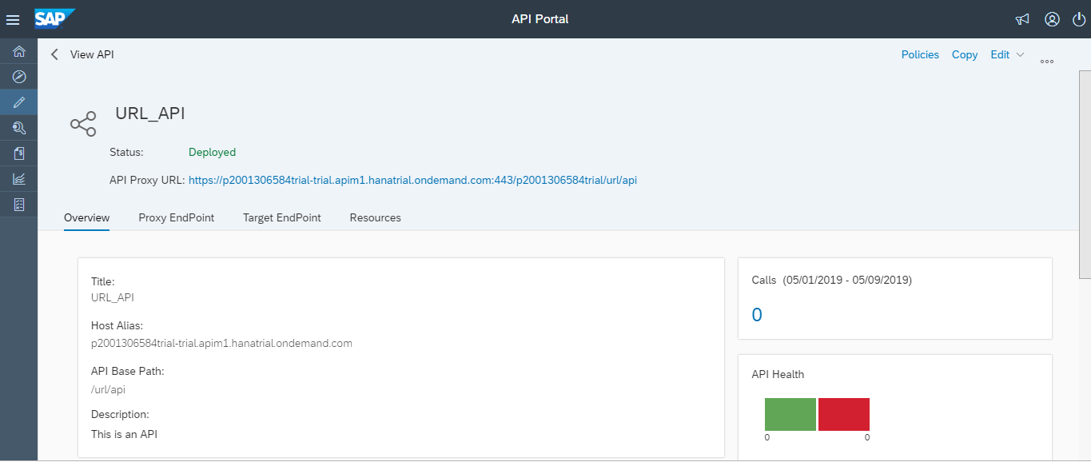

*Figure 73: Creating Policy in API*

* To navigate to the policy window click on the Policies option present on top right of the API window.

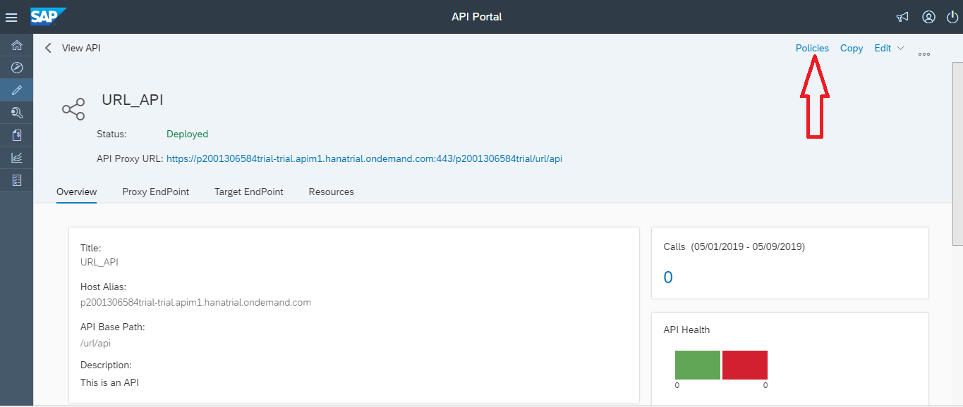

*Figure 74: Creating Policy in API*

* To add the Policies click the edit option present on right top of the window.
* While creating an API Proxy, choose Policies on the details screen.
* Select a Flow on which you want to apply the policy.

Note:

Flows are available in the top left section of the Policy Designer. You can select an existing flow or create a conditional Flow. To create a conditional Flow, choose the icon + beside the Proxy Endpoint or Target Endpoint depending on which endpoint you want to assign the policy. Enter a name for the conditional Flow.

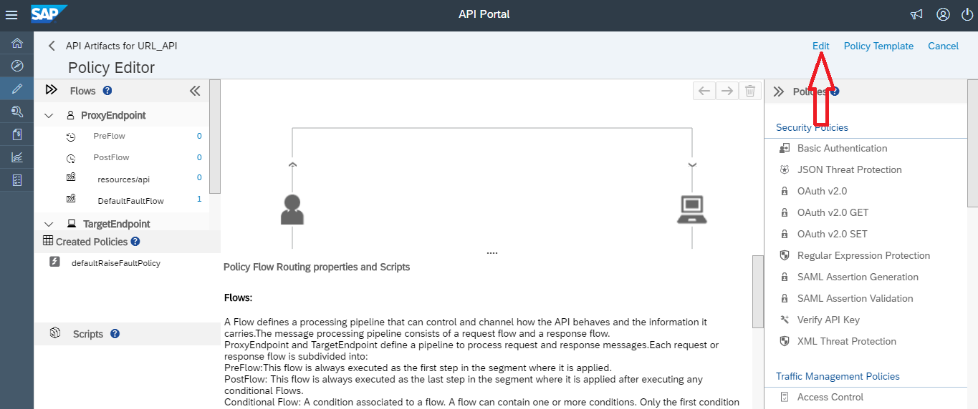

*Figure 75: Creating Policy in API*

When deciding where to add logic, you'll first choose whether to add it to a proxy endpoint or target endpoint. An API proxy divides its code between code that interacts with the proxy's client (proxy endpoint) and optional code that interacts with the proxy's backend target, if any (target endpoint).

You configure flow with XML that specifies what should happen and in what order. The following illustration shows how flows are ordered sequentially within a proxy endpoint and target endpoint:

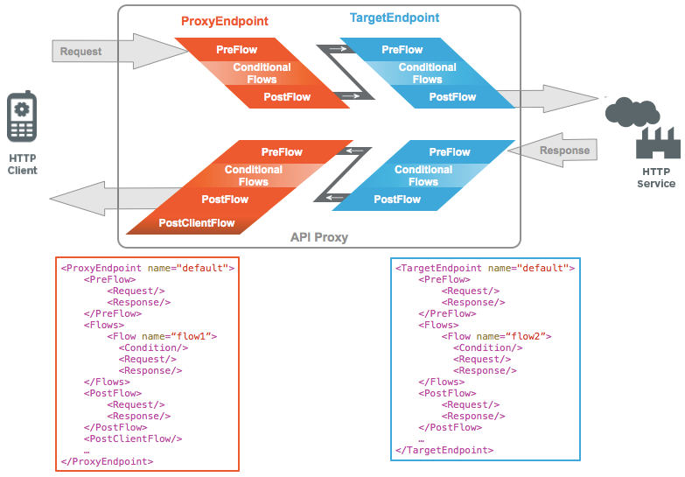

|  |  |
| --- | --- |
| **Field** | **Description** |
| Flow Type | PreFlow: Useful when you need to make sure that certain code executes before anything else happens. If the PreFlow is in a target endpoint, it executes after the proxy endpoint's PostFlow.  PostFlow: A good place to need to log data, send a notification that something happened while processing the request, and so on. Executes after conditional flows and PreFlow. If the PostFlow is in a proxy endpoint, and there's a target endpoint, the proxy endpoint PostFlow executes before the target endpoint PreFlow. |
| Policy Name | Unique name for the policy. The policy name matches the display name with the following exceptions:   * Spaces are replaced by dashes. * Consecutive dashes are replaced by a single dash. * Except for dashes, underscores, and spaces (which are replaced, as noted above), characters that are not alphanumeric, such as pound signs, percent signs, ampersands, and so on, are removed. |
| Stream | API Proxy Endpoint   * Incoming request – Requests from external source (User application, B2B resource, etc.) to the API Proxy residing on SAP API Management * Outgoing response – Data request sent from API Proxy residing on SAP API Management to original request source.   Target Endpoint   * Incoming request – Requests from API Proxy on SAP API management to Target Endpoint * Outgoing response – Data response from Target endpoint to API Proxy on SAP API management, in response to request received from API Proxy. |
| Policy Types | JSONThreatProtection policy: The JSONThreatProtection policy minimizes the risk posed by attacks by enabling you to specify limits on various JSON structures, such as arrays and strings.  VerifyApiKey policy: By applying a policy of the type VerifyApiKey, you can enforce verification of API keys at runtime.  GetOauthV2Info policy: The GetOauthV2Info policy type enables you to get attributes of tokens and to make them available to policies and code executing in an API proxy.  OAuthV2 policy: SAP API Management provides a policy type that enables you to configure OAuth 2.0 authorization for your APIs.  RegularExpressionProtection policy: The most common usage of RegularExpressionProtection is the evaluation of JSON and XML payloads for malicious content.  XMLThreatProtection policy: SAP API Management enables you to enforce XMLThreatProtection policies that address XML vulnerabilities and minimize attacks on your API.  SAMLAssertion policy: The SAML policy type enables API proxies to validate SAML assertions that are attached to inbound SOAP requests.  Basic Authentication policy: The Basic Authentication policy type enables you to use the lightweight Basic Authentication for last-mile security. |
| Endpoint Type | Proxy Endpoint: Contains the API proxy flows closest to the client. Provides places for logic to act first on the request from the client, then last on the response to the client.  Target Endpoint: Contains the API proxy flows closest to the backend resource. Provides places for logic to prepare a request for, then handle the response from, a backend resource. |

* Click on PreFlow (in left panel) and then click on Verify API Key among the list of policies (on right side panel).

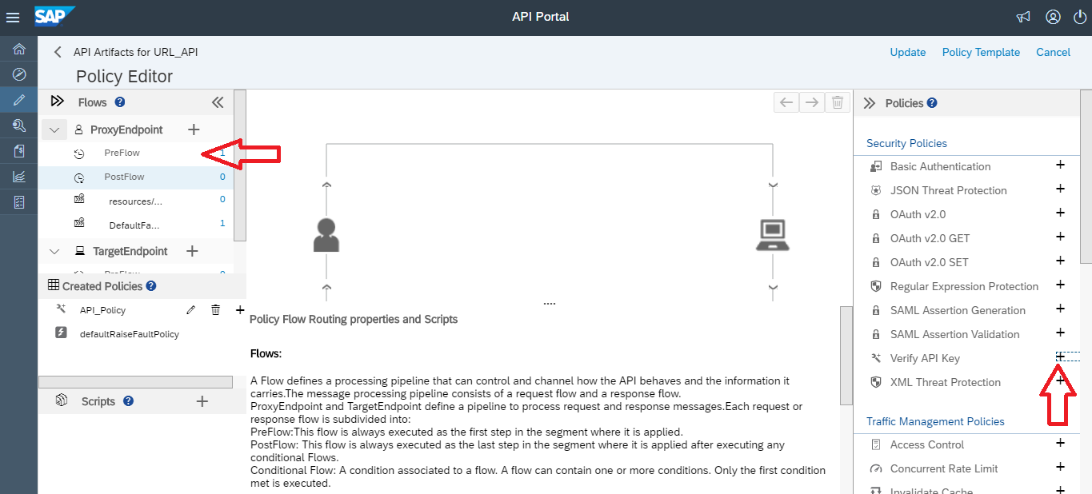

*Figure 76: Creating Policy in API*

* In the Create Policy pop-up, enter a name for your policy.
* From the Stream drop-down, select the processing pipeline where this policy should be assigned.

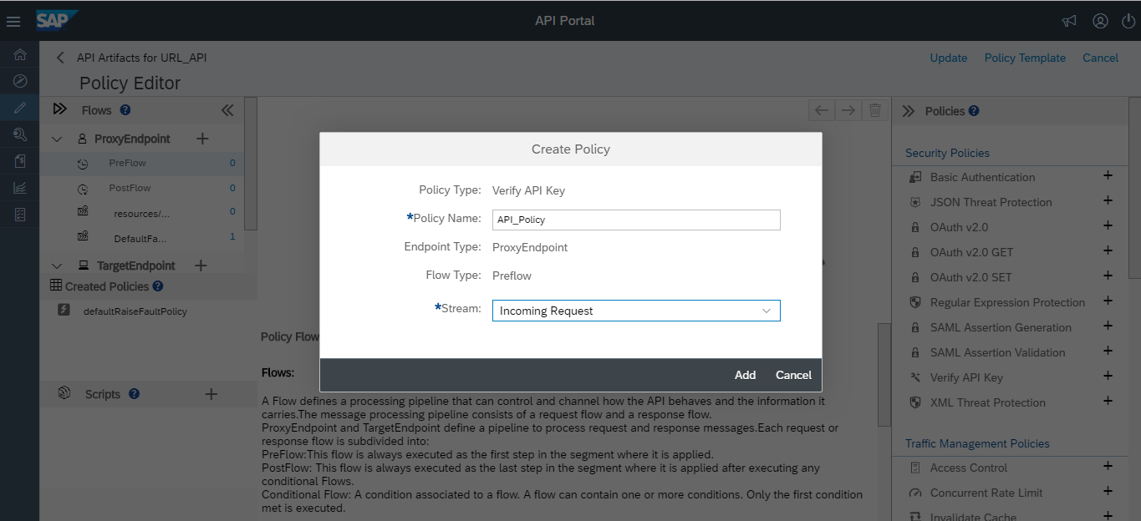

*Figure 77: Creating Policy in API*

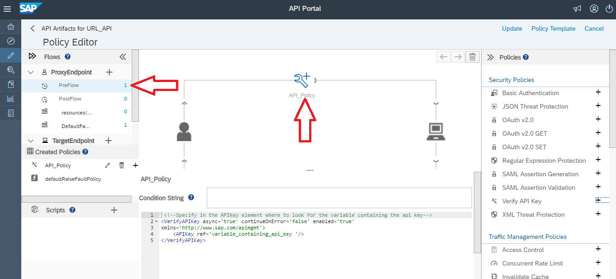

*Figure 78: Creating Policy in API*

Then update the policy by clicking Update.

* The API Key ref is the key which is used while consuming this API.
* Since, the key is saved as request header, so the while consuming, this key is to be passed as request header.
* Refer [here](https://help.hana.ondemand.com/apim_od/frameset.htm?4d15a0427494452dbb42a319e9bb420f.html) for more details

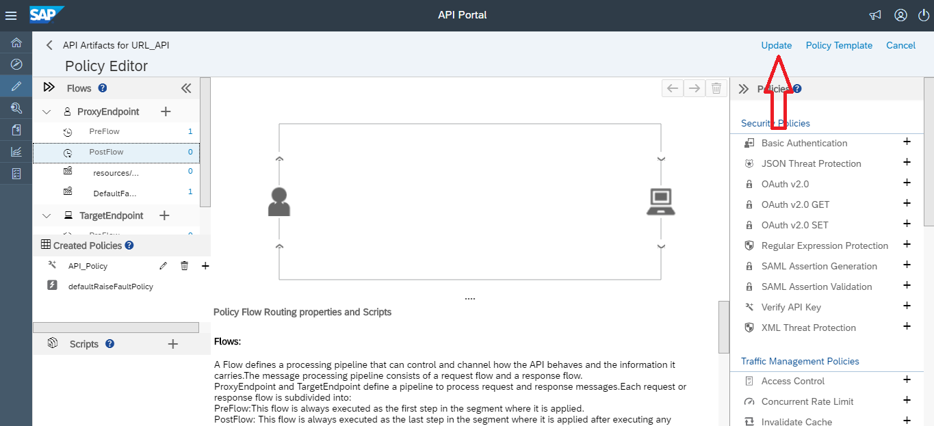

*Figure 79: Update Policy in API*

* Then the API Proxy will be updated with newly added policy; and then Click Save
* The API Proxy will be updated successfully

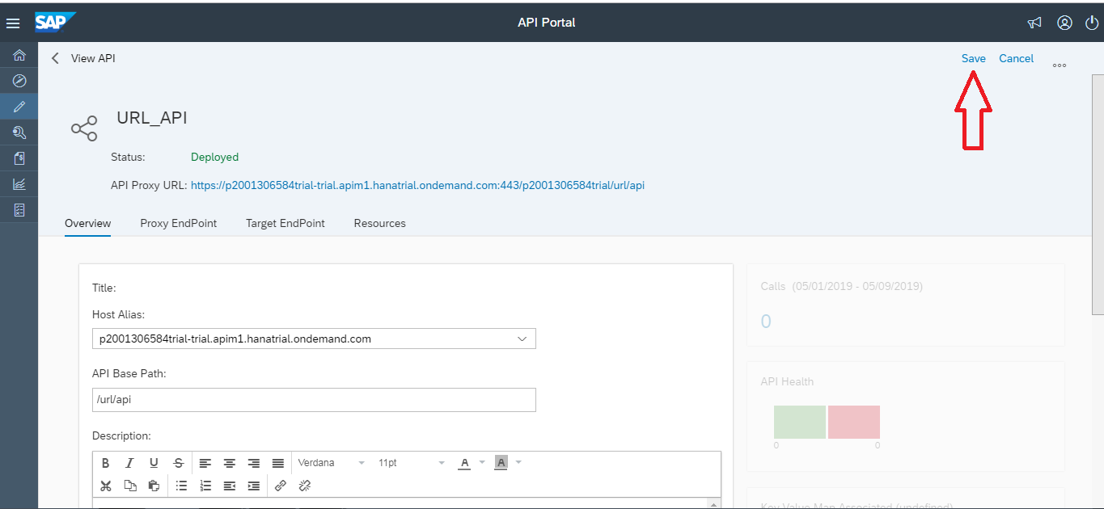

*Figure 80: Save changes*

* Go to Test console in the API Portal to test the API

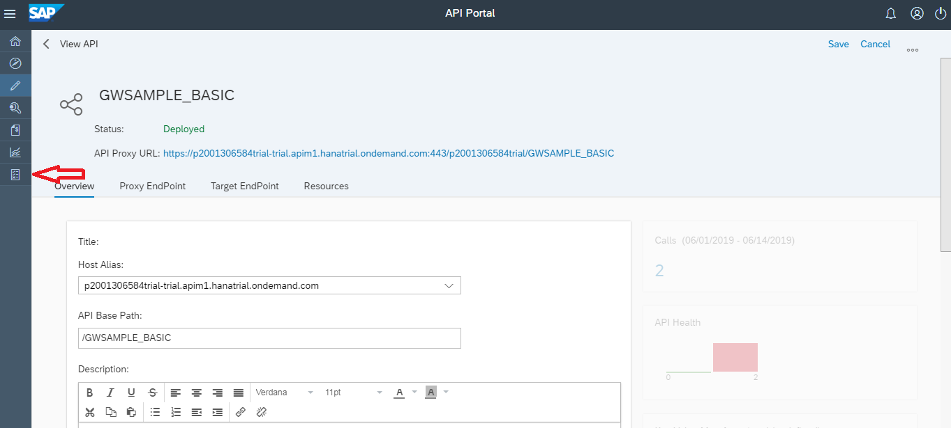

* Choose the API which has to be tested. Set the authentication has none.

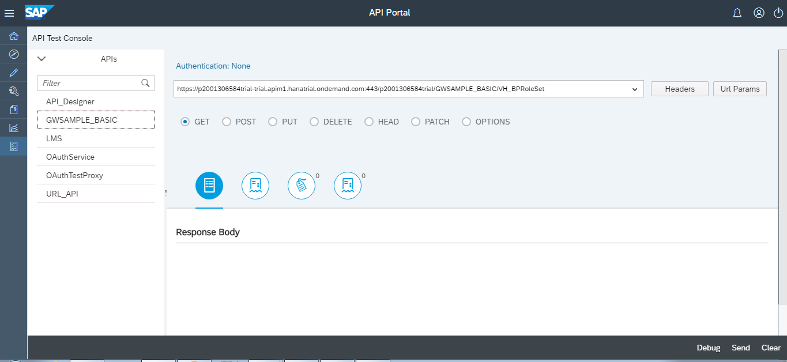

* After selecting the API hit the URL by selecting the send button after selecting the correct method.
* As we have secured the URL with Verify API Key policy we must get the following response in respone body.

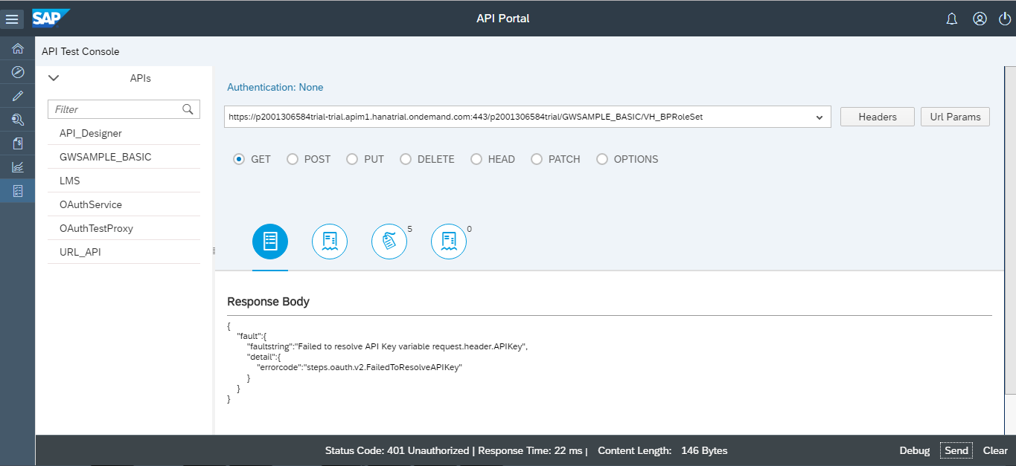

* Create a product and add this API to the product. For creating a product refer section 3.8.
* After creating the product consume the API in developer portal. For consumption of the product refer section 3.9.
* After doing the above steps, come back to the Test console in API Portal. Select the authentication as Basic Auth.

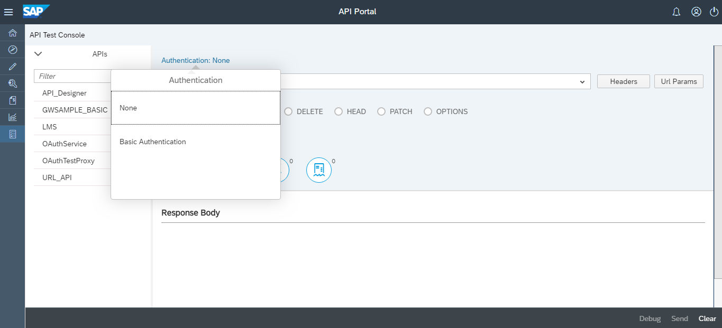

* Give the gateway credentials and log in.

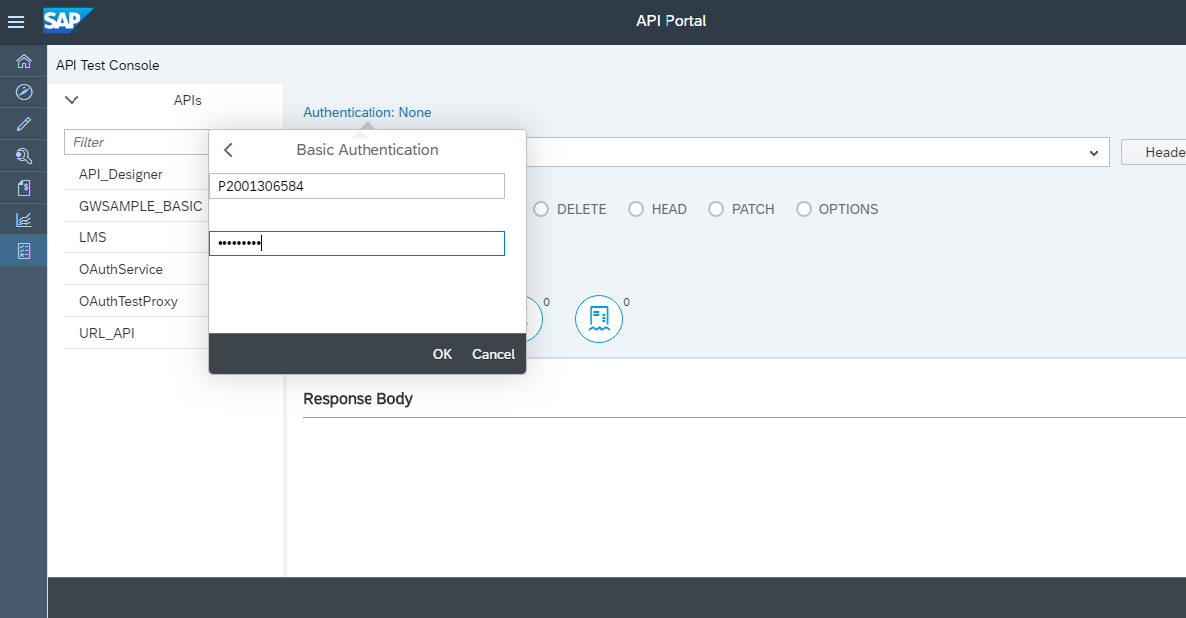

* After logging again select the API and add header to it. In the value of header give it as APIKEY and the value should be the Application ID acquired after consuming in develop portal.
* After giving the header hit the URL. The status code should be 200 and there should a response body.

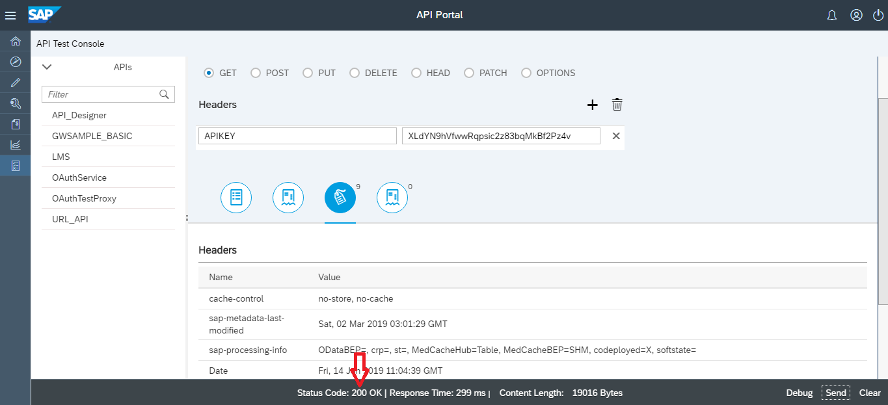

* This way we can secure the API using Verify API Key Policy.

### Spike Arrest

The Spike Arrest policy protects against traffic spikes with the <Rate> element. This element throttles the number of requests processed by an API proxy and sent to a backend, protecting against performance lags and downtime.

* To add the **Spike Arrest Policy**, follow the steps mentioned below:
* To start with the policy creation we need to open the API Proxy created. Then navigate to the policy window.
* To navigate to the policy window click on the Policies option present on top right of the API window.

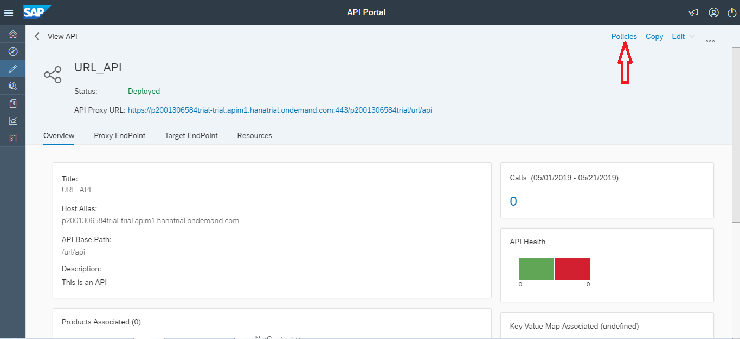

*Figure 87: API details*

* To add the Policies click the edit option present on right top of the window.
* While creating an API Proxy, choose Policies on the details screen.
* Select a Flow on which you want to apply the policy.
* We have chosen Preflow in creating Spike Arrest policy.

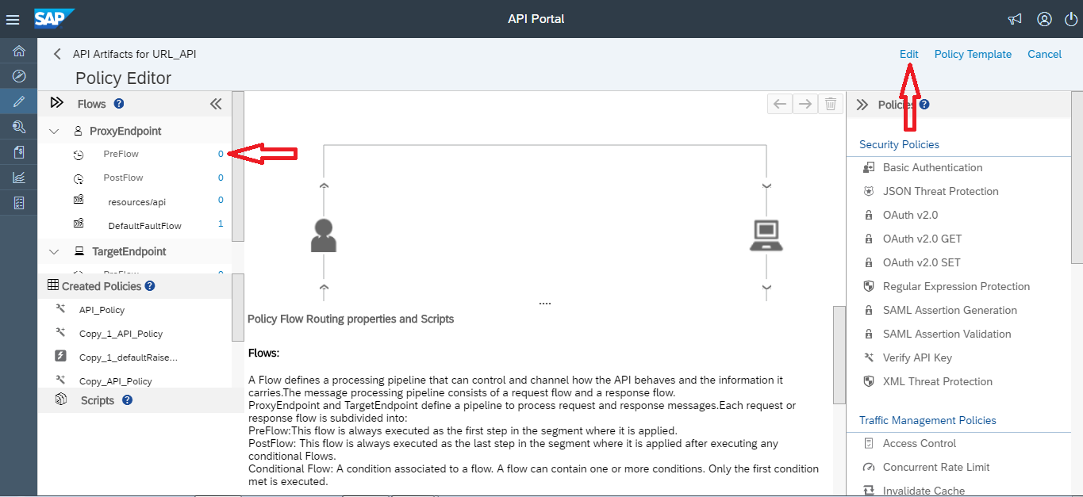

*Figure 88: Policy creation*

* Select **Spike Arrest** in the Traffic Management category. The New Policy dialog appears.

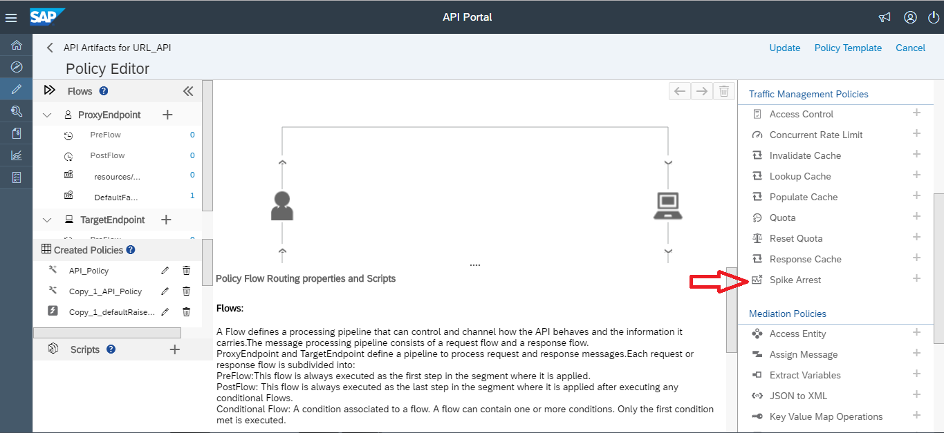

*Figure 89: Selecting Spike Arrest*

* We can name the policy as per the field description present in the 3.4.1.1 section.

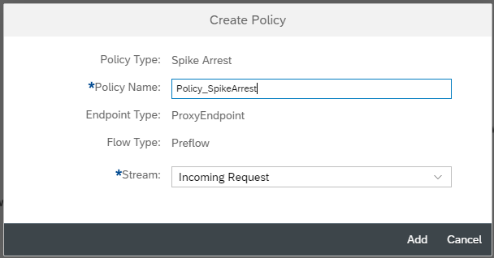

*Figure 90: Naming API Policy*

* You can see the policy gets created. We can update the API by choosing update option.

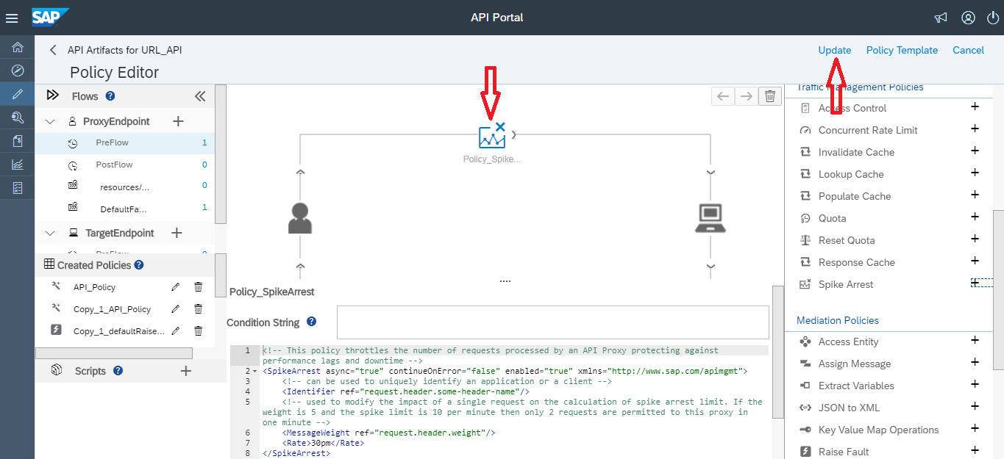

*Figure 91: Viewing Policy*

* You can specify the rate as an integer value per minute (pm) or per second (ps). This is a very low limit and is used only for this tutorial to demonstrate the policy. Typically, you set it to a much higher limit.
* Notice that the Rate value in the Property Inspector also changes to 1pm. Alternatively, you can change the Rate value in the Property Inspector and it will be reflected in the XML view.
* Click Save to save the current revision with your changes and the API policy gets created.

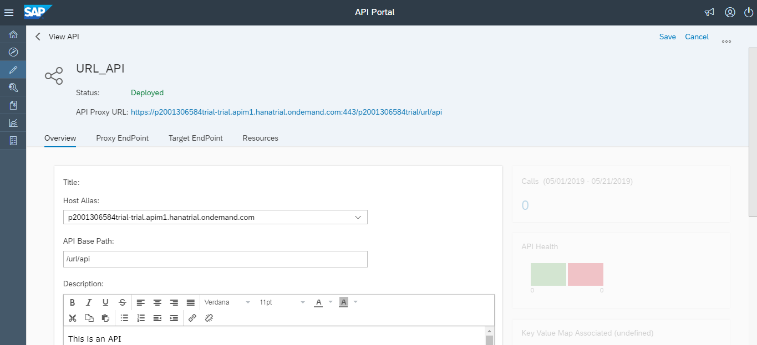

*Figure 92: Saving Policy*

### OAuth 2.0

[OAuth 2.0](https://oauth.net/2/) is a protocol that allows a user to grant limited access to their resources on one site, to another site, without having to expose their credential.

* To start with the policy creation we need to open the API Proxy created. Then navigate to the policy window.
* To navigate to the policy window click on the Policies option present on top right of the API window.

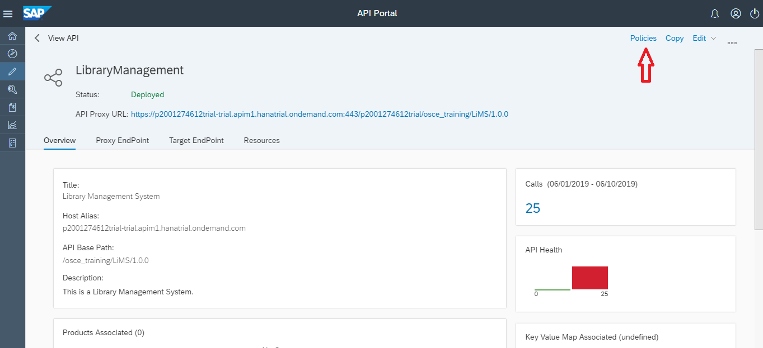

*Figure 93:Selecting Policies*

* To add the Policies click the edit option present on right top of the window.
* While creating an API Proxy, choose Policies on the details screen.
* Select a Flow on which you want to apply the policy.
* We have chosen Preflow in creating OAuth v2.0 policy.

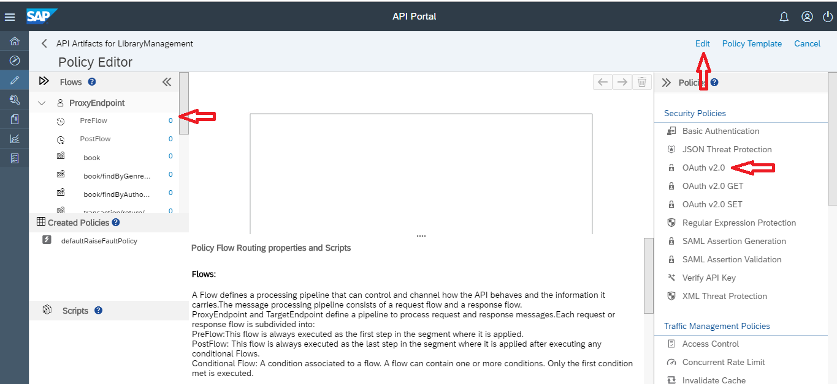

*Figure 94:Selecting Policy*

* We can name the policy as per the field description present in the 3.4.1.1 section.

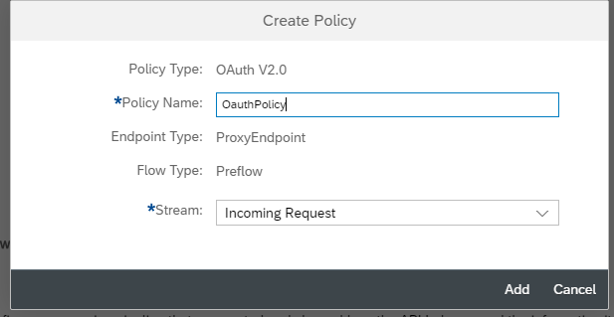

*Figure 95:Creating Policy*

* You can see the policy gets created. We can update the API by choosing update option.

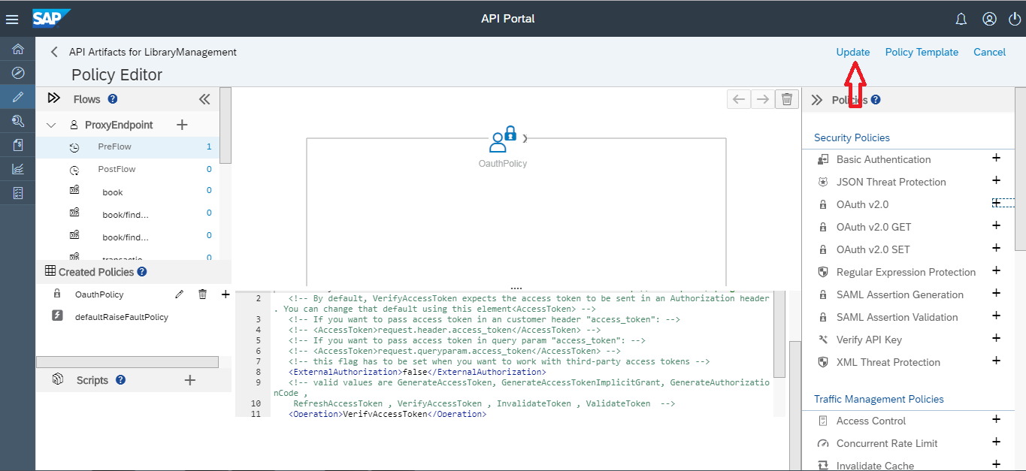

*Figure 96:Creating Policy*

* Click Save to save the current revision with your changes and the API policy gets created.

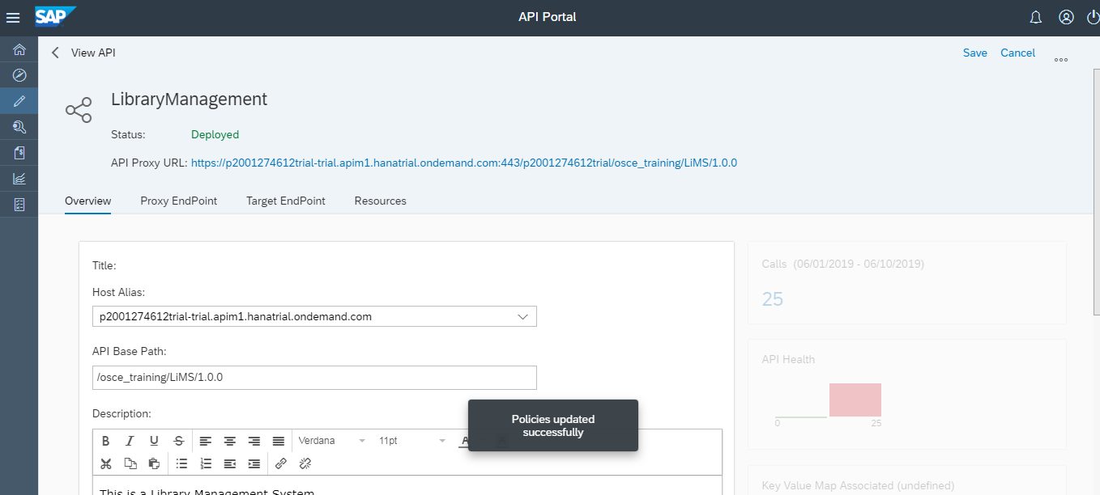

*Figure 97:Updating Policy*

* Go to the main page of your subaccount in the SAP Cloud Platform cockpit and choose Security → OAuth.

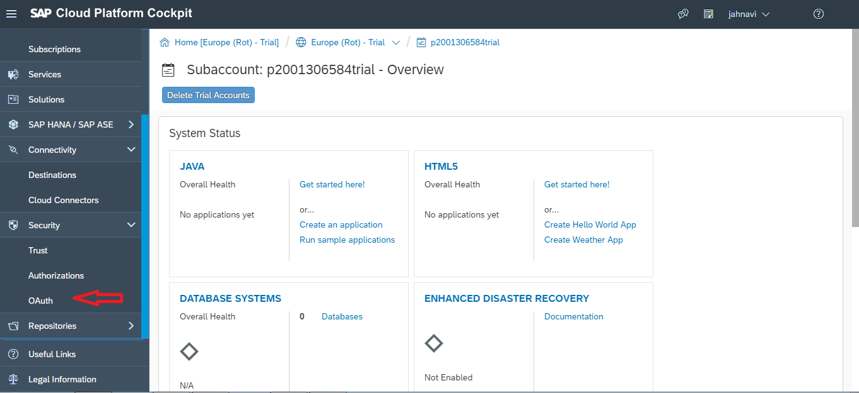

*Figure 98:Creating Client*

* Go to the Clients tab. Here you can register new clients that are authorized to use the SAP.

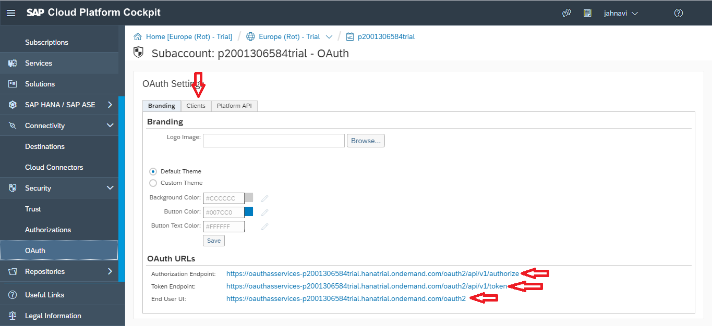

*Figure 99:Creating Client*

* Press the button Register New Client.

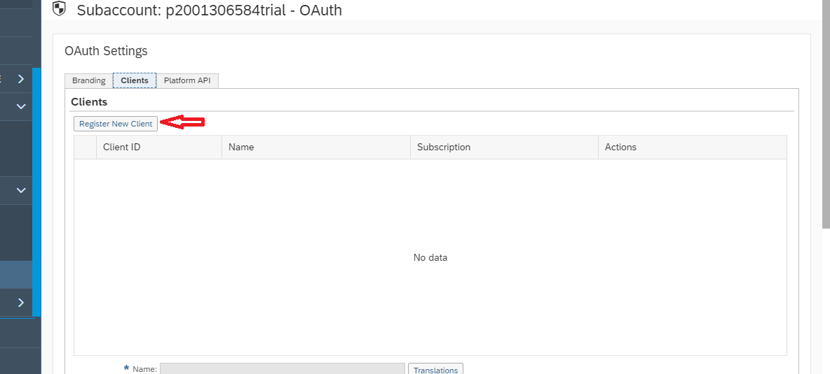

*Figure 100:Creating Client*

* Enter <Name> and <Description> of the OAuth client used.
* For <Subscription> select the entry from the drop down list.
* In <Redirect URI>: enter the redirect URL of the OAuth client you use, e.g. https://www.getpostman.com/oauth2/callback.
* Adjust the <Token Lifetime> according to your needs.
* Press Save.

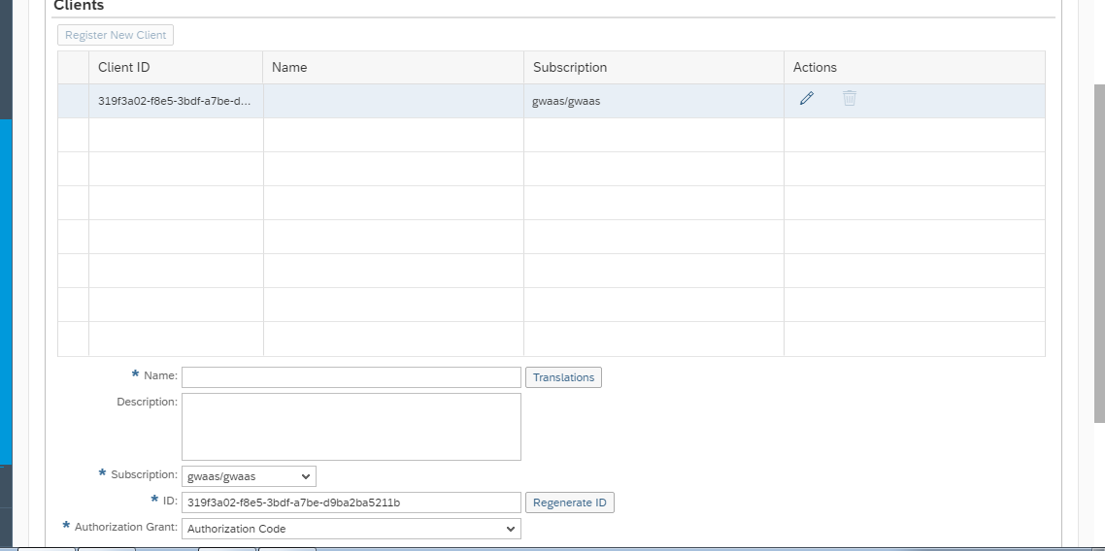

*Figure 101:Creating Client*

* The following screenshot of the SAP Cloud Platform cockpit shows the usage of *Postman* as client:

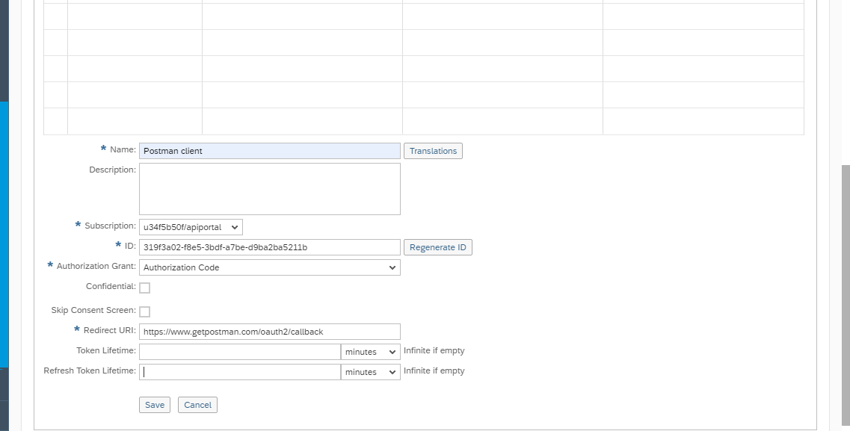

*Figure 102:Creating Client*

* In Postman, go to Authorization and select OAuth 2.0 as Type
* Make a copy of the ID. You will need it later in Postman.
* Go to the tab Branding.
* Make a copy of the URLs for *<Authorization Endpoint>* and *<Token* Endpoint>.
* You will need to enter these URLs later in your OAuth client:

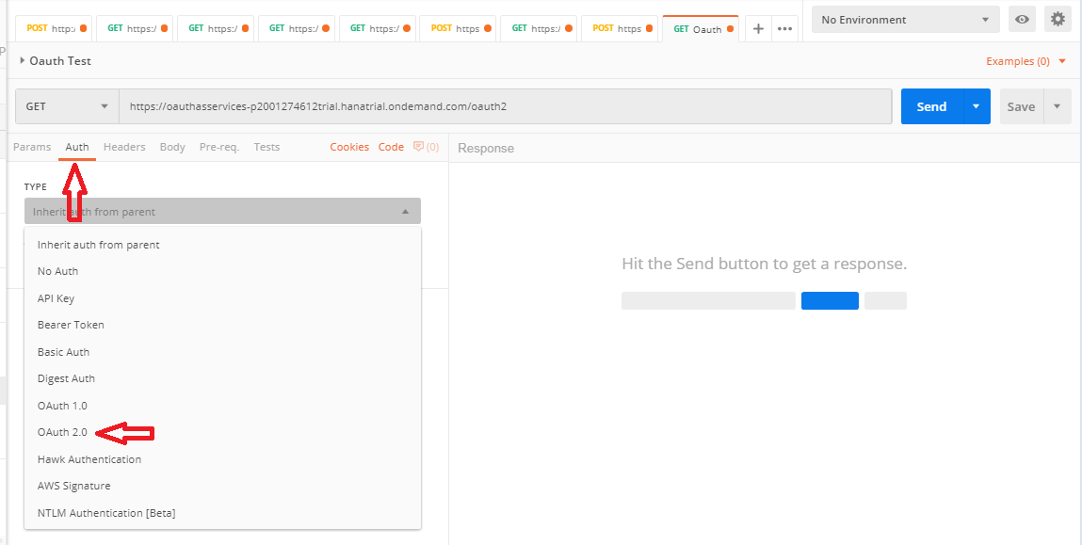

*Figure 103:Postman Authorization*

* Press button Get new Access Token

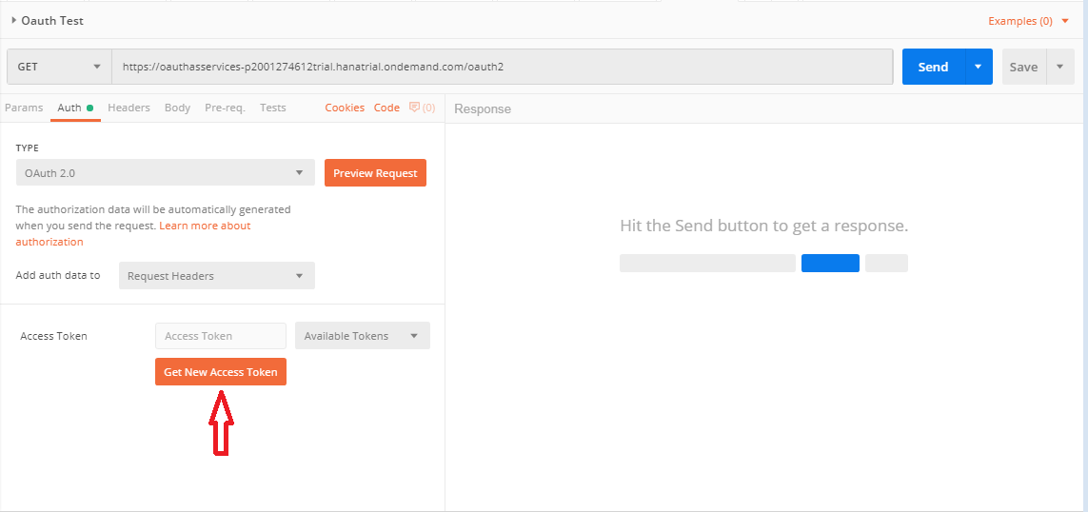

*Figure 104:Getting Access token*

* Enter any name for <Token Name>.
* In <Auth URL> enter the Authorization Endpoint URL you have copied before.
* In <Access Token URL> enter the Token Endpoint URL you have copied before.
* In <Client ID> enter the ID from the client you have registered in the SAP Cloud Platform cockpit before.
* Press the button Request Token.

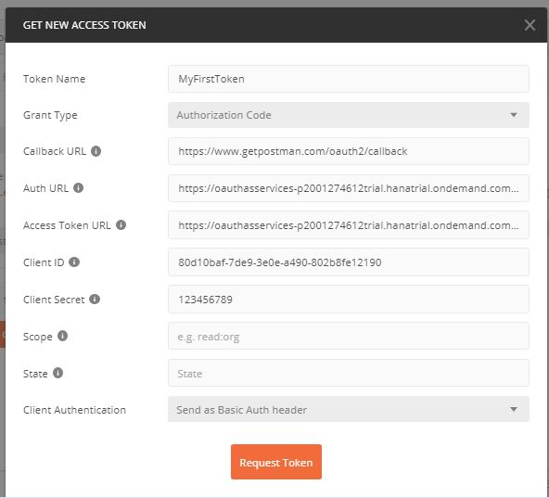

*Figure 105:Getting Access token*

* The SAP Cloud Platform Authorization Endpoint page opens. Press Authorize.

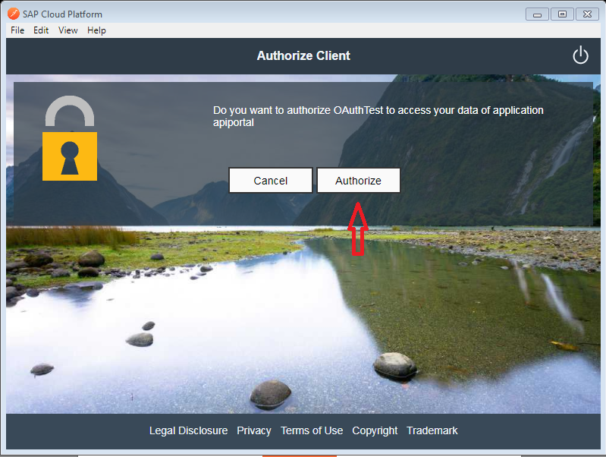

*Figure 106:Getting Access token*

* In Postman choose the newly created Token.
* Under Add token to select Header from dropdown list.
* Press the button Use Token.
* You have now created a token. Postman will use it for each request to the SAP

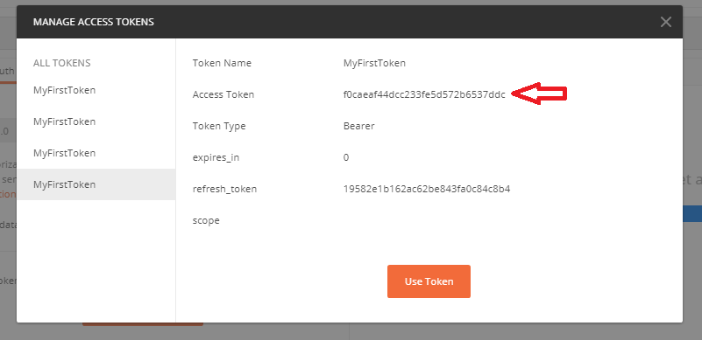

*Figure 107:Getting Access token*

* 1. **Policy Template.**

In order to simplify your life, SAP API Management now allows users to store a set of policies as templates.

That means that you can define, within SAP Management itself, a set of policies that can be re-used by you and your peers. Instead of manually creating each policy, you simply import the set of pre-configured policies into your API proxy. These policies will then automatically placed in the response or request of your existing API proxy. Note that you can also chose which policies you want to use.

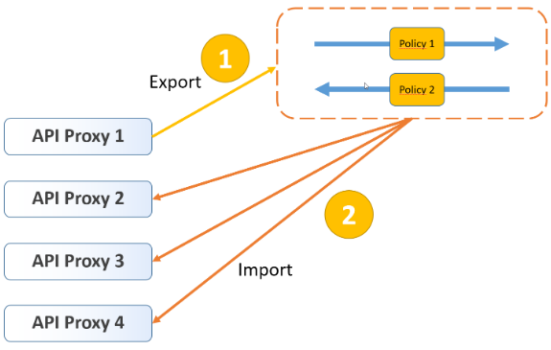

* + 1. **Create a Policy Template.**

Create a policy template using the API Portal.

* Log on to the API Portal.
* From the navigation bar, choose Develop.  
  A list of registered APIs appears in the catalog.
* In the list, click the API for which you want to create the policy template.

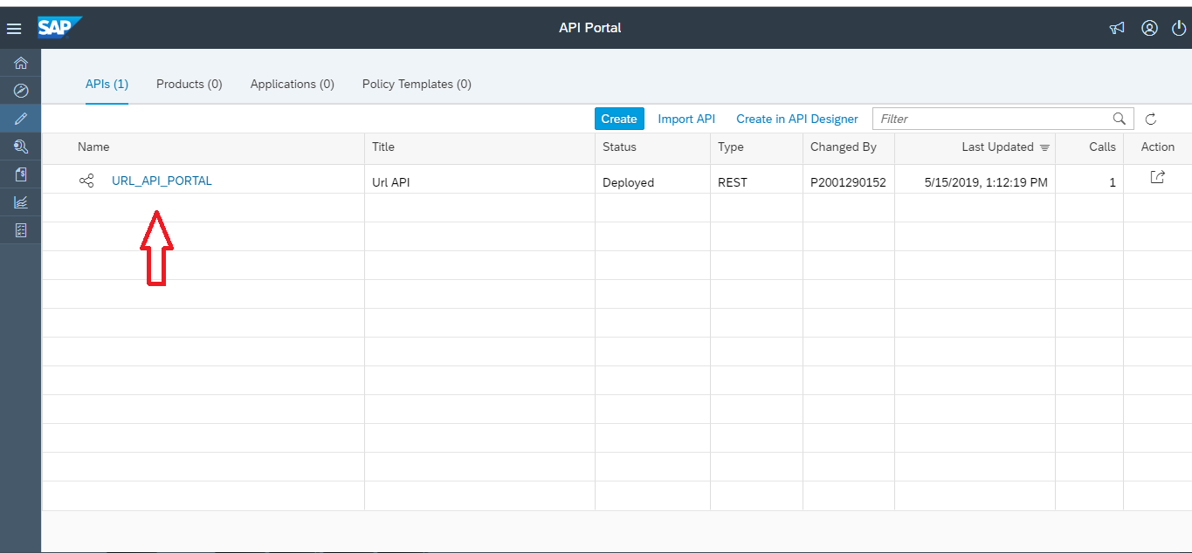

*Figure 108: Creating Policy Template*

* On the details screen, choose Policies.

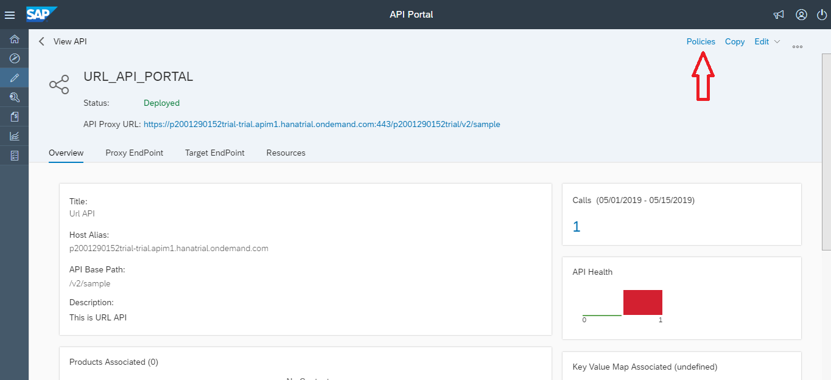

*Figure 109: Creating Policy Template*

* On the Policy Editor screen, choose Policy Template -> Create.

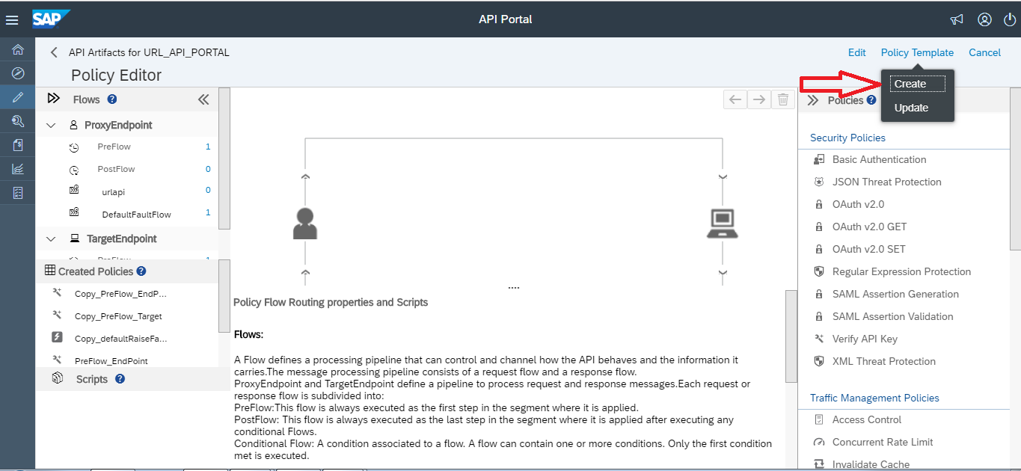

*Figure 110: Creating Policy Template*

* In the Create Policy Template window, proceed as follows:
  + Enter a name for the template in the Name field.
  + Enter a description for the template in the Description field.
  + Select the required policies from the Policies Available list.
* Choose OK.

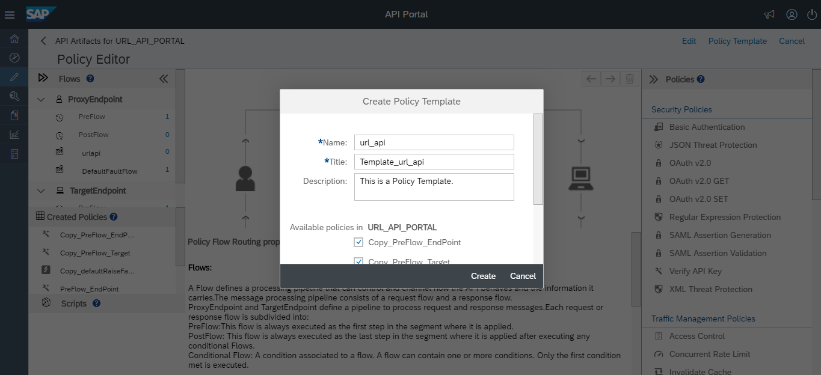

*Figure 111: Creating Policy Template*

* To view the policy template that you have just created, navigate from the API Portal home page to Develop ->Policy Templates.

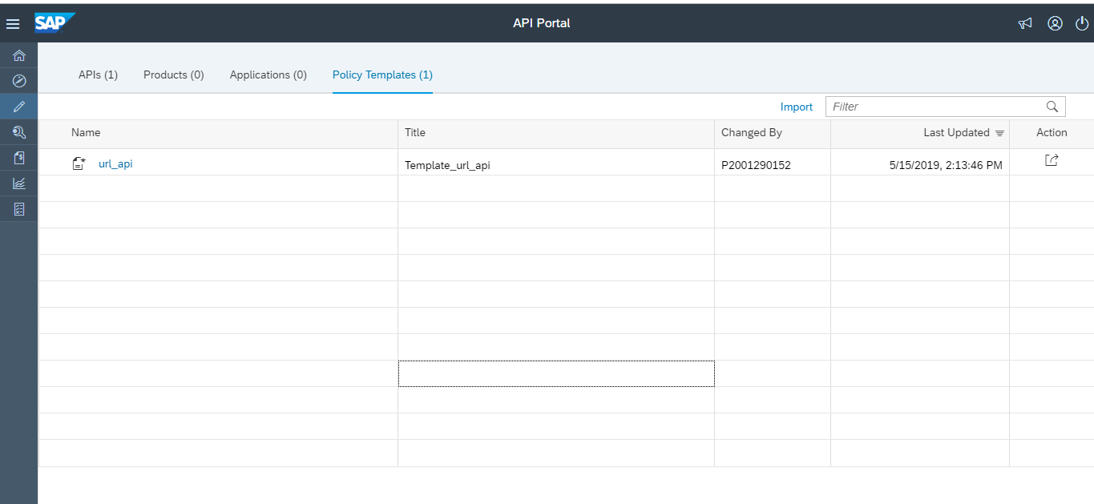

*Figure 112: Creating Policy Template*

* + 1. **Apply a Policy Template.**

Apply a policy template using the API Portal.

**Context**

You are applying a policy template and want to apply it to an API Proxy.

**Procedure**

* Log on to the API Portal.
* From the navigation bar, choose Develop.  
  A list of registered APIs appears in the catalog.
* In the list, click the API for which you want to apply the policy template.



*Figure 113: Apply Policy Template*

* On the details screen, choose Policies.



*Figure 114: Apply Policy Template*

* On the Policy Editor screen, choose Edit->Policy Template ->Apply

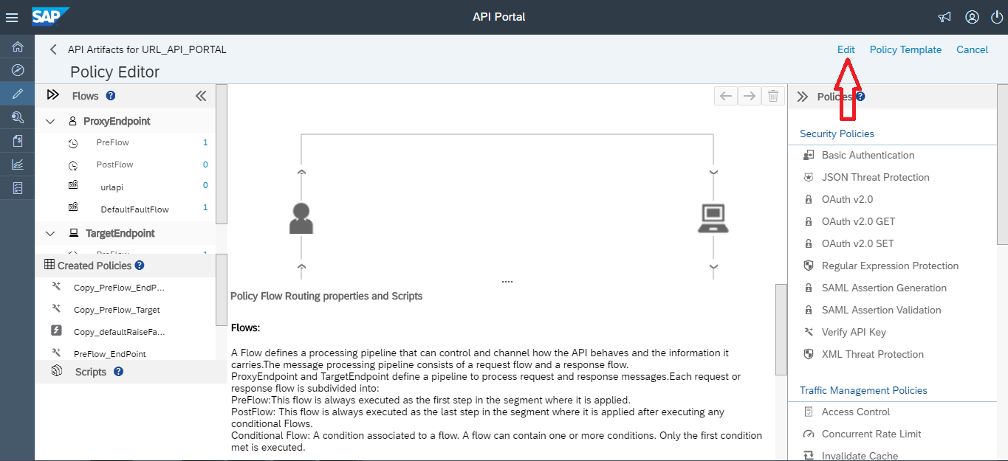  
*Figure 115: Apply Policy Template*

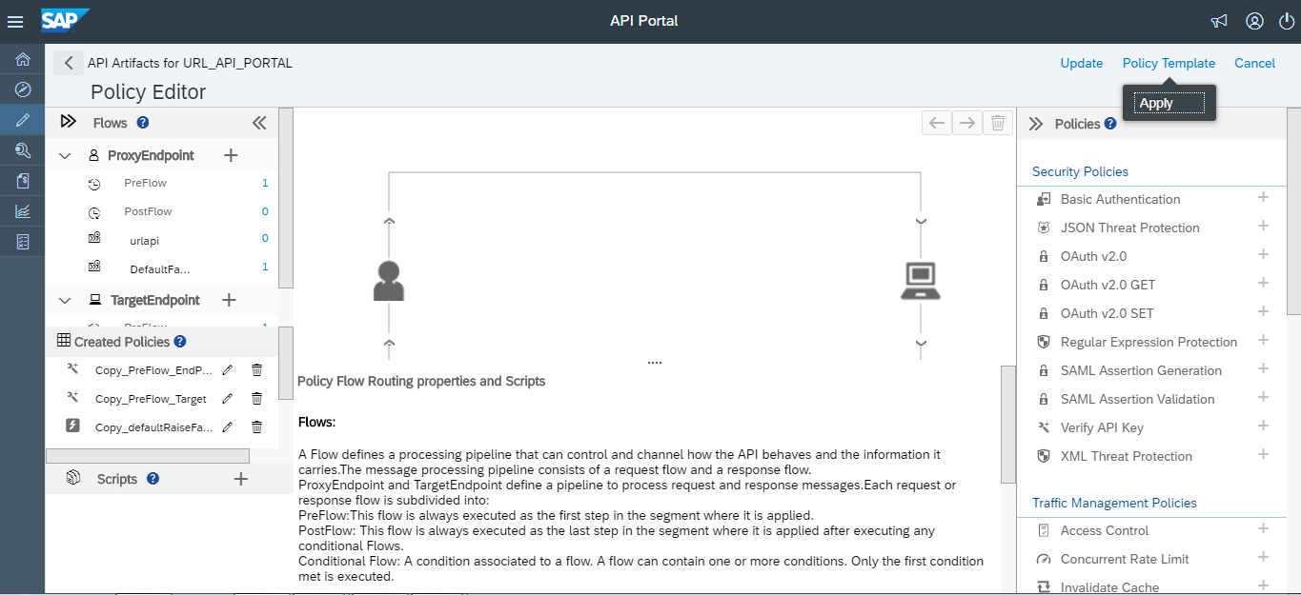

*Figure 116: Apply Policy Template*

* Select the policy templates you want to apply from the Apply Policy Template window.
* You can click a template to view all the policies available and also select the required policies in that template.
* If you want to copy only the policies and not the flows, choose Copy Only. Otherwise, choose Apply to copy both polices and flows.

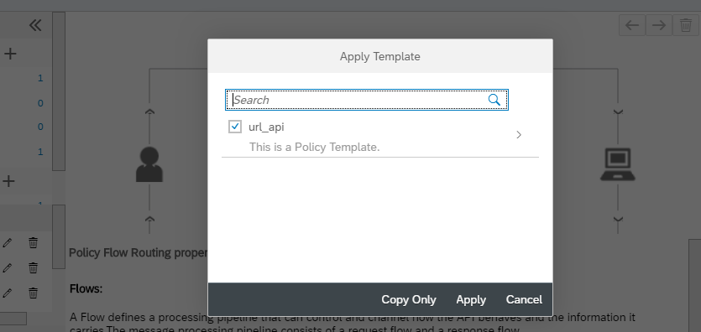

*Figure 117: Apply Policy Template*

1. Finally it will show an Applied Successfully Pop-up.

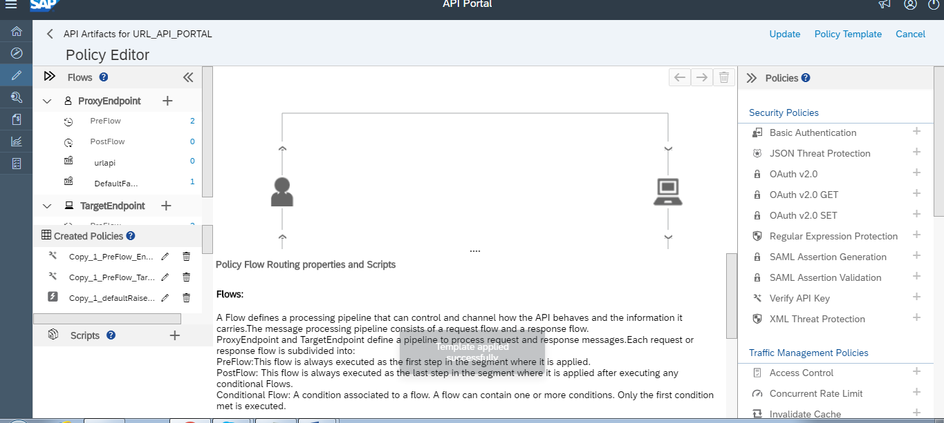

*Figure 118: Apply Policy Template*

* + 1. **Update a Policy Template.**

Update a policy template using the API Portal.

**Context**

You are updating a policy template and want to apply it to an API Proxy.

**Procedure**

1. Log on to the API Portal.
2. From the navigation bar, choose Develop.  
   A list of registered APIs appears in the catalog.
3. In the list, click the API for which you want to apply the policy template.



*Figure 119: Update Policy Template*

1. On the details screen, choose Policies.



*Figure 120: Update Policy Template*

1. In the policy editor screen, choose Policy Template -> Update.

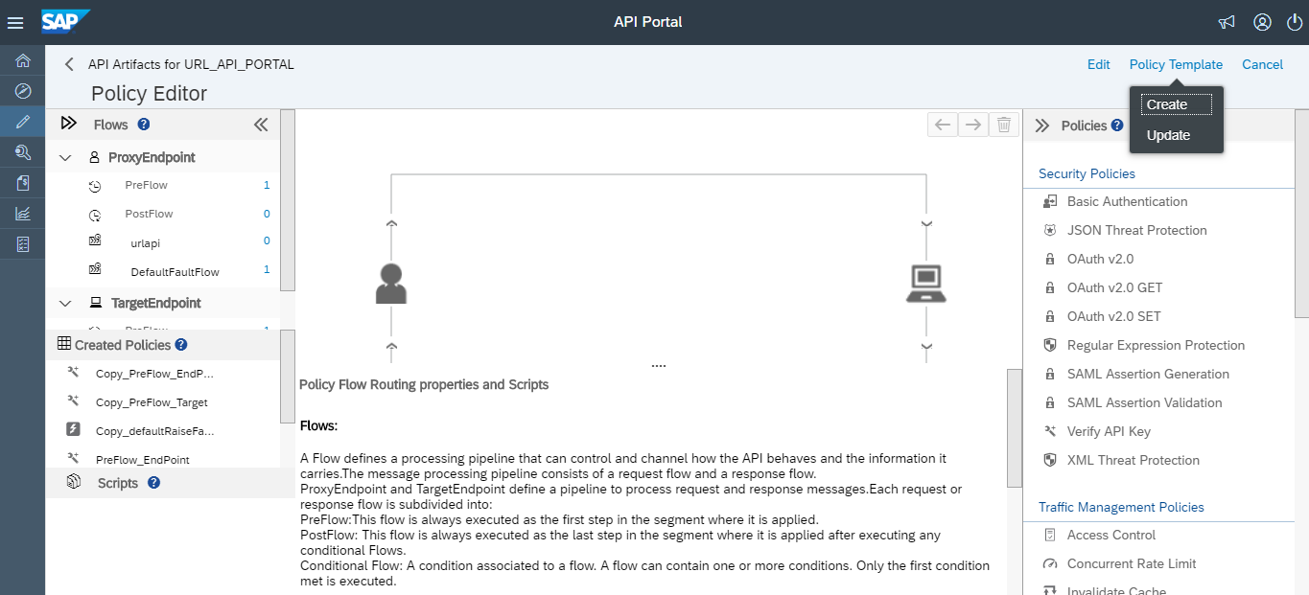

*Figure 121: Update Policy Template*

1. In the Update Policy Template window :Select the policy template that you want to update, from the Name dropdown box.
2. Choose the required policies from the list of policies available.
3. Click ok

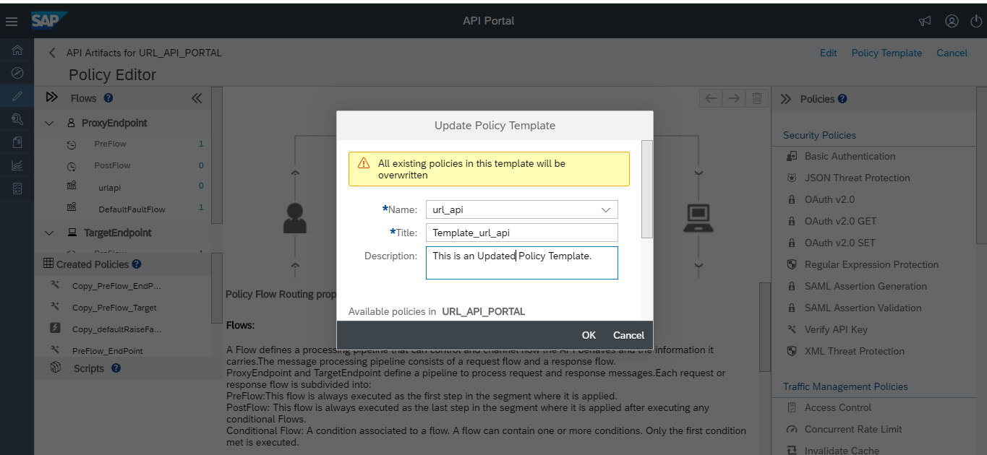

*Figure 122: Update Policy Template*

1. Finally it will show an “Updated Successfully” Pop-up.

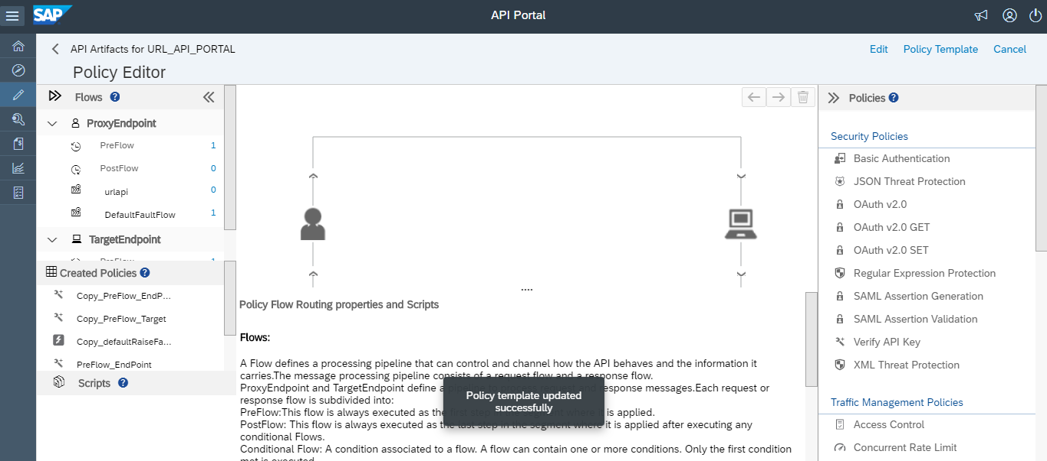

*Figure 123: Update Policy Template*

* + 1. **Import a Policy Template.**

Import a policy template using the API Portal.

**Context**

You are importing a policy template and want to apply it to an API Proxy.

**Procedure**

* Log on to the API Portal.
* From the navigation bar, choose Develop.
* On the Develop screen, choose POLICY TEMPLATES.

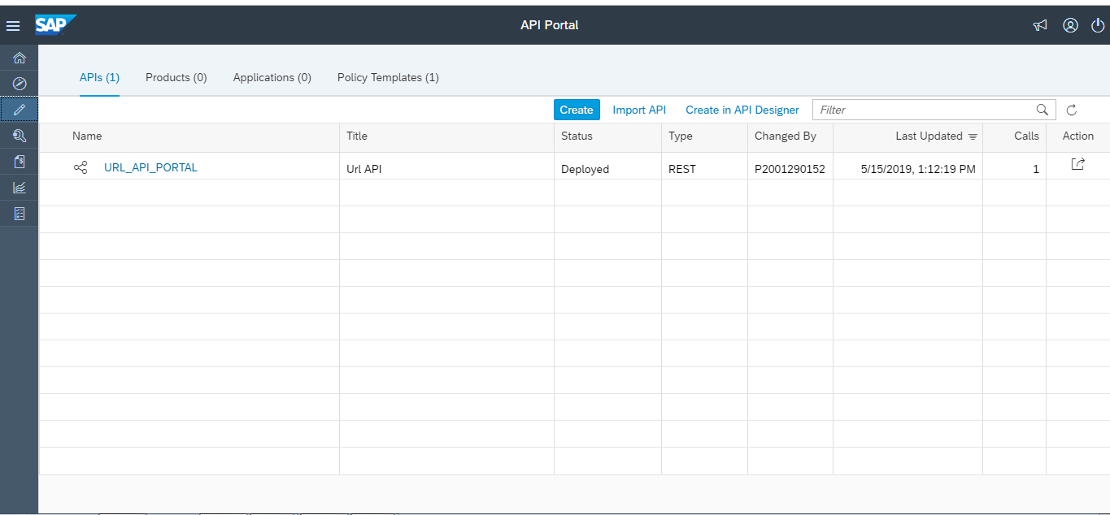

*Figure 124: Importing Policy Template*

* A list of available policy templates appears in the catalog.
* Choose Import

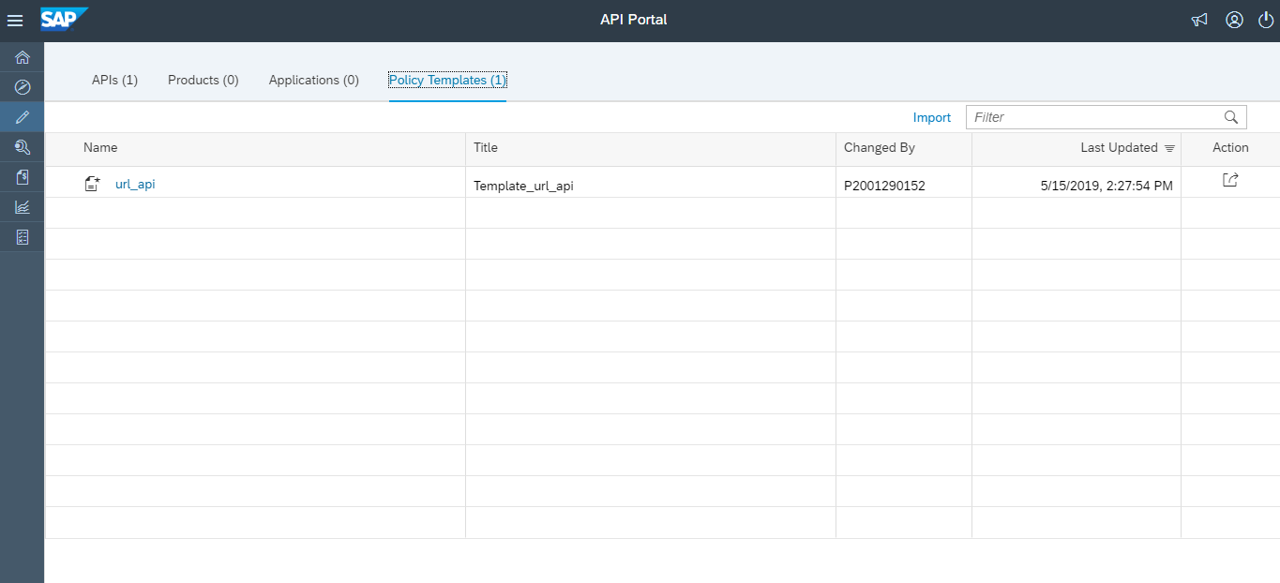

*Figure 125: importing policy Template*

* In the Import Policy Template window, attach the policy template you want to import and choose OK.

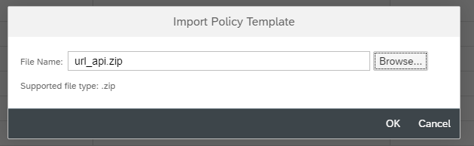

*Figure 126: Importing Policy Template*

* The Policy Template is successfully imported.
  + 1. **Export a Policy Template.**

Export a policy template using the API Portal.

**Context**

You are exporting a policy template and want to apply it to an API Proxy.

**Procedure**

* Log on to the API Portal.
* From the navigation bar, choose Develop.
* On the Develop screen, choose POLICY TEMPLATES.



*Figure 127: Exporting Policy Template*

* A list of available policy templates appears in the catalog.
* In the Actions column, select Export by choosing the  icon for the policy template you want to export



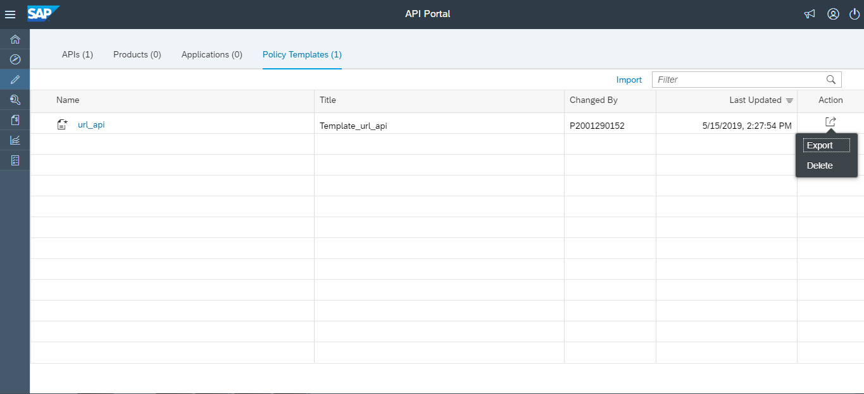

*Figure 128: Exporting Policy Template*

* The Policy Template is Exported Successfully.

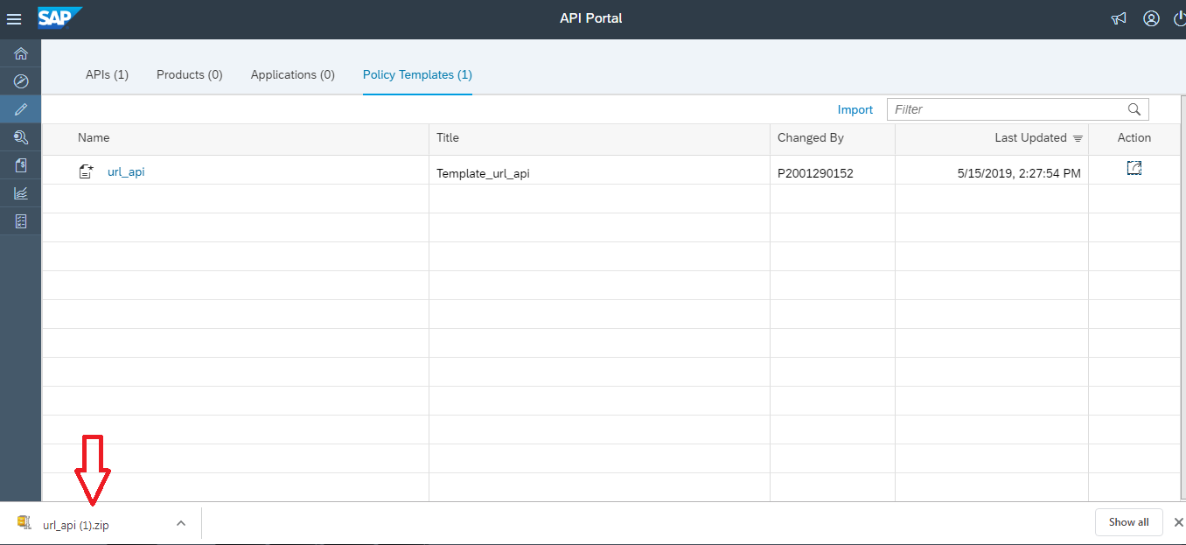

*Figure 129: Exporting Policy Template*

* + 1. **Delete a Policy Template.**

Deletea policy template using the API Portal.

**Context**

You are deleting a policy template and want to apply it to an API Proxy.

**Procedure**

* Log on to the API Portal.
* From the navigation bar, choose Develop.
* On the Develop screen, choose POLICY TEMPLATES.



*Figure 130: Deleting Policy Template*

* A list of available policy templates appears in the catalog.
* In the Actions column, select Delete by choosing the  icon for the policy template you want to delete





*Figure 131: Deleting Policy Template*

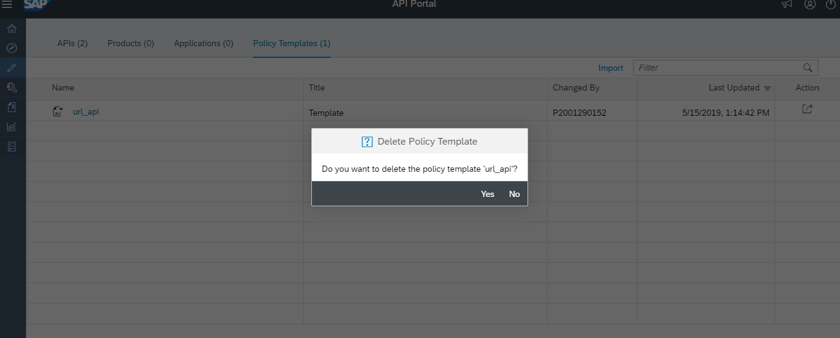

*Figure 132: Deleting Policy Template*

* Choose OK.
* The Policy Template is Deleted Successfully.
  1. **Test API’s**

API Management provides an API Test Console, which enables you to test your APIs. Testing an API is essential to understand the runtime behavior of the APIs. The test console allows you to explore the resources associated with an API and execute the operations.

The API Test Console allows you to test OData and REST-based services.

* Log onto the API Management portal.
* From the navigation bar on the left choose the icon API Test Console.



* A list of APIs appears on the left.

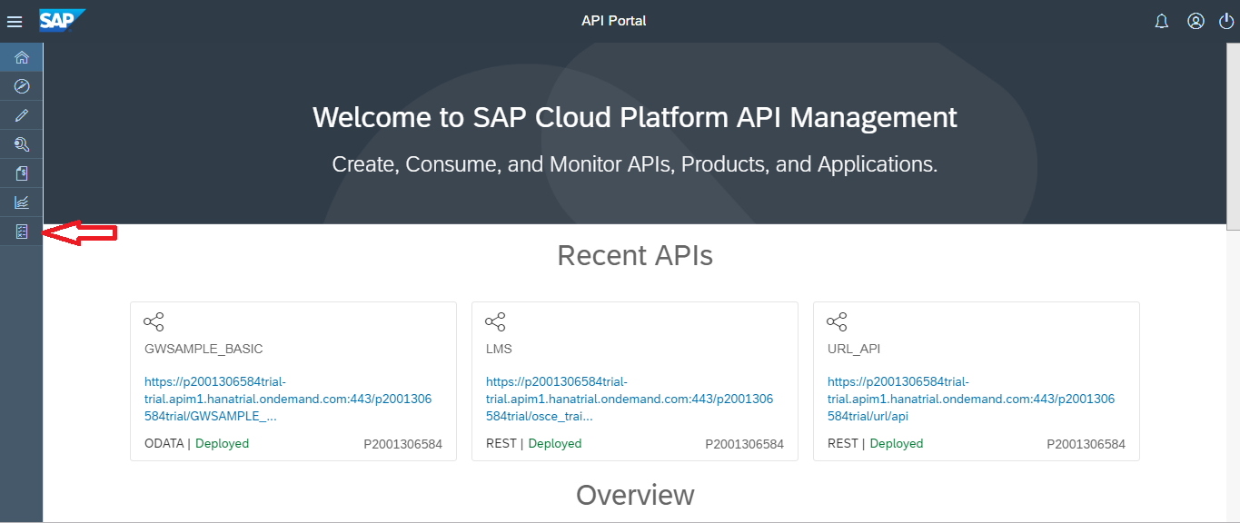

*Figure 133:Testing API*

* Select the required API.
* The URL for the selected API is populated automatically in the API Test Console. For the selected API, the URLs of the supported resources appear in the dropdown list. One resource is selected by default.
* If you want to choose a different collection, use the dropdown list to select the required collection
* If you have the URL of the service that contains the API, enter the service URL.
* Choose Authentication to select the required type of authentication. You can choose from the following options:
* **None**: No authentication required.
* **Basic Authentication**: Provide a user name and password.
* Enable the required method:
* **GET**: Reads an entity
* **POST**: Creates an entity
* **PUT**: Updates an entity
* **DELETE**: Deletes an entity

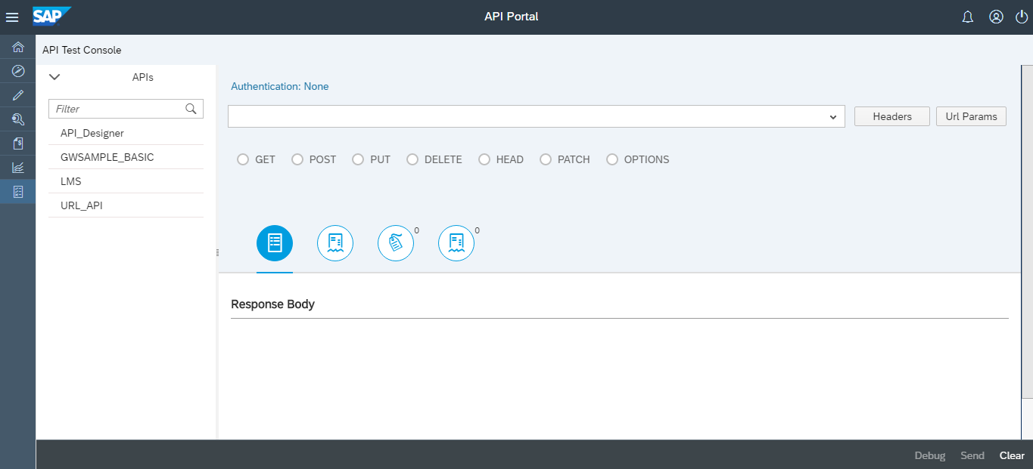

*Figure 134:Testing API*

* Enter the Request Body for PUT and POST methods.
* Choose Header to add a header.NoteIf you want to add multiple headers, choose Add Request Headers.
* Choose Url Params to enter the query parameter and value.NoteIf you want to add multiple query parameters, choose the button Add URL Params. Test Console supports passing of custom headers such as X-sap-apimgt-proxy-host:-proxy-trai and X-sap-apimgt-proxy-port:- 8080
* Choose Send.

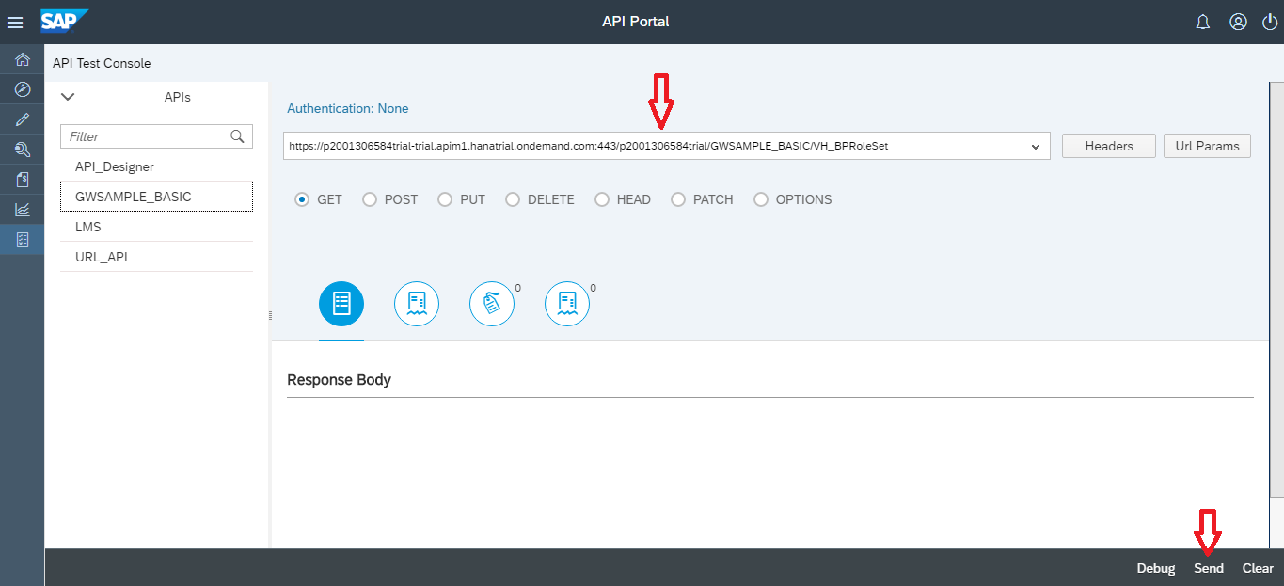

*Figure 135:Testing API*

* The response appears in the tabs:
* Body: View the formatted response.
* Body (Raw): View the unformatted response.
* Headers: View the headers.
* Cookies: View the cookies.
* If you want to use the response body as an input request, choose Use as Request on the Body (Raw) tab.
* To view the transactions based on the testing activity that you did, choose Launch API Viewer. For more information on tracing API proxy, see [Debug API](https://help.sap.com/viewer/66d066d903c2473f81ec33acfe2ccdb4/Cloud/en-US/fb2c7aa34cdc443294a325ccb7876785.html)

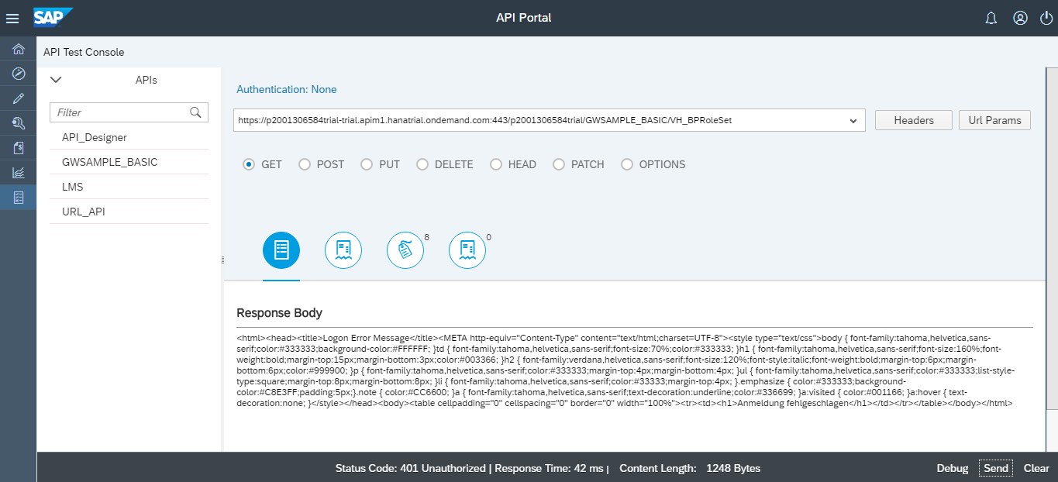

*Figure 136:Testing API*

* 1. **Debug API’s**

You debug an API proxy to troubleshoot and monitor them in API Management, by probing the details of each step through the API proxy flow.

* Log on to the API portal.
* Select the navigation icon and choose Develop.
* A list of registered APIs appears in the catalog.
* Select the required API that you want to debug.

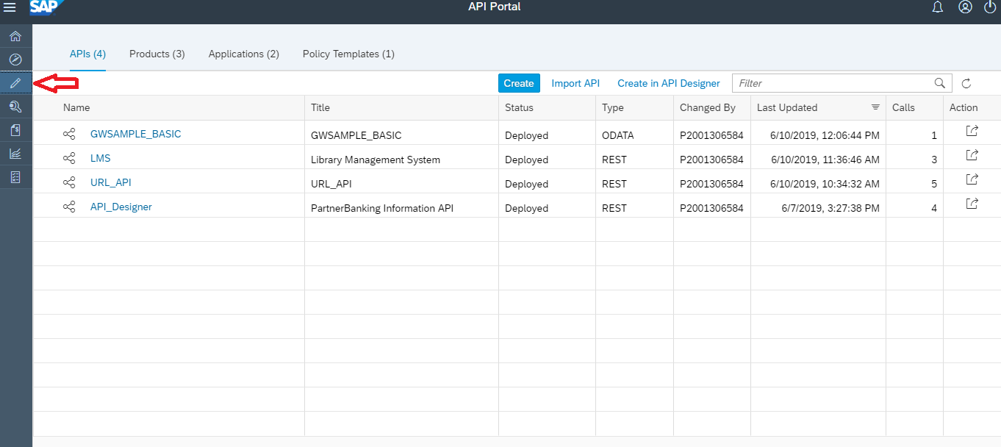

*Figure 137:Debug API*

* Choose Debug in the View API page.
* Alternatively, you can also launch the debug viewer from the API Test Console by following the sub steps below:
* Select the navigation icon and choose Test.
* Select the required API from the APIs list.
* Choose Debug at the bottom right corner.

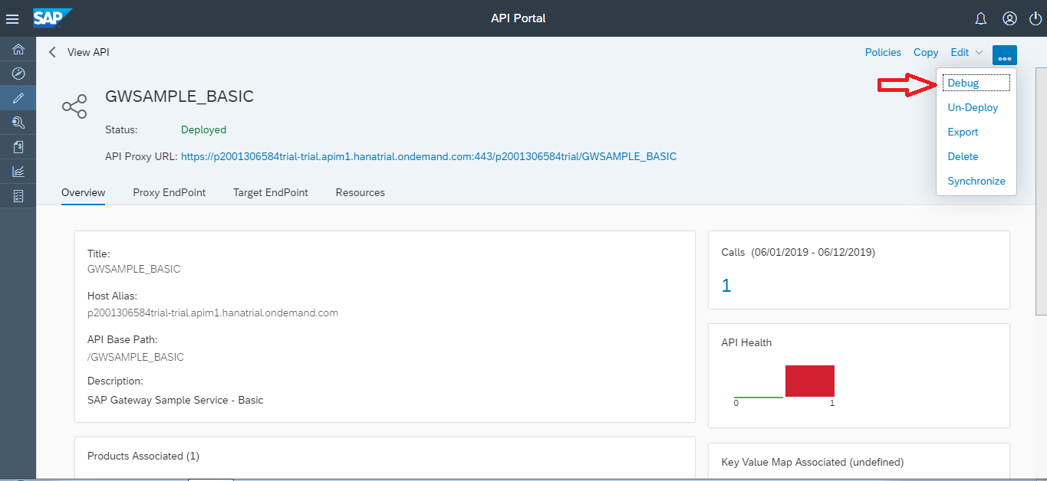

*Figure 138:Debug API*

* In the API Debug Viewer, choose Start Debug.
* When you start the debug, the API records details of each step in the processing pipeline. While the debug session is running, messages and contextual data are captured from live traffic.

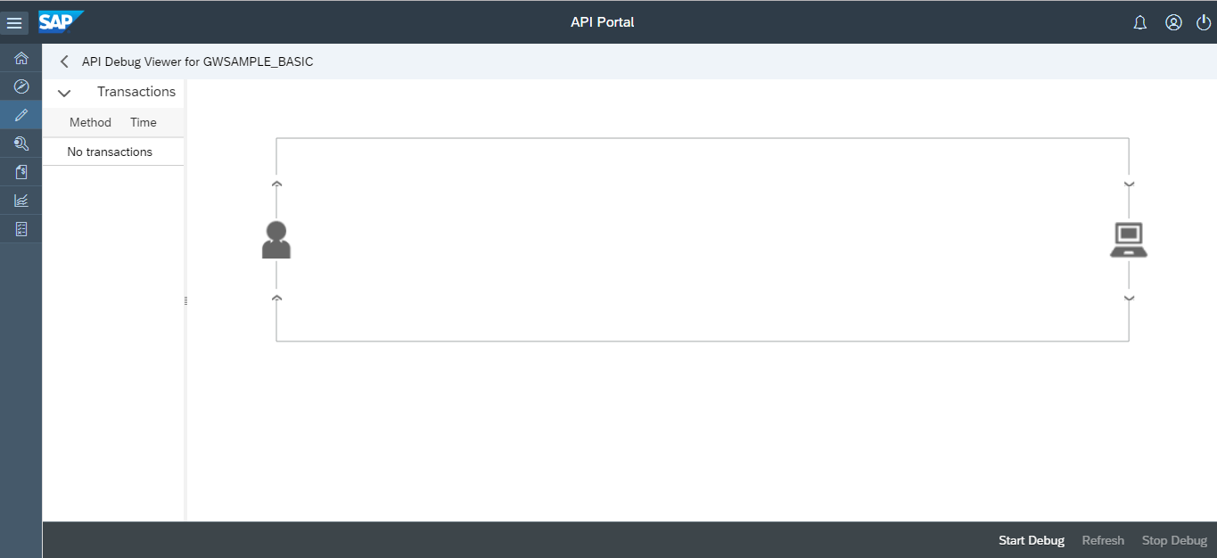

*Figure 139:Debug API*

* You can view a list of captured request/response transactions on the left menu. Choose any of the transactions to view the detailed debug map and the corresponding properties.
* To view the transaction details at any point in time of an active debug session, choose Refresh.

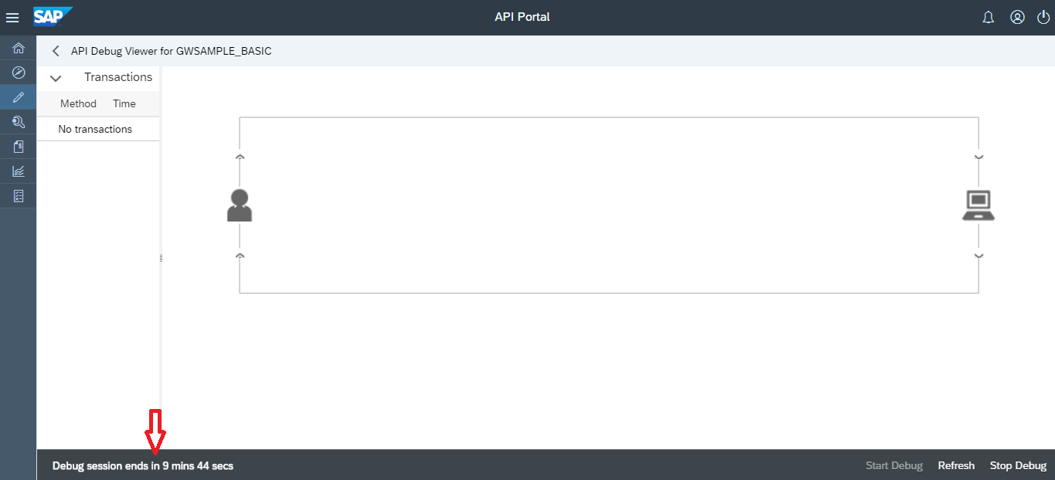

*Figure 140:Debug API*

* When you've captured a sufficient number of requests, choose Stop Debug.
* Debug the API using the guidance provided below:
* Transaction Map details

| Icon | Description |
| --- | --- |
| Condition | Indicates a condition evaluated on the API |
| State Change | Indicates the change of state of the execution flow |
| Flow Information | Indicates the information about the current flow |
| Execution | Indicates the result of a condition execution |
| Error | Indicates an occurrence of error at the time of policy execution |

* In addition to the above mentioned icons, each policy is represented by an icon. By choosing the icon, you can view the policy details.
* Phase Details
* Using phase details you can check the headers that are being sent to the backend, variables set by policies and so on. You can verify the base path to ensure that a policy is routing the message to correct server. Refer the table below to understand each phase:

| **Phase** | **Description** |
| --- | --- |
| Proxy Endpoint | Indicates the selected proxy Endpoint flow for execution. An API proxy can have multiple named proxy endpoints |
| Request Headers | Lists the HTTP request headers |
| Request Content | Displays the HTTP request body |
| Variables Read | Lists the flow variables that were read by a policy |
| Variables Read and Assigned | Lists the flow variables that were read and assigned a value by a policy. |
| Target Endpoint | Indicates the selected Target Endpoint for execution |
| Response Headers | Lists the HTTP response headers |
| Response Content | Displays the HTTP response body |

* 1. **Publish your API Proxy**

You need to publish APIs to make it consumable by external application developers. Publishing enables to expose the APIs in a structured manner in the form of a product. To publish APIs, you need to know how to bundle APIs and publish them together as a product.

* + 1. **Create a Product**

A Product is a bundle of APIs. It contains metadata specific to your business for monitoring or analytics. For example, all APIs related to CRM can be bundled as one CRM Product. Instead of publishing APIs individually, it is easier to bundle related APIs together as a Product and publish it. After including the required APIs to a Product, the Product is published to the Catalog, where the Product is available for Application developers to browse through.

* In SAP Cloud Platform, API Management, API Proxies are grouped and exposed as so called Products.
* Open the SAP API Management API Portal.
* Open the SAP API Management API Portal (you can get the URL from Enable the SAP Cloud Platform, API Management Service).

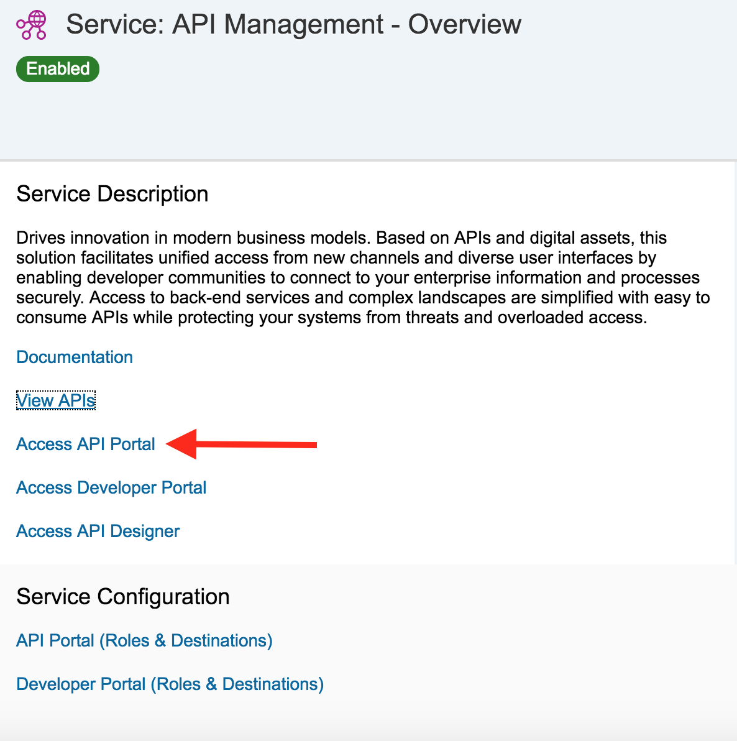

*Figure 141:Publishing API*

* From the Home screen, click on **Product** under the Quick Actions tile.

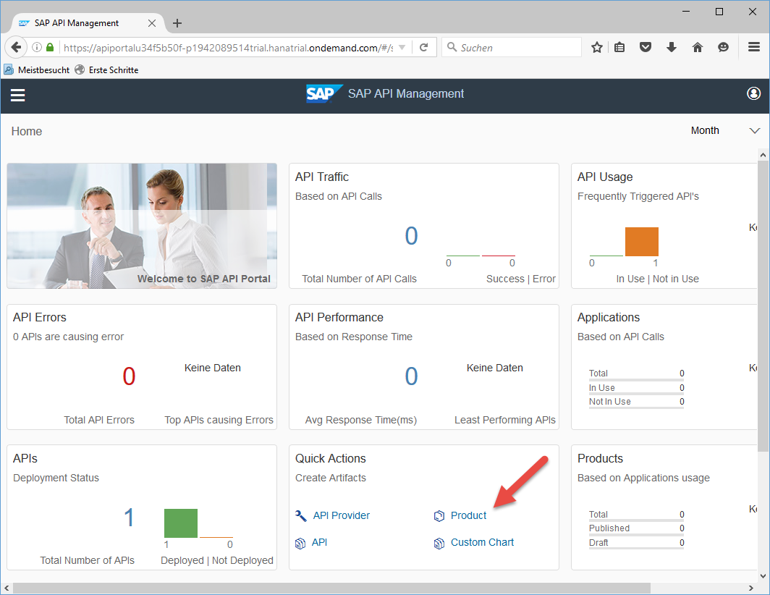

*Figure 142: Publishing API*

[Done](https://developers.sap.com/tutorials/hcp-apim-create-product.html)

* To access the list of Products, select the **Menu** in the upper left corner and click on **Develop**

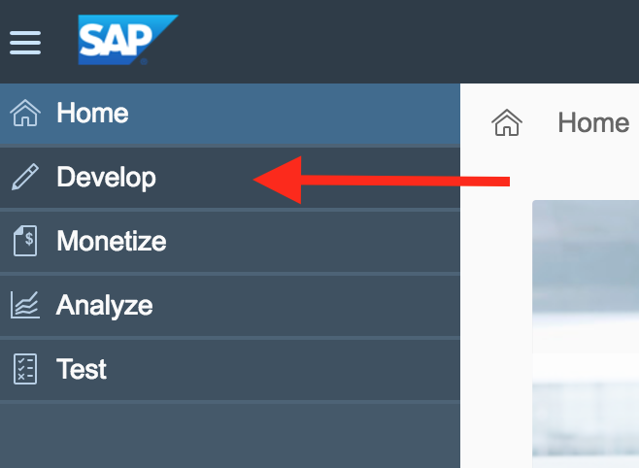

*Figure 143: Publishing API*

* Select Products from the tab menu. This will bring up the list of previously created products.

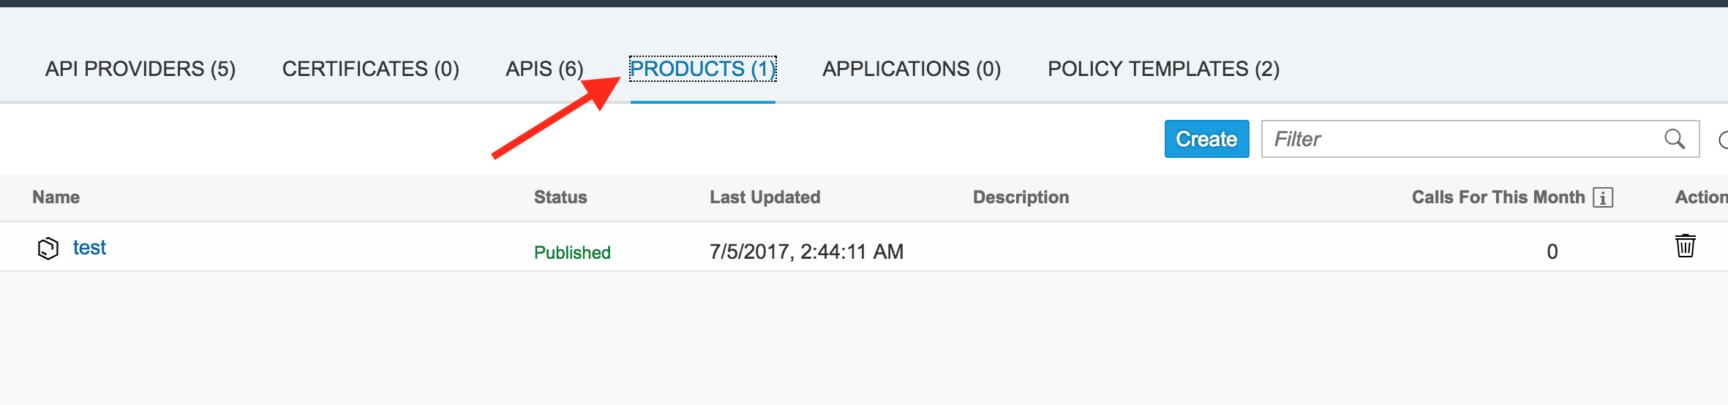

*Figure 144:Creating Product*

* On the Products tab, click on Create to start the new product wizard.
* On the Overview page, Enter the values for Name and Title.

| **Field** | **Value** |
| --- | --- |
| Name | ProductForFirstAPIProxy |
| Title | Product For First API Proxy |

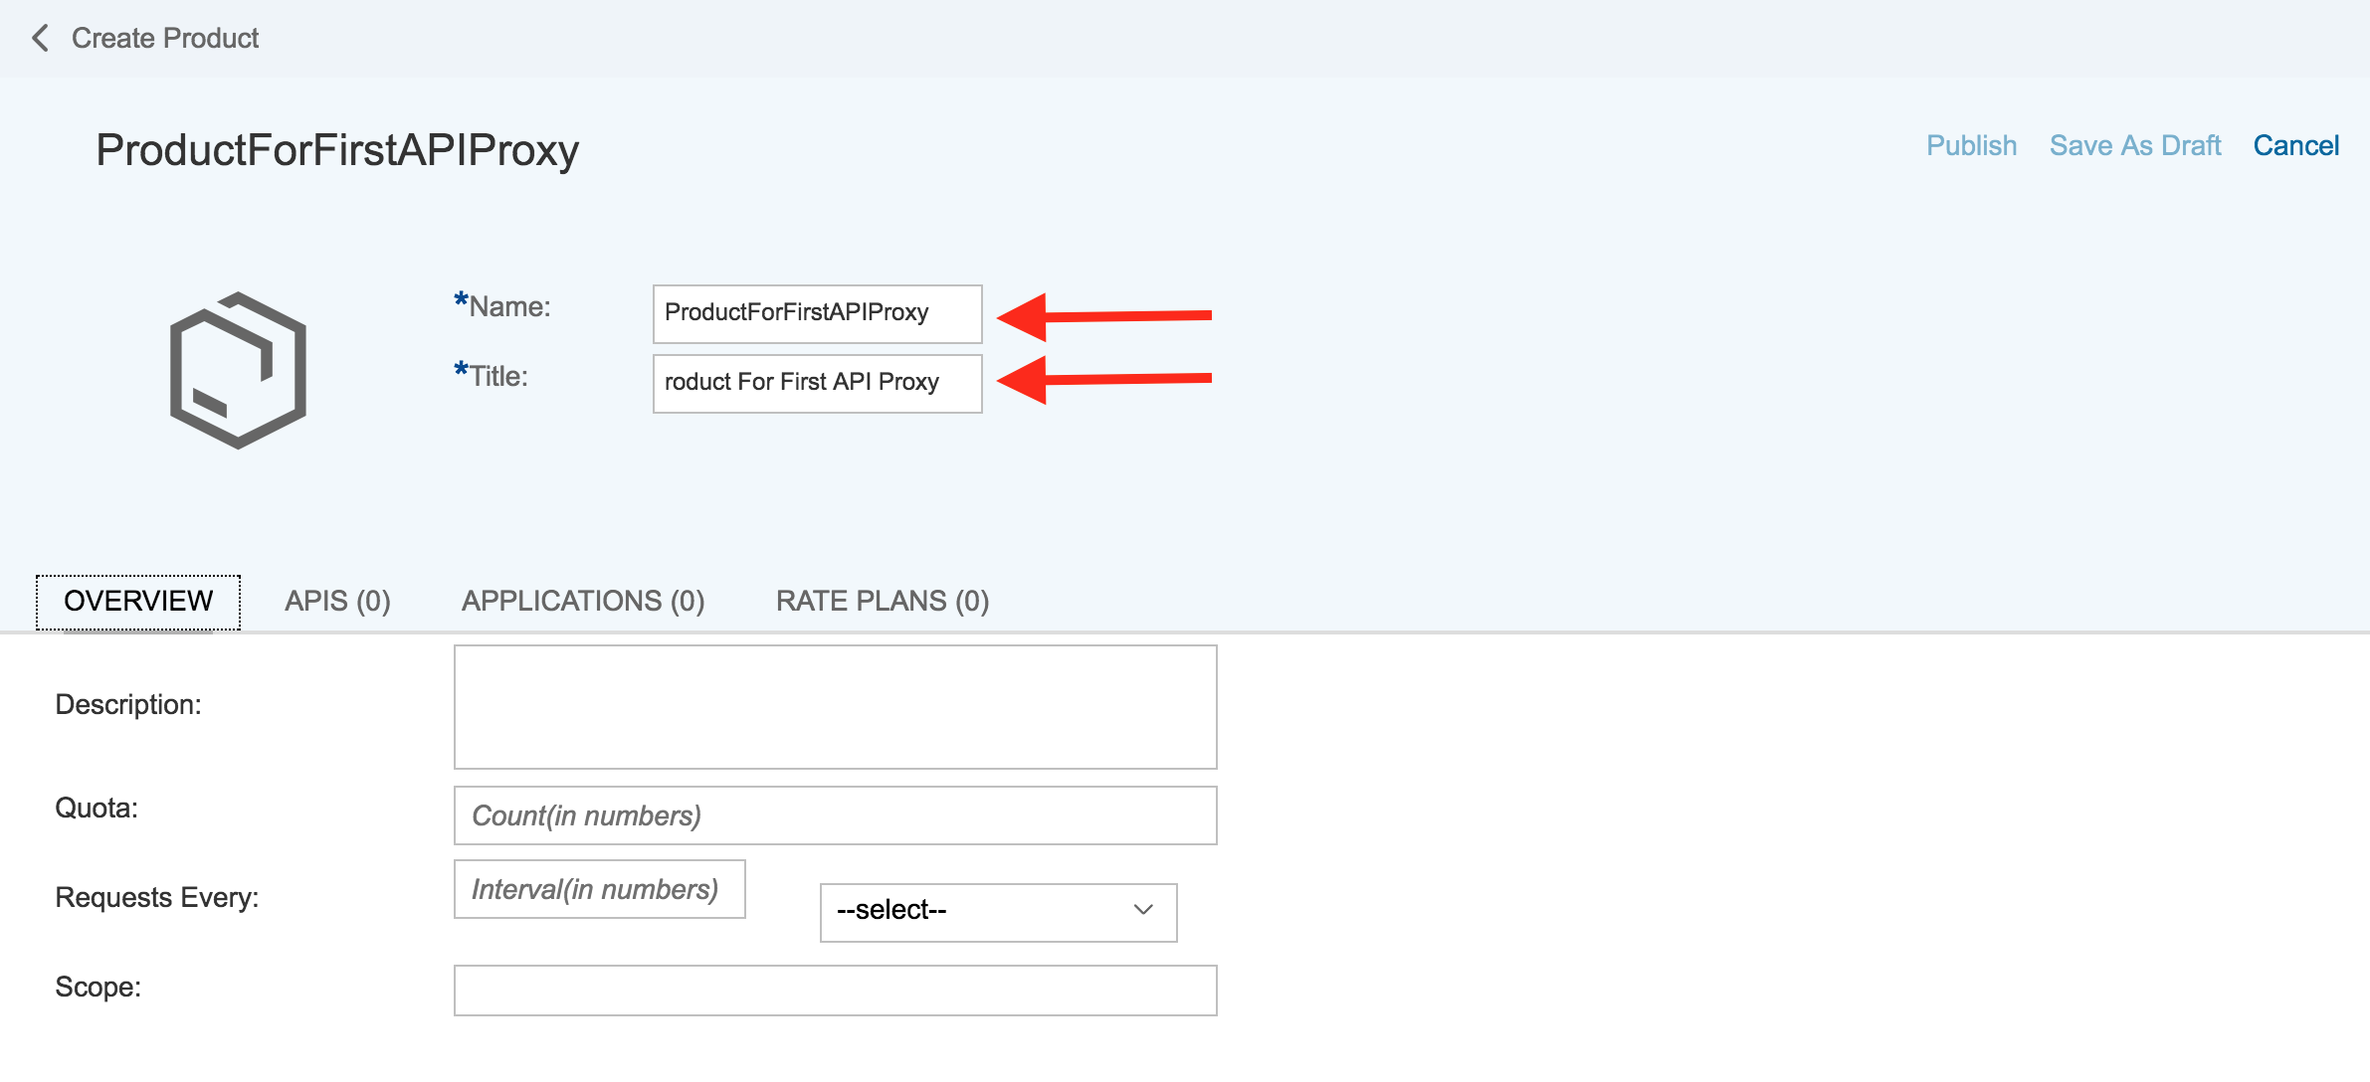

*Figure 145: Creating Product*

* In the tab menu, select **API**. This is were you can add and remove APIs and API Proxies from the product.
* Click the **Add** button.

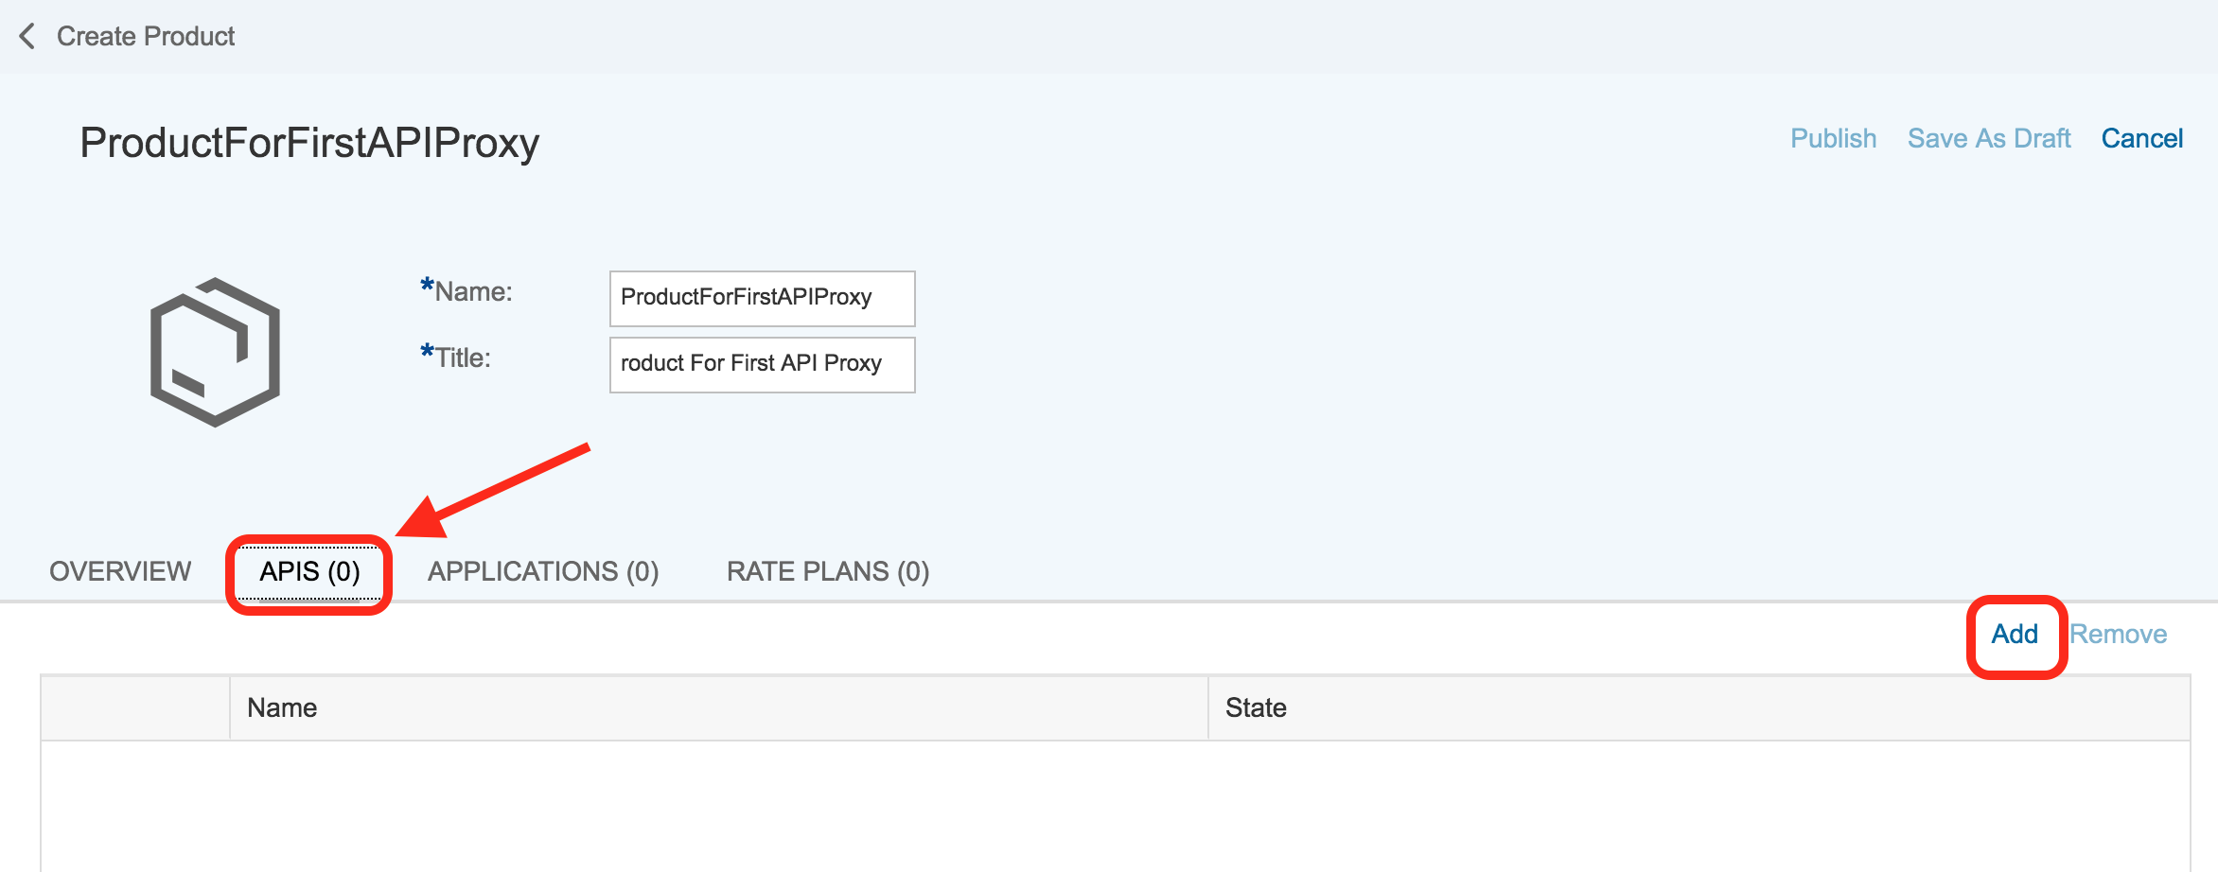

*Figure 146: Creating Product*

* The list of API Proxies is populated from the APIs you have created. Select the API Proxy GWSAMPLE_BASIC that you created in the previous tutorial. Click OK.

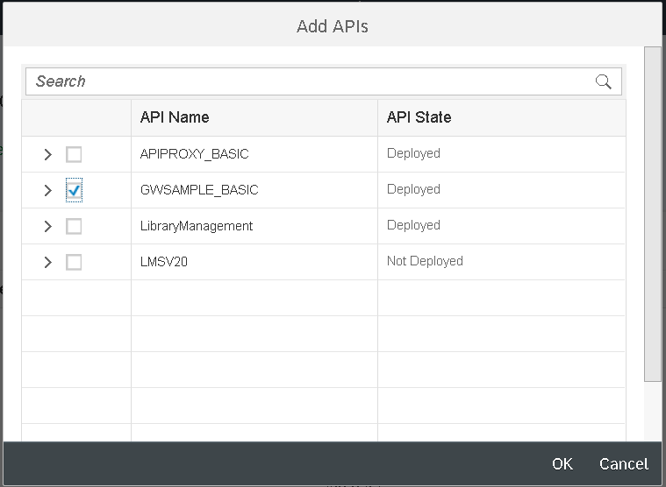

*Figure 147: Creating Product*

* Click on Publish.

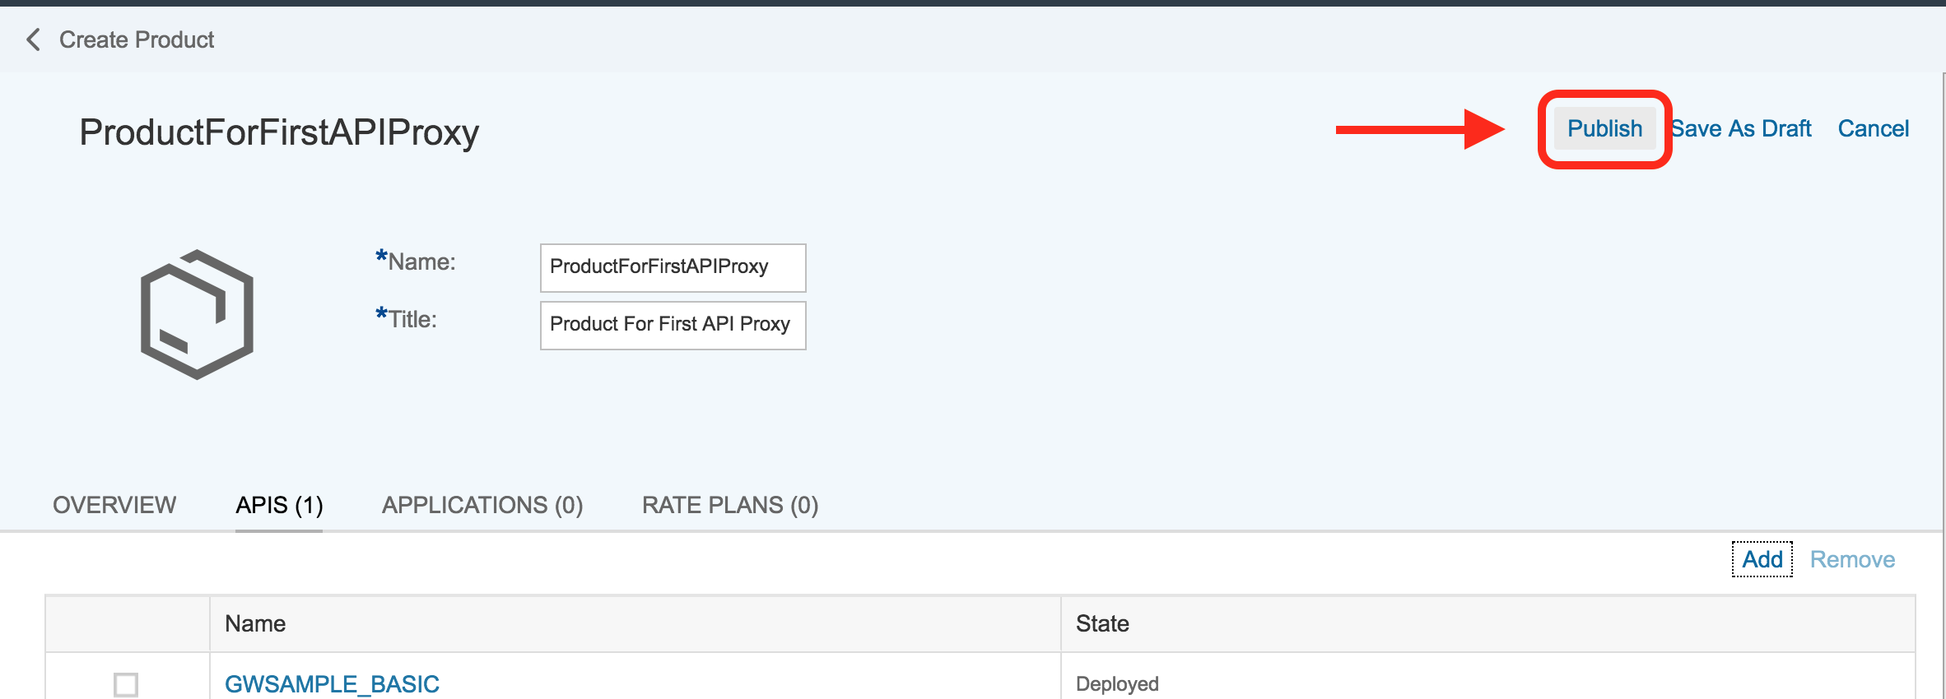

*Figure 148:Publishing Product*

* One Product is now available.

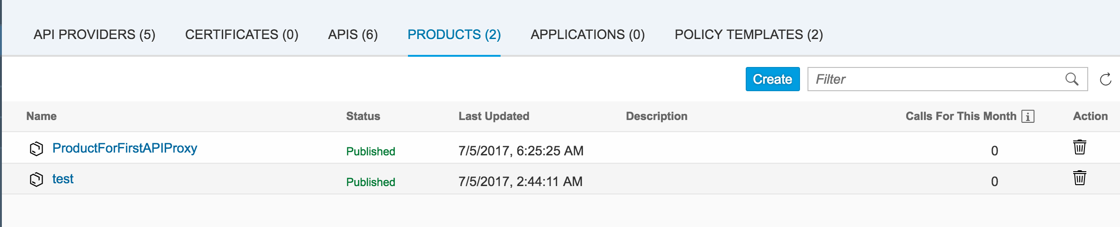

*Figure 149:Publishing Product*

* 1. **Consume API’s**

Consume APIs via the Developer Portal. In the Developer Portal, an application developer registers, explores the API exposed by customers, creates applications, and tests APIs.

* Log on to the Developer portal.
* Navigate to the required Product. You can search for the required product.

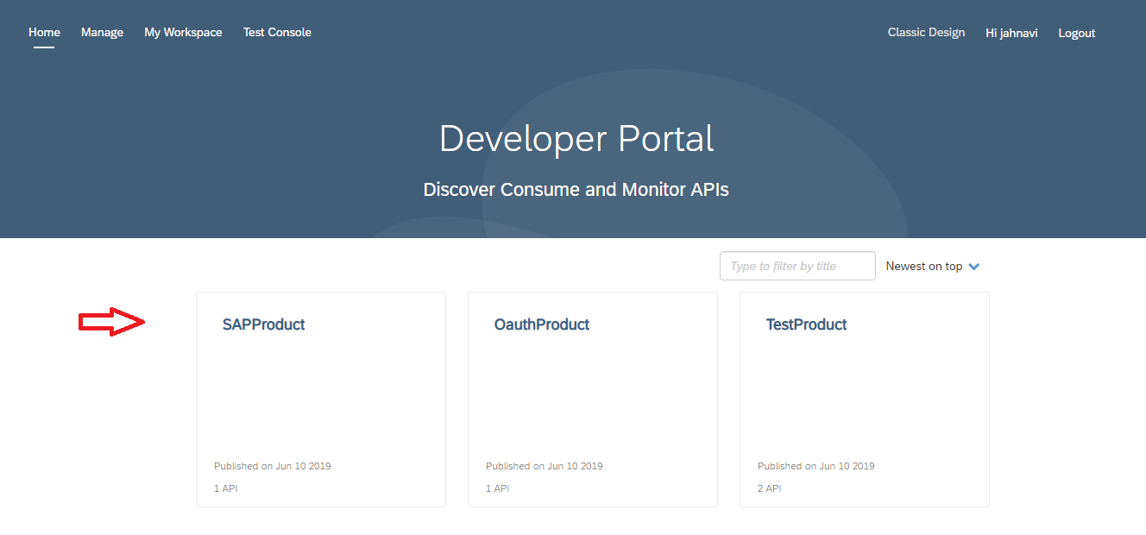

*Figure 161:Dev Portal*

* In the product details screen, choose Subscribe. You can subscribe.

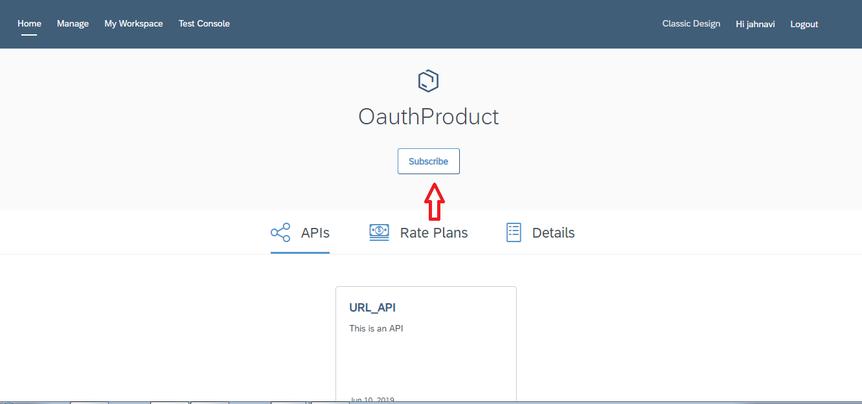

*Figure 162:Subscribing Product*

* **Add to Existing Application**: The list of applications appears. Choose the required application.
* **Create New Application**: Create an application by entering the name and title. The selected Product is added to the application by default.

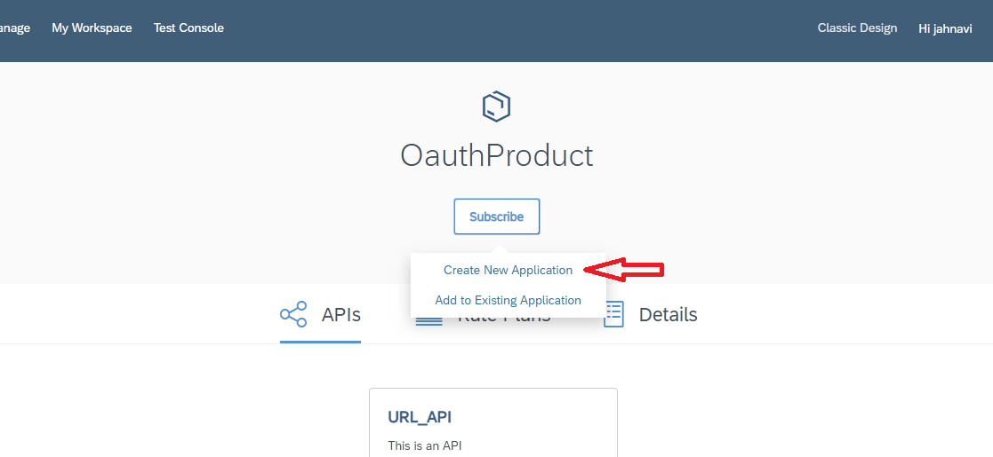

*Figure 163:Subscribing Product*

* Fill up the required fields and choose **Save**.

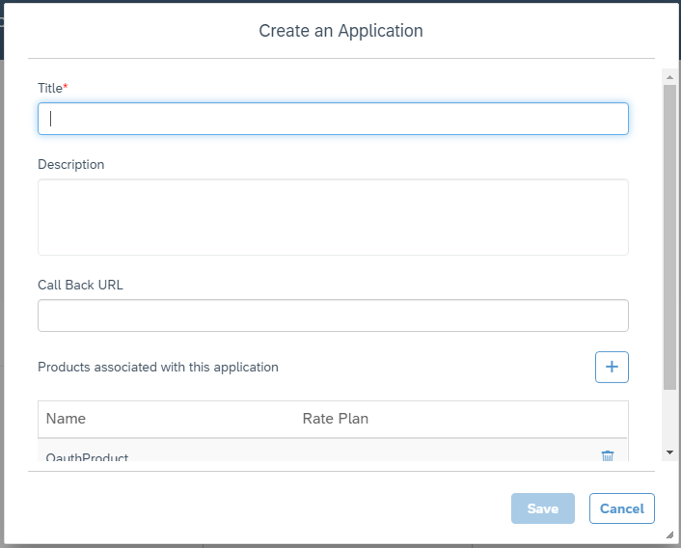

*Figure 164:Creating Application*

* Once you create an Application, you can then consume the APIs based on your business requirement.
* Click on the Classic Design option for our convenient movement in Dev Portal.

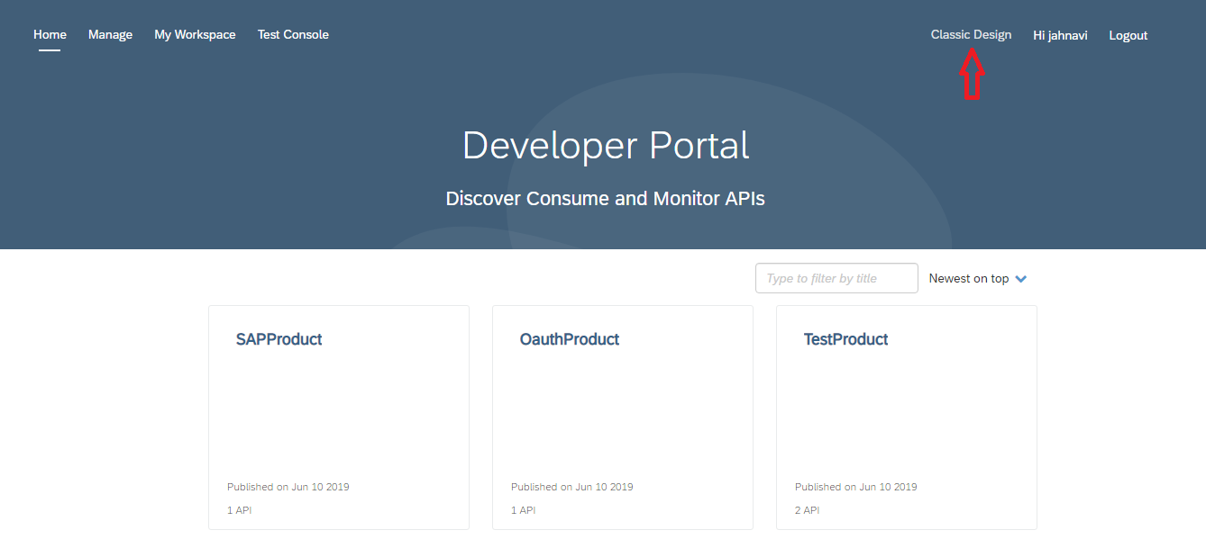

*Figure 165:Classic Design selection*

* On the left side panel you can see the consume option. Click on consume to consume the created applications.

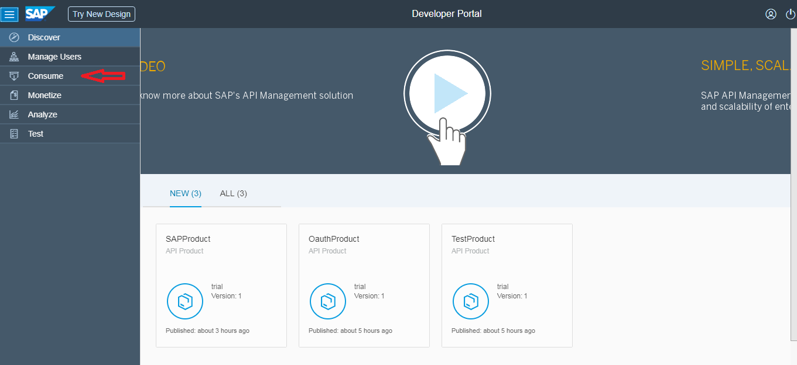

*Figure 166:Consuming Application*

* You can see the applications created. Select the required application to see the application id and secret.

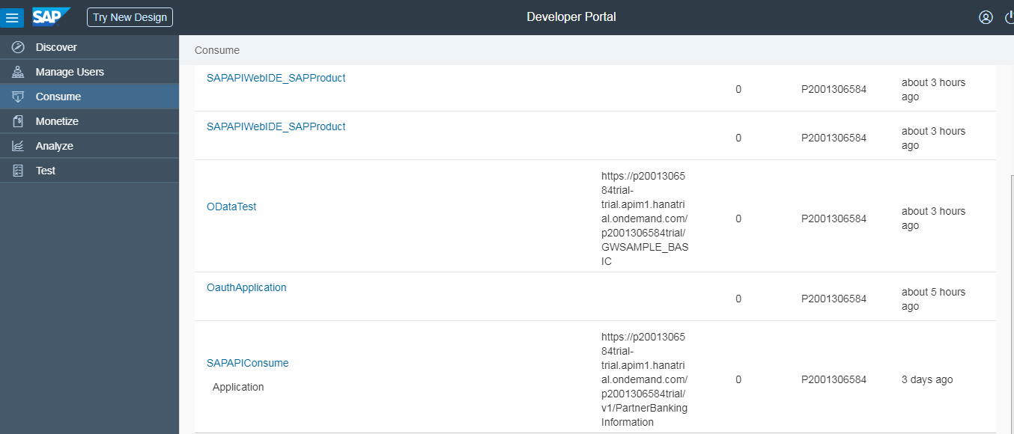

*Figure 167:Consuming Application*

* On subscribing to an application, the application developer receives an API key that the application must pass on every request to the API. API keys provide a simple mechanism for authenticating applications.

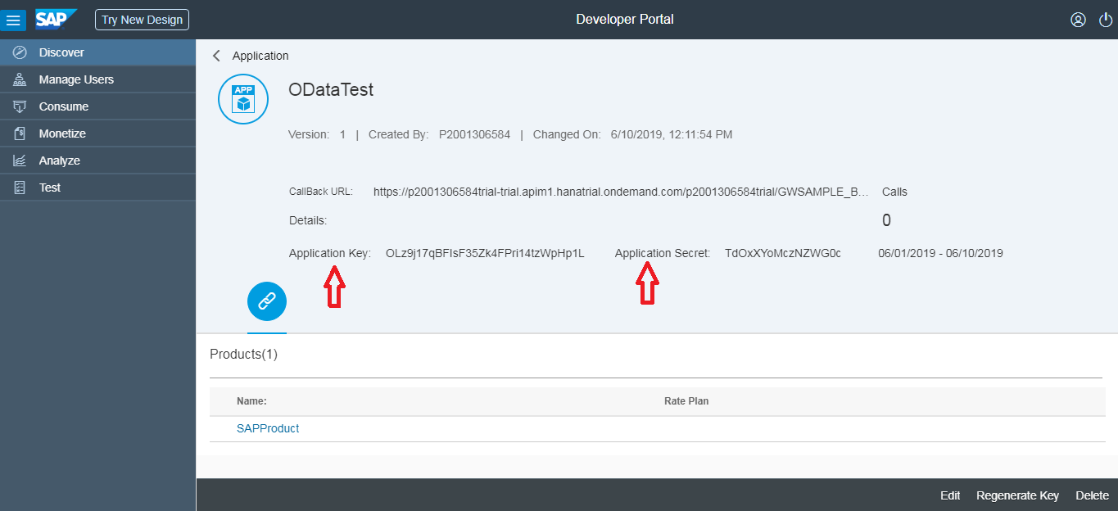

*Figure 168:Consuming Application*